AYURVEDIC MANAGEMENT OF MUTRASHMARI W.S.R. TO NEPHROLITHIASIS: A CASE SERIES
¹ Hanmante Suresh S., ² Hanmante Varsha S., ³ Karade Ruchika S.
¹ Professor, Dept. of Sharir-rachana, B.R.Harne Ayurvedic Medical College, Vangani, Thane.
² Professor, Dept. of Sharir- kriya, B. R. Harne Ayurvedic Medical College, Vangani, Thane.
³ PG Scholar, Dept. Of Panchakarma, R. A. Poddar Medical Ayu College, Mumbai.
Corresponding author- ruchikakarade1@gmail.com
ABSTRACT: Background: Mutrashmari (urinary stones) is one among the ashtamahagada (eight fatal conditions) and is kaphapradhan tridoshaja vyadhi, which can be correlated with nephrolithiasis. The recurrence rate is 50 to 80%. Males are more frequently affected than the female and their ratio is 4:3. The incidence is still higher in the age group between 30-45 years. Many treatment modalities have been adopted in medical sciences, but it is quite expensive and also the pathogenesis behind recurrence of formation of stone cannot be avoided. Hence, it is necessary to find out an economical effective, easily available medicine to treat mutrashmari. Objectives: The aim of this study was to evaluate the efficacy of panchakarma like virechana, yogabasti and shamana chikitsa in mutrashmari w.r.t. to nephrolithiasis. Materials and Methods: In this case series 3 patients with complaints of pain in abdomen and back, which was radiating from loin to groin region; burning micturition; and dysuria were diagnosed as nephrolithiasis and treated. The patients were administered with panchakarma like virechana, yogabasti and shaman aushadhi. Results: The patient got significant results in chief and associated complaints. Conclusion: Satisfactory relief in symptoms were seen in patient of nephrolithiasis by ayurvedic management and there was no recurrence.
KEYWORDS: Mutrashmari, Nephrolithiasis, Virechana, Yogabasti, Shamana chikitsa.
INTRODUCTION: Mutrashmari (urinary stone) is one of the common diseases of urinary system yet more painful one. It is one among the ashtamahagada (eight fatal conditions).⁽¹⁾ It is dreadful, potential to disturb the anatomy and physiology of urinary system and once it formed in the body, it has tendency of recurrence, therefore it is not easy to cure, thus the Acharyas call it mahagada. It is considered difficult to cure because of its marma ashrayatwa due to involvement of basti.⁽²⁾ Acharya Sushruta has described its complete pathophysiology in nidansthana. ⁽³⁾It is kapha predominance tridoshaja vyadhi.⁽⁴⁾ It is the formation of stony concretions in the bladder and urinary system. It is the common diseases of mutravaha strotas (urinary tract) that occur due to disequilibrium between stone inhibiting and promoting factors in the urinary system. The incidences of mutrashmari are increasing at the present era due to various reasons like altered food habits, changed lifestyle, stress, strain, environmental pollutions etc.
Mutrashmari is compared to urolithiasis or nephrolithiasis as per site of the formation of stone. In India, approximately 5-7 million patients suffer from stone disease ⁽⁵⁾ and at least 1/1000 of Indian population needs hospitalization due to kidney stone disease. Thus, the disease is as widespread as it is old, particularly in countries with dry, hot climate⁽⁶⁾. These are “stone belt regions”. The incidence of calculi varies as per geographical distribution, sex and age group. The recurrence rate is 50 to 80%. Males are more frequently affected than the female and their ratio is 4:3.⁽⁷⁾ The incidence is still higher in the age group between 30-45 years and incidence declines after age of 50.
Many treatment procedures have been adopted in medical sciences to treat the disease but it is quite costly and also the prognosis behind recurrence of stone formation cannot be avoided. In alternative medicines, mainly surgery is described to treat the one. So, there is a need of such treatment which has properties like diuretic, splitting, scarification, breaking, and cutting; it facilitates the dissolution of the urinary stones. Hence, in this study, panchakarma chikitsa like virechana followed by yogabasti and shamana aushadhi were selected for the management of mutrashamri.
AIM AND OBJECTIVE:
The aim of this study was to evaluate the efficacy of ayurvedic chikitsa in the management of mutrashmari with special respect to nephrolithiasis.
MATERIAL AND METHODS:
In present study, three cases with sign and symptoms of mutrashmari were treated with panchakarma therapy like virechana followed by yogabasti and shamana aushadhi. Assessments were done in criteria like pain in abdomen, dysuria, serum creatinine and ultra- sonography investigation (USG) before and after the treatment as follows.
Pain abdomen: Pain was assessed by VAS (Visual Analogue Scale): By gradation method, Grade 0: Absence of pain/No pain; Grade I: 1 to 3 mark on scale (mild pain); Grade II: 4-6 (moderate pain); Grade IV: 7-10 (severe pain).
Dysuria: was assessed by history of pain and radiation during micturition. Grade 0-Absence of pain during micturition; Grade 1-Mild pain during micturition; Grade 2-Moderate pain during micturition; Grade 3-Severe pain during micturition.
Serum creatinine: was assessed by routine urine examination.
USG: was assessed before treatment and after treatment and was presented with Present (1) and Absent (0), size of stone was seen.
CASE SUMMERIES:
CASE 1 – A 22 years male patient came with complaints of pain in abdomen associated with difficulty in urination from 1 month. Patient was asymptomatic one month ago. One day he suddenly felt severe pain in the abdomen and vomiting and fever. He took allopathic treatment and got temporary relief from the complaints. Later he observed that pain in abdomen and flank region, dysuria and decreased in frequency of urination. Patient stated that the pain was intermittent and colicky in nature. Dysuria felt by patient normally at beginning of urination which was pricking type. Diet history revels that his food intake was irregular and had junk food. His occupation was quite stressful. On examination the abdomen there was tenderness elicited in the both side of lumbar region and right side of renal angle. He was advised USG of abdo-pelvis revealed that in right kidney calculus of size 6.2 mm was present at night renal lower pole. Mild hepatomegaly with diffuse fatty changes was seen. There was no obstruction and hydronephrosis. In haematological investigation level of serum creatinine was found to be increased (Table no. 2).
CASE 2 – A 47 years old male patient came with complaint of severe pain in right flank region associated with nausea, burning micturition, pain radiating to groin region intermittently from 2 months. Pain started gradually with increase in pain intensity. Patient was taking modern analgesics tablets but didn’t get relief. USG abdomen was advised suggestive of right renal calculi of size 4.2 mm in mid and 7.5 mm at upper pole with hydronephrosis. Left kidney showed simple cortical cyst of size 25 x 26 mm upper pole (Table no. 2) Patient was taking milk in diet frequently and has sedentary lifestyle. He was known case of hypertension and was on medication from 5 years.
CASE 3 – A 50 years old male patient came with complaints of abdominal pain and it was found that pain was intermittent and colicky in nature and it was present on right side of the abdomen which was radiating to groin region, difficulty in micturition normally beginning of urination which was pricking type, burning micturition sometimes and occasionally dark yellow coloured smoky urine from past 1 month. He has known case of diabetes mellites and was on regular medication from 5 years. Patient has taken allopathic medicines but was not satisfied. In personal history, it was found that patient was non-vegetarian, insufficient water intake, sedentary lifestyle and suppression of natural urges. He has addiction of alcohol from past 20 years. USG abdomen showed a 7.2 mm calculus at mid pole of right kidney. There was no hydronephrosis or calculus on left side. Mild multiple irregularity with multiple echogenic foci seen in urinary bladder. In haematological investigations, serum creatine was seen to be increased (Table no. 2).

TREATMENT MODALITY
Table no. 1: Treatment given in Mutrashmari
Sr. No. | Chikitsa | Drug | Anupan | Dose | Duration
1 | Deepan - pachana | Amapachaka vati | Koshna jala | 500 mg after meal BD | 5 days
2. | Snehapana | Mahatikta ghrita | Koshna jala | 50ml- 100 ml-150 ml | 3 days
3. | Gap days | - |  |  | 1 day
4. | Virechana | Triphala Kwath  Erand taila  Madhu  Abhayadi modak  Ichhabhedi rasa |  | 20 ml  40 ml  30 ml  2 tab  3 tab | 1 day
 | Sansarjana krama | Peyadi krama |  |  | 5 days
5. | Yogabasti  Niruha  Anuvasana | Mutral kashay+ Madhu+ Tila taila+ saindhav  Tila taila+ mutral kashay |  | 500 ml  100 ml | 8 days
6. | Shamana chikitsa | - Chandraprabha vati  - Gokshuradi guggul  - Shwetparpati  - Tankanbhasma |  | 120 mg  120 mg  5 gm  5 gm

OBESERVATION AND RESULT:
Table no 2: Assessment before and after treatment in nephrolithiasis
Sr. no. | Criteria | Case 1 |  | Case 2 |  | Case 3
 |  | BT | AT | BT | AT | BT | AT
1. | Colic pain | Grade IV | Grade 0 | Grade III | Grade I | Grade IV | Grade I
2. | Dysuria | 3 | 1 | 3 | 0 | 3 | 1
3. | Burning micturition | Present | Absent | Present | Absent | Present | Absent
4. | Serum creatinine | 3.1 | 2.3 | 7.47 | 3.9 | 1.47 | 0.92
5. | Size of calculi | 6.2 mm | No calculus | 7.5 mm | No calculus | 7.2 mm | No calculus
6. | USG | 1 | 0 | 1 | 0 | 1 | 0
Follow-up and Outcome After treatment, patient got relief in all symptoms with also improvement of associated complain. Reduced in Pain, relief in burning sensation during urination, relax during forcible urination, lower abdomen is soft no tenderness at renal angle, vomiting was stop, digestion was good, no weakness, fever was subsided. During follow-up period patient had informed that after days the calculus was expelled out and he experienced extreme pain and disturbance in the urine flow and no signs of recurrence were noticed. (figure no. 1, 2)
Figure no 1: Size of calculus before and after during treatment
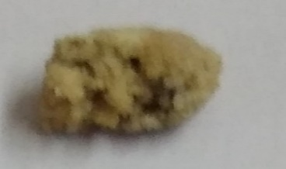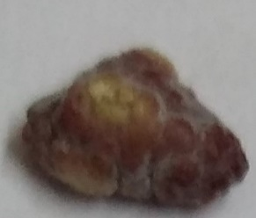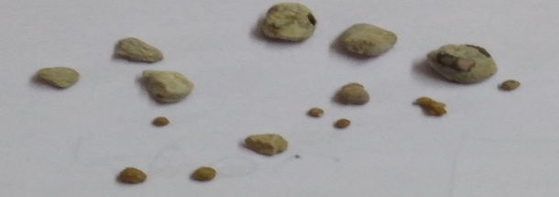

Figure no 2: USG reports before and after treatment
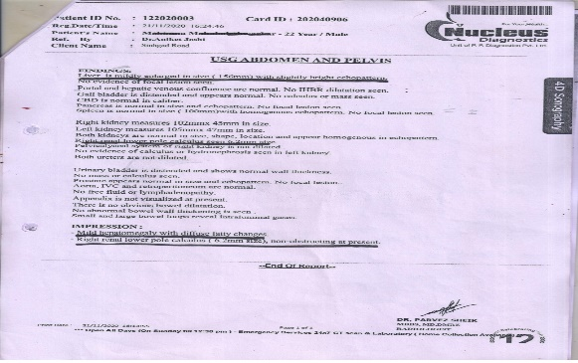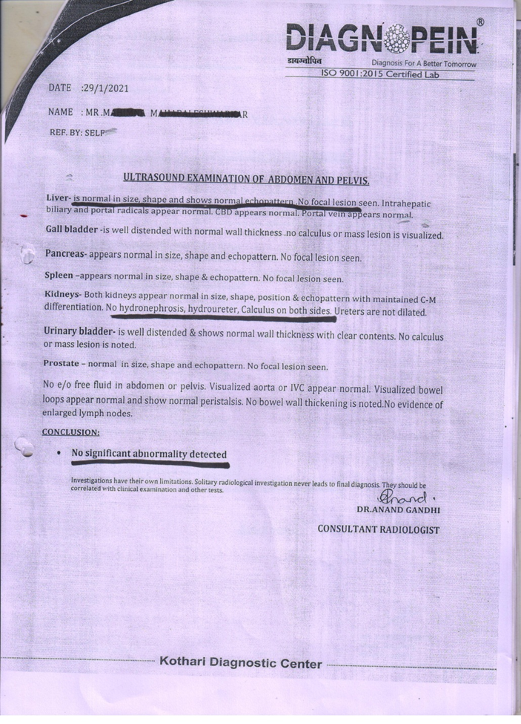

DISCUSSION:
In case of mutrashmari we need therapy and medicine which act as tridoshashamak, mutral, deepanpachan, nirama, shoolaghna, chedaniya, bhedaniya and lekhaniya, ashmari bhedana, mutrapravrittikarak, sadhya. So according to Samprapti, virechana, yoga basti karma (~combination of medicated enema) with combination of shaman aushadhi chandraprabhavati, gokshuradi guggul, shwetparpati and tankan bhasma gives best result in this disease. In the classics this is mentioned in prameha chikitsa, mutrakricchra chikitsa and ashmari chikitsa adhyaya combinely act on mutravaha srotas vyadhies having the properties dosha karmata (~action on vital forces) tridosha shamaka, dhatu karmata (action on body elements) act on medohara, balya, vrishya, rasayana, agni karmata (action on digestive fires) deepana pachana, mala karmata (action on excretory system) mutral, vibandhhara, srotokarmata (action onchannels) srotoshodhana, lekhan. The action of every drug is determined by the dominant pharmacodynamics factors. The line of treatment in Ayurveda is mainly based on dosha chikitsa(treatment).
As shodhana chikitsa in yogabasti karma mutral kwatha was used as a niruha karma. Its actions depend on the ingredients of basti. The main ingredient of basti include saindhava ,makshika, Sneha, kalka and kwatha. It reaches up to micro channels of body due to sukshmaguna It breaks morbid mala and dosha sanghaat due to tikshnaguna and liquefies the doshas due to snigdhaguna property. Kalka by its irritant property eliminates the basti (induce colonic distension due to irritant property), kwatha up to homogeneous mixture. It facilitates the absorption of endotoxin and produce detoxification during elimination.⁽⁸⁾ Kwatha- mutral kwatha possess all the needful properties like kaphahara(~antiphlegmatic), lekhana(~sraping) and mutrala(~diuretics). The possibility of the absorption of basti dravyas (~drugs) through colon works due to its fat-soluble property. Snigdhaguna of basti produces softness and wetness in body which in turn help for easy eliminations of doshas and mala with increases permeability of cell membrane. Apart from these functions, it also protects the mucus membrane. By taking all the above-mentioned discussion into consideration that the overall effect of all treatment regimen planned in this patient was diuretic, splitting, scarification, breaking and cutting, it facilitates the dissolution of the urinary stone.
ChandraprabhaVati -It has properties like tikta, katu, kashya, lavana kshar rasa pradhan, laghu, ruksha, vishada, sukshma, sitoshna and prabhava karma aushadha, kaphahara, jantughna, puyahara, shula hara, mutral. It has multi-dimensional action and effective for acute and chronic cases. Broad spectrum antibiotic, tonic (Strengthen nerves) for urogenital system, anti-inflammatory, immunomodulator etc.⁽⁹⁾
Gokshuradi guggul- diuretic, anti-inflammatory, and muscle relaxation actions, which has been used in genitourinary infections, painful micturition, dysuria and benign
prostatic hyperplasia.⁽¹⁰⁾

COCLUSION: This study provides an example of successful management of nephrolithiasis with Ayurveda treatment alone and without using any modern analgesics. This study also gives leads for the experiments on role of panchakarma in the management of pain. Clinical trials on Ayurveda management of mutrashmari (nephrolithiasis) are warranted.
REFERENCES:
- Sharma PV, editor. Ashmarichikitsa adhyaya. Verse 3. In: Sushruta, Sushruta Samhita, Chikitsa sthana. Varanasi, India: Chaukhambha Surbharati Prakashan; 2013. p. 234.
- Sharma PV, editor. Ashmarichikitsa adhyaya. Verse 37-38. In: Sushruta, Sushruta Samhita, Chikitsa sthana. Varanasi, India: Chaukhambha Surbharati Prakashan; 2013. p. 240
- Sharma PV, editor. Ashmarinidan adhyaya. Verse 1. In: Sushruta, Sushruta Samhita, Nidan sthana. Varanasi, India: Chaukhambha Surbharati Prakashan; 2013. p. 481.
- Sharma A, editor. Ashmarinidanam. Verse 1. In: Text book of Madhavnidan. Vol 1. Pune, India: Chaukhamba Sanskrita Pratishtan; 2007. p. 506.
- Norman S Williams (2010) Bulstrode. Bailly & Love’s short practice of Surgery. Chapter 71. (25thedn), Hodder Arnold publishers, London. Townsend CM, Beauchamp D, Mattox KL (2010) Sabiston Textbook of Surgery. In editor. Sabiston Textbook of Surgery. Elsevier publications, Newdelhi.
- Kaviraj Ambikadutt Shastri (2001) Sushrut Samhita with Ayurved tatva Sandipika Hindi commentary, Nidaansthan ¾. (Reprint edition), Choukhambha Sanskrit Sansthan, Varanasi.
- Amitkumar singh (2009) Comparativeclinical Study in the Management of Mootrashmari with Kulattha Churna and Swetaparpati, MD Thesis. RGUHS, Bangalore.
- Subina S., Pratibha C.K., Ananda raman P.V., Prashanth D., Understanding the mode of action of basti karma (medicated enema): Anveshna Ayurveda medical journal, Volume 1, Issue 4, July –August 2015, Page 267- 274.
- Muhammed S.V., SAMS, urinary system diseases, prameha chapter 2 Volume 1 third edition page no 405
- Muhammed S.V., SAMS, urinary system diseases, mutrakrchra & mutraghata chapter 1 Volume 1
third edition page no 393

