A Case Study To Evaluate The Effect Of Blood Letting ( Leech Application) In The Management Of Vicharchika (Eczema)
Authors-
- Dr. S.D.Waghmare;M.S.Professor,Shalyatantra Dept., GAC, Osmanabad.
Email id- drwaghmaresd1@gmail.com Mob no.- 7506945239
- Dr. Pratiksha P. Pattewar, PG Scholar,Shalyatantra Dept., GAC, Osmanabad.
Corresponding author –
Dr. Pratiksha P. Pattewar, PG Scholar,Shalyatantra Dept.,GAC,Osmanabad.
Email id- doctorpratiksha123@gmail.com Mob no.- 8669218197
Abstract-
Skin disease is a most common health disorder worldwide. Skin disorders vary greatly in symptoms and severity. Eczema is a skin condition marked by itchy and inflamed patches of skin which causes psychological and social burden on patients. Allopathic medications which are used to treat chronic eczema are mainly topical steroids, antihistaminic and antibiotic drugs. Patients get temporary relief with these treatments but in many patient reoccurrence and relapses are commonly seen.
In Ayurveda for skin disorders Shodhan therapy is mainly advised out of which bloodletting is more effective. In the present case study a patient having classical sign and symptoms of Vicharchika (Eczema) is treated with bloodletting therapy and significant results were seen.
Key Words - Eczema, Bloodletting, Leech Application, Vicharchika
Introduction -
Skin is the organ of body which is interacting with environmental factors like physical, chemical and biological agents. In present era change in lifestyle, environment and dietary habits have made man as main victim of skin diseases. Ayurveda has considered all skin diseases under a broad heading of Kushtha, which are further divided Mahakushtha and Kshudrakushtha. Vicharchika is described under Kshudrakushtha^{[1]} . Vicharchika is not one of the life threating disease but patient become worried due to its appearance, severe itching, chronicity and disturbance in routine work.
In Charak Samhita characteristics are of Vicharchika described are skin eruption with dark discolouration, itiching and profuse discharge^{[2]}. A similar clinical presentation is seen in eczema charectrized by erythma, oozing, oedema, vesiculation. According to Ayurveda one of the prime causes for all skin diseases is Rakta Dushti. All ancient scholars have repeatedly advocated that Raktamokshana (Bloodletting) should be considered as the supreme method for the treatment of skin diseases. There are so many methods are available for the same^{[3]}. Among the various methods of bloodletting, leech application was selected.
Aim and objective -
To evaluate the effect of bloodletting (leech application) in eczema (Vicharchika)
Case Study -
A case of 77 year old male patient complaining oozing of grade 3, intense itiching of grade 2, burning sensation of grade 2, discolouration of grade 2 on ventral and dorsal side of bilateral leg, also thicking of skin of grade 2 [Image 1] since 15 days attending Shalya Tantra OPD, was chosen having clinical sign of Vicharchika (Eczema).
History of present illness -
According to patient he was asymptomatic 15 days ago than he gradually developed intense itiching, oozing and discolouration on ventral and dorsal side of bilateral leg.
Past history -
No any history of Diabetes and Hypertension or no any other major illness.
Also no any specific medicinal and family history was present.
After admitting the patient, following investigations were done and patient was planned and treated by Bloodletting (Jalookavcharan).
Investigtions - Hb – 10.5 gm% , BT – 2.03 min. , CT – 4.07 Min. , BSL random – 80 mg/dl, Urine routine – With in normal limit , HbsAg and ICTC – Negative
Criteria for Assessment -

Criteria of assessment were kept on the basis of relief in the signs & symptoms of the disease Vicharchika. For this purpose, cardinal signs & symptoms were given scores according to their severity before & after treatment.

Scoring criteria

- Kandu (itching)
0 - No itching
1 - Mild itching not disturbing normal activity
2 - Occasional itching disturbs normal activity
3 - Itching present continuously

- Daha (burning)
0 - No burning sensation
1 - Mild type of burning not disturbing normal activity
2 - Occasionally burning disturbing normal activity
3 - Burning present continuously & even disturbing sleep

- Srava (Oozing)
0 - No discharge
1 - Moisture on the skin lesion
2 - Occasionally oozing disturbing normal activity
3 - Oozing present continuously

- Vaivarnya
0 - Nearly normal skin colour
1 - Brownish red discolouration
2 - Blackish red discolouration
3 - Blackish discolouration

Treatment plan –
Patient was planned and treated by bloodletting (leech application) ; 3 setting with interval of 7 days.
Procedure of leech application
Purva Karma -
The patient was placed on proper position according to the site of lesion. Four Leeches were kept in turmeric water to make them active, increase appetite and free from natural urges, after keeping the leeches for 30 min they were put in fresh water.
Pradhana Karma -
Lesion is cleaned by water and dried with cotton. After this, rubbing of the skin was done by sterilized cotton bandage pad. The activated leeches were applied over the lesion site. Leech become elevated like a horse shoe or raised in an arched position from its neck that indicates that they are sucking the blood vigorously or strength fully. After catching the site, leeches were covered with wet cotton pad and regularly sprinkled with cold water. The leeches usually detach from the site after sucking the vitiated blood or have to be removed by sprinkling turmeric over it when the patient complains pain or itching
indicates that fresh blood is being sucked.
Paschat karma -
After detachment of leech, wound was cleaned with and after that tight bandage with turmeric powder was applied for prevention of secondary hemorrhage. After falling off, turmeric powder was applied on the mouth of leech to make it vomit the sucked blood. Leeches after vomiting were put in fresh water, when they move freely without sinking down, were considered as properly vomited. Used leeches were kept in a separate pot containing pure water and used for the same patient after a interval of 7 days.

Result – There is markedly improvement seen in this case of Vicharchika (Eczema) after 3 setting of bloodletting (leech application).

Graph 1: Changes in symptoms of patient before treatment and after treatment.
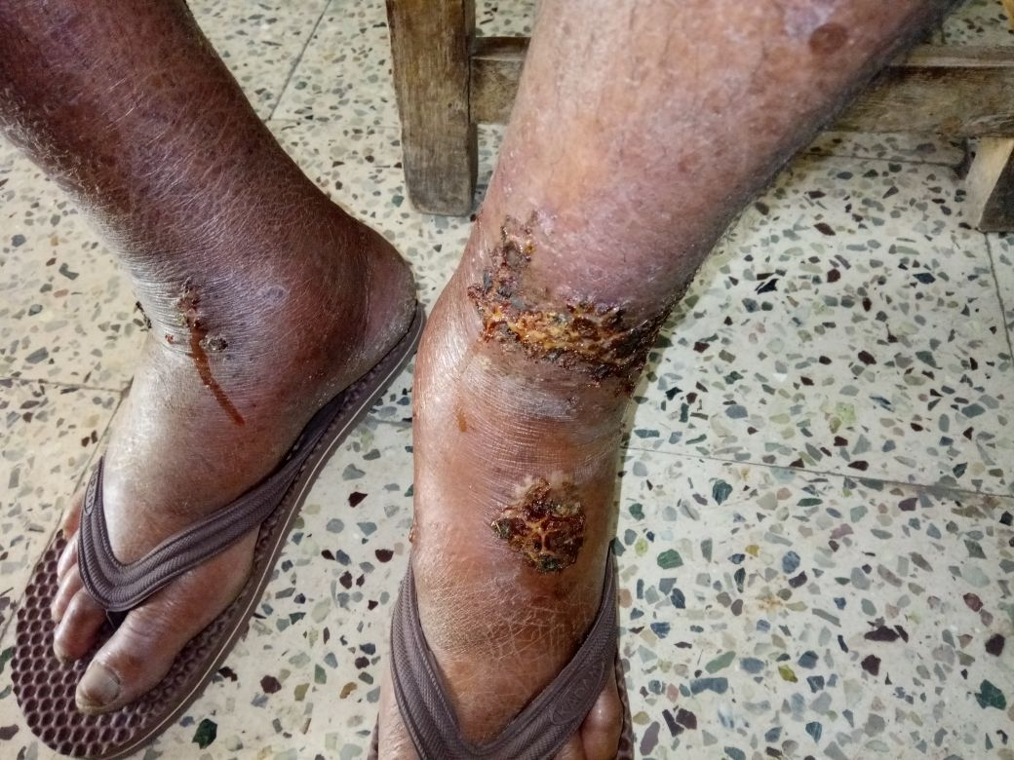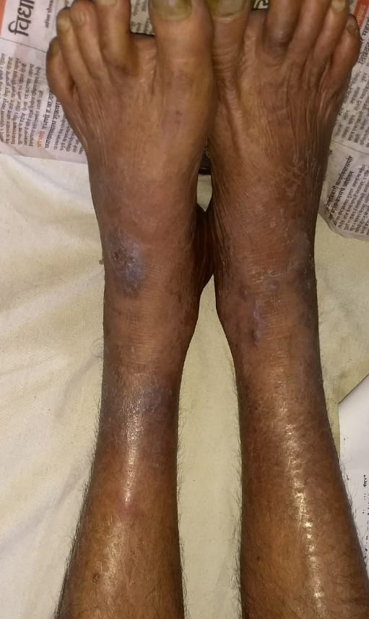
[Image 1 - Before Treatment] [Image 2 – After Treatment]
Discussion -
The probable mode of action of leech application in Vicarchika can be explained in the following way. Leech saliva contains hirudine having antibiotic properties^{[4]} which helps in reduction of infection and oozing in Vicharchika.The saliva of leeches contain antihistaminic protease^{[5]} this factor play an important role in reducing itch impulse (in turn scratching). Leech application helps in normalization and improvement of capillary circulation^{[6]}. Leech saliva contains two types of fibrinases and a collagenase that help to reduce formation in hypertrophic scars and keloids in turn reduces the thickening of skin.^{[7]}
Venous congestion affects the viability of tissue. Leech saliva contains a broad number of anticoagulant agents^{[8]} such as the thrombin inhibitor hirudin, apyrase, as well as collagenase, hylaurinadase, factor X a inhibitor and fibrinase I and II which results in a remarkable decrease in venous congestion.
Conclusion -
In the present case study leech application gives markedly relief to the symptoms of eczema such as oozing, itiching and discolouration. In this case, during the follow-up period of 1 month the disease progression was static. No adverse reactions were reported; hence the application of leeches in the cases of Vicharchika (Eczema) can be an effective treatment.
Refrences -
- Brahmanand Tripathi. Charak samhita of Agnivesh. Chikitsasthan. Kushthachikitsa adhyay 7/13. Chaukhamba Sankrit Pratishthan. 2005:302.
- Brahmanand Tripathi. Charak samhita of Agnivesh. Chikitsasthan. Kushthachikitsa adhyay 7/26. Chaukhamba Sankrit Pratishthan. 2005:305.
- Brahmanand Tripathi. Charak samhita of Agnivesh. Chikitsasthan. Kushthachikitsa adhyay 7/39. Chaukhamba Sankrit Pratishthan. 2005:307.
- Anantkumar Shekokar. Textbook of Shalyatantra. Part One. Shantanu prakashan. 2014:175.
- Anantkumar Shekokar. Textbook of Shalyatantra. Part One. Shantanu prakashan. 2014:176.
- Anantkumar Shekokar. Textbook of Shalyatantra. Part One. Shantanu prakashan. 2014:177.
- Anantkumar Shekokar. Textbook of Shalyatantra. Part One. Shantanu prakashan. 2014:178
- Anantkumar Shekokar. Textbook of Shalyatantra. Part One. Shantanu prakashan. 2014:178.

