“EFFECT OF AYURVEDIC FORMULATIONS IN THE MANAGEMENT OF BAHUPITTA KAMALA WSR TO JAUNDICE – A CASE STUDY.”

Author-
- Dr. Kalyani P. Nalkande¹ 2) Dr. Subhash B. Jamdhade²
P. G. Scholar Associate professor
Departmant of kaychikitsa P. G. Dept. Of kaychikitsa
D. M. M.Ayurved college, Yavatmal D. M. M.Ayurved college, Yavatmal

3) Dr. S. K. Jaiswal ³ 4) Dr. Pradnya S. Jamdhade ⁴
HOD/ Professor M.D. (Ayu.)
P.G. Dept. of kaychikitsa Assistant professor
D. M. M.Ayurved college, Yavatmal D. M. M.Ayurved college, Yavatmal

Abstract:-
In this competitive world peoples are habitual of irregular eating and tremendous changes occur in day to day lifestyle. Irregular eating and habit of eating street foods increases the risk of intake of contaminated water and food. All these factors lead to risk of many more diseases.
One of them which is most important and life threatening disease is “Bahupitta kamala”(jaundice).
Jaundice is a condition in which, yellow appearance of the skin, sclera and mucous membranes resulting from an increased billirubin concentration in the body fluids.
Ayurveda described Jaundice as “kamala vyadhi.” In this ancient literature kamala vyadhi described in detail along with cause, symptoms, complications and management.
Here is case report of a 52 years male diagnosed Bahupitta kamala (jaundice), who was treated with Ayurvedic formulations, which gives effective result in its management.

INTRODUCTION:-
Due to the bad habits of eating pittakar –Aahar like spicy food, street food in daily life and increased in tendency of alcohol consumption, tobacco chewing etc. All these etiological factors affect the health of individuals and increased the incidence of such a life threatening disease like kamala.
Bahupitta kamala is type of kamala,in which skin , eyes, urine ,stool become yellowish ,which indicate excess bile pigment in blood, sometimes patient may complains nausea, vomiting and fatigue.
In modern medical science, jaundice (kamala) has symptomatic treatment only, which can cause recurrence of disease. In ayurvedic text treatment of kamala is given very well.
“kamalatuvirechana” is chikitsa sutra of kamala according to samhitas , some ayurvedic formulations are also useful in kamala chikitsa .
It is one attempt to manage and treat bahupitta kamala with some Ayurvedic formulations, which gives effective result.

A CASE REPORT:-
A 52 years male patient came to OPD of kayachikitsa department of L.K.Ayurvedic hospital, Yavatmal with chief complaints of-
- Pitta varniya mutrata (yellowish discolouration of urine)
- Pitta varniya twaka (yellowish discolouration of skin)
- Hrullhas ( nausea)
- Chardi (vomiting)
- Daurablya (severe weakness)
- Bhram (vertigo)
- Anorexia (agnimandya )
- Aruchi
Patient having above complaints since 20 days
N/H/O- HTN & DM
No any H/O major illness.
H/O – Alcohol consumption (180ml/day) since 8-10 years.
Withdrawal from 3 months.

HISTORY OF PERSONAL ILLNESS:-
The patient was normal before 20 days ago
Since then patient has been suffering from Pitta varniya mutrata, Pitta varniya twak , Hrullas, Vomiting, Daurablya, Bhram, Agnimandya, Aruchi etc.
For Ayurvedic treatment patient came to our hospital L.K. Ayurvedic hospital yavatmal in OPD of kaychikitsa department , we admitted patient in IPD section for further treatment.
Rugna parikshan:-
Nadi(pulse) - 68/min
Mala( stool) - Pittavarniya
Mutra(urine) -Pittavarniya
Jivha(tounge) - Alpa sam
Netra(eyes) - Pittavarniya
Shabd(speech)-Spashta (normal)
Sparsh(skin) -Pittavarniya & samshitoshna
Akriti - Madhyam
Bala - Madhyam
Raktachaap(B.P) - 110/70 mm of Hg

MATERIAL AND METHODS:-
METHOD:-
- A case study.
- Centre of study:- Postgraduate Department of kaychikitsa, L.K Ayurvedic hospital , Yavatmal affiliated to D.M.M. Ayurved college Yavatmal.

MATERIAL:-
Table 1 - showing material of case study.
Sr.no | Dravya | Dose | Duration | Anupana
1 | Avipattikar churna | 1gm | Twice a day | Warm water
2 | Amalaki churna | 1gm | Twice a day | Warm water
3 | Shatavari churna | 1gm | Twice a day | Warm water
4 | Yashtimadhu churna | 1gm | Twice a day | Warm water
5 | Guduchi churna | 500mg | Twice a day | Warm water
6 | Kutaki churna | 500mg | Twice a day | Warm water
7 | Aarogyavardhini vati | 250mg | Twice a day
8 | Sutshekhar ras | 250mg | Twice a day | Arandpatra  swaras
9 | Punarnava mandoor | 250mg | Twice a day
10 | Kamdudha ras | 250mg | Twice a day
11 | Praval panchamrit | 250mg | Twice a day
12 | Guducyadi kwath | 30ml | Twice a day
13 | Swadishtya virechan churna | 3gm | HS | Warm water

DISCUSSION:-
Hetu :-
1)Aahar – Atimadyapan(excessive alcohol consumption)
- Kshara-amla-lavana-ushna aahar
-Nishpav(pawta), masha, til taila
-Virudhnna

2)Vihar - Atishram(excessive work)
- patient is S.T. Conductor by occupation, that’s why he is more exposed to street food .
-

3)Manas - Kama, chinta, Bhay, Krodh, Shok etc.
hetu

SAMPRAPTI GHATAK:-

- Dosha – Pitta
- Dushya – Rasa ,Rakta
- Strotas - Rasavaha strotas
Raktavaha strotas
4)Udbhavsthan – Mahastrotas
5) Adhishthan - Rakta, Mansa
6) Vyaktisthan- Twaka

TABLE 2-MODE OF ACTION OF FORMULATIONS USED IN CHIKITSA:-

Sr.no | Dravya | Mode of action
1 | Avipattikar churna | Pittaghna, yakrut uttejak
2 | Amalaki churna | Pittahara, Ruchya, Dipana, Rasayana
3 | Shatavari churna | Balya,Pittahara
4 | Yashtimadhu churna | Mutravirajaneeya, varnya
5 | Guduchi churna | Rasayana, pittahara, kamalahara
6 | Kutaki churna | Pittavirechaniya,
7 | Aarogyavardhini vati | Agnideepana,grahanidoshnashak,regulation of pitta secretion.
8 | Sutshekhar rasa | Aampachak , pitta shamak
9 | Punarnava mandoor | Hepatoprotective , detoxifies the blood ,acts as digestive stimulant. haematinics
9 | Kamdudha ras | Pittaghana, pacifies excess pitta,Dahashamak
10 | Praval panchamrit | Pittahara, plihadoshnashak, yakrut uttejak
11 | Swadisht virechan churna | Appetiser, According to its in-depth ingredient analysis,it acts mainly on pitta dosha,it first detoxifies pitta and then release it out, mruduvirechak.

The patient had started improving during hospital stay and the symptoms decreased gradually .

TABLE 3- SHOWING CHANGES IN INVESTIGATIONS DURING CHIKTSA:-
Test | 12/6/18 | 20/6/18 | 23/6/18 | 25/6/18 | 5/7/18 | 14/7/18
Sr.billirubin total | 22.9 | 9.98 | 11.6 | 8.00 | 4.00 | 3.4
Sr.billirubin direct | 15.5 | 7.90 | 8.68 | 6.3 | 2.2 | 2.9
Sr.billirubin indirect | 7.5 | 2.08 | 2.93 | 1.7 | 1.8 | 0.5
SGOT | 26 | 58.0 | 61 | 230 | 120 | 48
SGPT | 36 | 44.0 | 54 | 420 | 100 | 54

CONCLUSION :-
On the basis of above discussion, it can be concluded that Ayurvedic formulations can give significant effect on disease like jaundice ( bahupitta kamala).
In bahupitta kamala mainly pitta dosha is vitiated . we used drug like kutaki churna, swadishtha virechan churna which acts a virechan dravya, and satisfied the chikitsa sutra of kamala i.e “ KAMALI TU VIRECHANA”, which acts on vitiated pitta dosha , pacifies the excess pitta and release it out from the body, shows good result in Bahupitta kamala and regularised the liver functions.

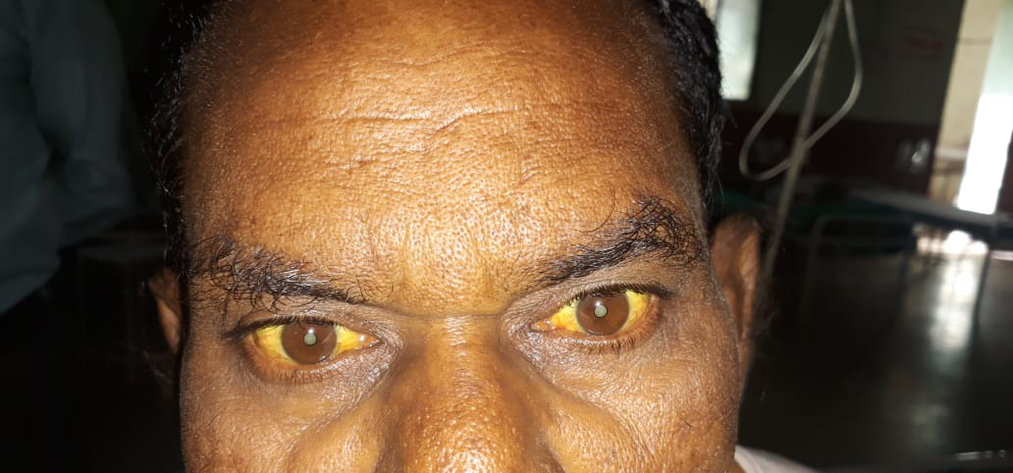
12/06/2018
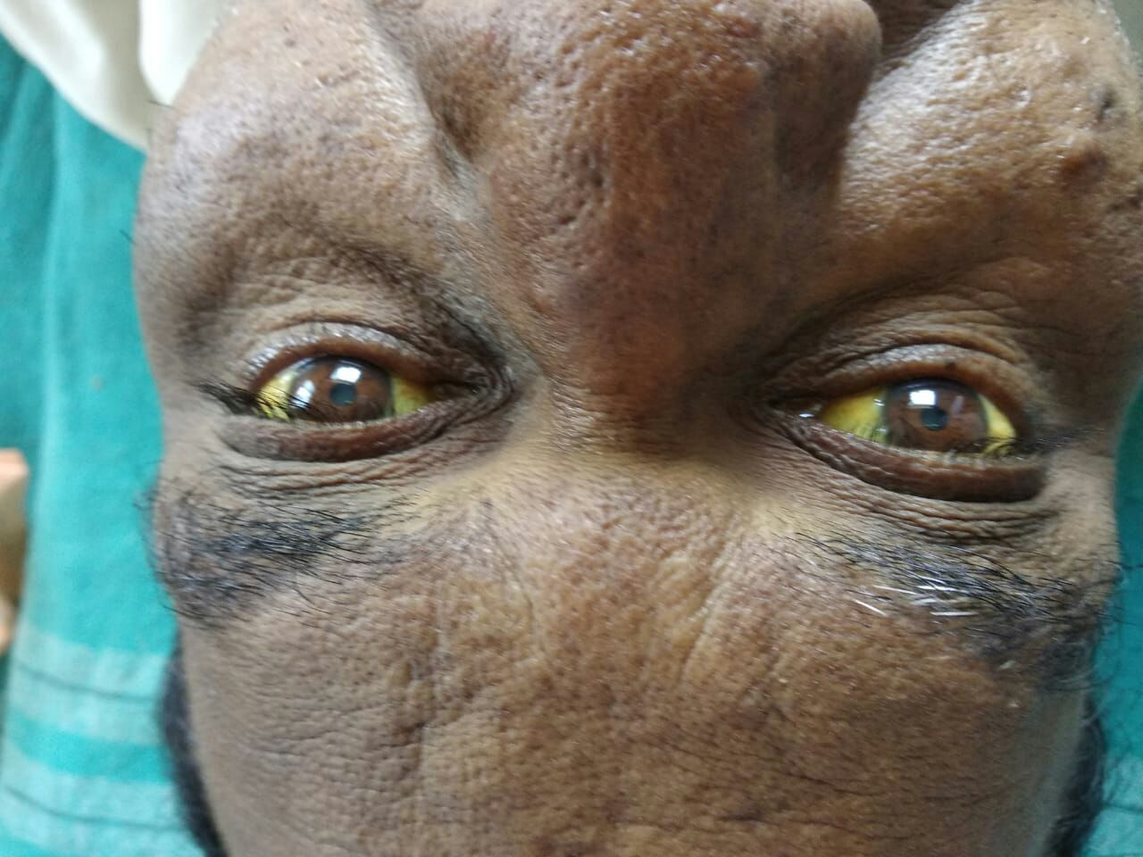
23/06/2018
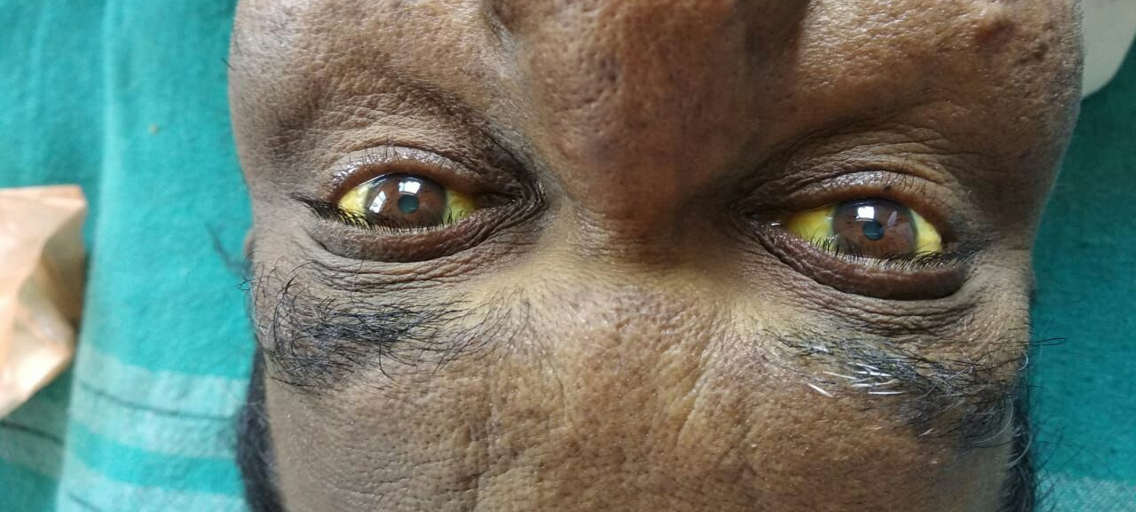
14/07/2018
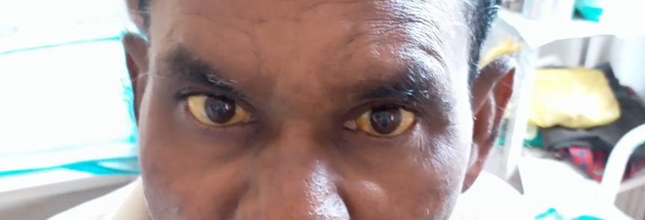
22/07/2018
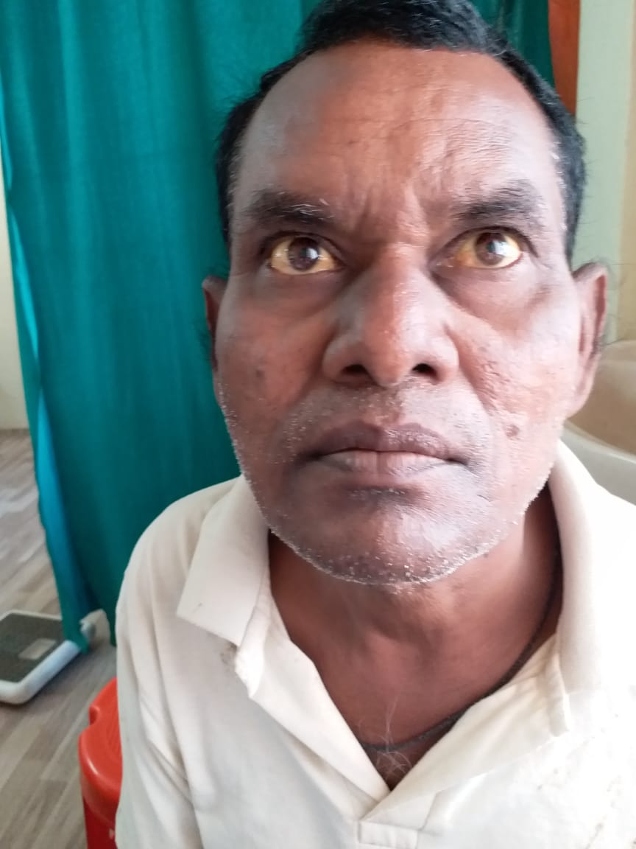
28/07/2018

References:-
- Charak chikitsa sthan , Pandurog chikitsa adhyay In- Charak samhita of Agnivesha elaborated by Charak & redacted by Drudhbala, vol-2 edited with “Vaidyamanorama” hindi commentary by Acharya Vidyadhar Shukla & prof. Rvai dutt Tripathi, foreword by Acharya Priyavat Sharma, Chaukhamba Sanskrit pratishthan, Delhi india. Page no. 399, 400
- Charak chikitsa sthan , Pandurog chikitsa adhyay In- Charak samhita of Agnivesha elaborated by Charak & redacted by Drudhbala, vol-2 edited with “Vaidyamanorama” hindi commentary by Acharya Vidyadhar Shukla & prof. Rvai dutt Tripathi, foreword by Acharya Priyavat Sharma, Chaukhamba Sanskrit pratishthan, Delhi india. Page no. 401,402
- Vishnu Gogate Vd (2008) Dravyagunvidyan in- Vishnu Gogate Vd.(Ed.) vaidyamitra prakashan (1st ed.) Pune, India.
- Acharya Priyavat Sharma, Dravyagunvidyaniya in- Acharya Priyavat Sharma, vol-2, Chaukhamba bharati academy, Varanasi, India. Page no-253,463,761.
- Yadavaji Trikamaji, editor, Ayurved-Dipika ,Sanskrit commentary ,charak samhita, chaukhamba- surbharati prakashan (2013), Varanasi, India.
- Kaviraj shri. Govindassen virchita , Bhaishjyaratnavali , Sidhhiprada- hindi commentary , prof. Siddhi Nandan Mishra, chaukhamba surbharati prakashan , Varanasi, India, page no.903
- Kaviraj shri. Govindassen virchita , Bhaishjyaratnavali , Sidhhiprada- hindi commentary , prof. Siddhi Nandan Mishra, chaukhamba surbharati prakashan , Varanasi, India, page no. 1126,1127
- Kaviraj shri. Govindassen virchita , Bhaishjyaratnavali , Sidhhiprada- hindi commentary , prof. Siddhi Nandan Mishra, chaukhamba surbharati prakashan , Varanasi, India, page no.871
- Kaviraj shri. Govindassen virchita , Bhaishjyaratnavali , Sidhhiprada-
hindi commentary , prof. Siddhi Nandan Mishra, chaukhamba surbharati prakashan , Varanasi, India, page no.381

- Kaviraj shri. Govindassen virchita , Bhaishjyaratnavali , Sidhhiprada-
hindi commentary , prof. Siddhi Nandan Mishra, chaukhamba surbharati prakashan , Varanasi, India, page no.658

- Kasper, Hauser, Longo, Braunwald, fauci et al. Harrison principles of internal medicine , mc Graw- hill medical publishing division 16th edition 2:1809.
- www. Wikipedia.org/wiki/jaundice.

