Title: Effect of Mirror Therapy in Postural correction and Pain management in patient with Sacroiliac joint Koch’s: Single case study
Authors: Dr. Shashikant Chandanshive,
e-mail-shashikantc78@gmail.com,Mob.No.+919820857059
Dr. Sheetal Sureshbhai Patel,e-mail-sheetal1992p@gmail.com,Mob.No.-+919765717511
Abstract-This single case study is done in treatment of patient with right Sacroiliac Joint Koch`s. The condition is rare and less documented on Indian population. Patient had severe pain and postural impairment. It was observed that activities of daily living (ADL) like independent transfer (get out of bed and sit on chair), toilet use (squat and get up), bathing, walking , stair case climbing and dressing independently were badly affected. Hence this study is done to assess the effect of mirror therapy in pain management, postural correction and activities of daily living in patient with SI joint Koch`s. Patient was diagnosed using MRI, X-ray and hematological assessment. Skin traction and anti tubercular treatment along with pain killers were started. Patient is referred to Occupational Therapy Services on 11/10/2017. On clinical evaluation FABER, GEANSLENS and Thomas test found positive. Hyperlordosis in supine and kyphosis in sitting was observed. Pain on VAS found 8 i.e. severe pain with Grade 2 of tenderness (tenderness to grimace or flinch to palpation) over right SI joint and posterior aspect of buttock and ADL scoring on Modified Barthel Index is 9 i.e. lower most indicates disabilities on first day of assessment. He was assessed and mirror therapy was started. Patient showed reduction in lordosis and kyphosis. Pain reduced from 8 to 5 then 3 to 0 i.e.no pain. Modified Barthel Index score of ADL also increased from 9 to 20 at the end of 6th week of treatment. Patient showed reduction in pain , hyperlordosis and kyphosis. Improvement is seen in ADL. Henceforth mirror therapy is found effective in pain management, postural correction and helpful in ADL independence. This study will help in research and treatment of SI Joint Koch`s. Furthermore extensive research and documentation on treatment of SI joint Koch`s has to be conducted.

Keyword: SI joint Koch’s, Mirror therapy, Postural correction,
Pain management, VAS, Modified Barthel index

Introduction- Sacro-Iliac Joint Koch`s is rare and less documented on Indian population. On review of literature we have found few studies^{1,7,8} on Afro- American countries and only single survey on Indian Poulation.1-3 % of Osteoarticular Tuberculosis was found, among which 5-8% belongs to Sacroiliac (SI) joint.² Tubercular infection of the bone and synovial tissue results from haematogenous spread from a pulmonary or other visceral or lymph node focus.³ It produces chronic granulomatous inflammation with caseation necrosis.⁴ Demeralisation of bone occurs because of intense local hyperaemia.
The cortices of bone gets eroded and the infected granulation tissue and pus find their way to the sub-periosteal and soft tissue planes. Once the synovium is inflamed, it starts destroying the cartilage from the periphery. As the articular cartilage is completely destroyed and the joint gets distended with the pus , capsules and ligaments become lax and joint may get subluxated.⁴
Infections related to Sacroiliac joint are rarely seen and also the diagnosis is usually delayed.⁵ Symptoms of Sacroiliac joint tuberculosis are vague and hence missed very often. The diagnosis of patient is not confirmed microbiologically or histologically but is supported by typical radiograph and clinical features. The Sacroiliac joint may be secondarily involved following a psoas abscess affecting the lower lumbar spine⁴. SI joint Koch’s affects posture, functional mobility and ADL due to pain. This study includes Mirror therapy as an adjunctive therapy.
Mirror Therapy was first introduced by Vilayanur S. Ramchandran in 1998. Mirror Therapy is based on concept of mirror neuron system (MNS). MNS discharges when an individual performs a goal directed action and also when he observes someone else performing a similar action. Their activation leads to recruitment of functionally interconnected cortical structures coupling action execution and observation.⁶ It is used in the treatment of neurological conditions like pseudobulbar affect and hemispatial neglect following stroke, epileptic seizure, phantom limb Sensation and Pain.
In this study Visual analogue scale (VAS) and Modified Barthel index scale are used. The VAS is a psychometric response pain scale which can be used in questionnaires. It is a measurement instrument for subjective characteristics or attitudes that cannot be directly measured. When responding to VAS item, respondents specify their level of agreement to a statement by indicating a position along a continuous line in between two end-points.
The Barthel index is simple tool to administer for assessing self care and mobility activities of daily living.
Few studies are done on SI joint Koch’s but study based on rehabilitation on Indian Population is not yet documented and henceforth this study will help in SI joint Koch’s rehabilitation in future.
Aims and Objectives- This single case study is made to 1. Assess the effect of Mirror therapy in postural correction in patient with Sacroiliac joint Koch’s. 2. Assess the effect of Mirror therapy in pain management in patient with Sacroiliac joint Koch’s. 3. Effect of Mirror therapy in ADL.
MATERIALS AND METHODS: 14 yrs old male (student) presented with h/o fall on his right side on 5th September 2017 at Mandgaon while playing. He felt thrice on same side in two days. He experienced bilateral knee pain and pin prick pain over right hip joint posteriorly within 3-4 days after fall. On 12th September 2017, after a week of fall he presented with mild to moderate degree of fever for which he was taken to private hospital and was treated for the same. On next day, he climb 3 floors in school after which he experienced bilateral lower limb weakness and stopped walking. He was again taken to private hospital where medication (diclofen) was prescribed but did not experienced relief from pain. Then he was shown to orthopedic surgeon. Doctor advised MRI and blood test.
MRI was done on 14/09/2017 which showed:
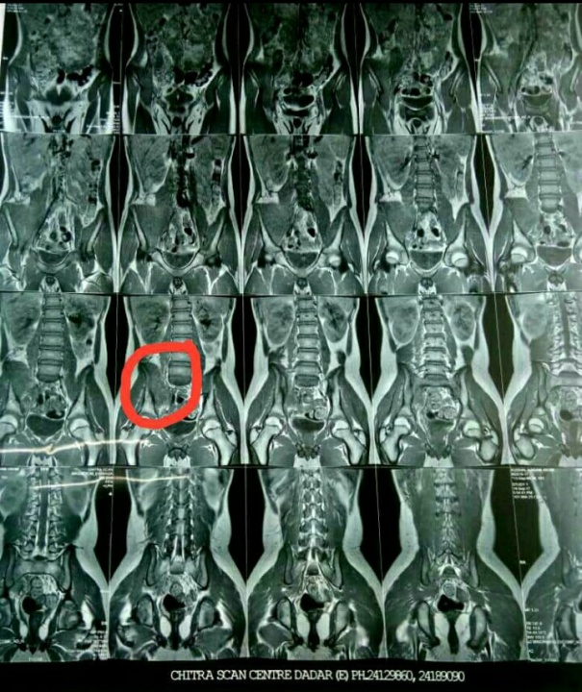
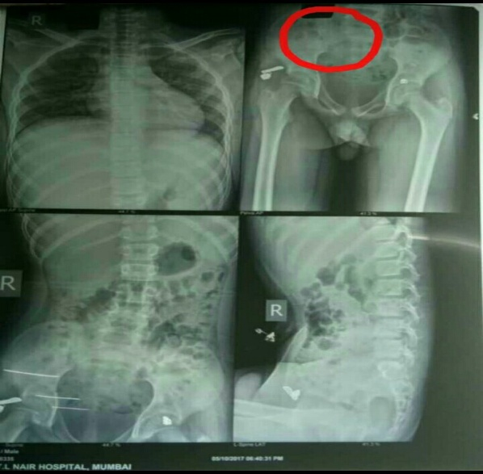
1) An erosive arthropathy involving right SI joint with sub articular erosions and marrow edema.
2) Minimal fluid in joint space with an associated large heterogeneously enhancing collection in right iliacus muscle belly 3) Extension on the collection along the right greater sciatic notch with edema of right sciatic nerve
Blood report- 1) C- Reactive protein: 39.223 mg/dl (Normal: 0-1 mg/dl) on 10/10/17
2) C- Reactive protein: 3.722 mg/dl on 16/10/17 3) ESR: 130mms at end of 1 hr. (Normal: 0-20mms) on 10/10/17 On the basis of the investigations, patient was diagnosed as right Sacroiliac joint Koch’s. He was admitted to Nair Hospital. Skin Traction was given to right lower limb and was managed conservatively from 04/10/17. Patient was on anti tubercular drugs since 2 months (Ethambutol and Rifampicin). Patient was assessed by Occupational Therapist on 11/10/17.

OCCUPATIONAL THERAPY ASSESSMENT: ON OBSERVATION: Posture: 1) Supine - Patient has tendency to keep his right hip in 400 flexion and knee in 400-500 flexion with hyperlordosis of lumbar region 2) Sitting – Patient sits with Kyphotic posture at midthoracic region (stretchable).
ON PALPATION: Grade 2 of tenderness (tenderness to grimace or flinch to palpation) over right SI joint and posterior aspect of buttock.
ON TESTING:
Orthopaedic test:² 1) FABER: positive 2) Gaenslen’s test: positive 3) Thomas test: positive
TREATMENT: Diagnosis of patient was done on the basis of MRI study. Most Sacroiliac joint tuberculosis patients could be effectively treated with medication especially in early stages of the disease. He is on antitubercular drug i.e. Ethambutol and Rifampicin since September 2017. Bed rest was recommended until clinical symptoms improved. Weight bearing on right lower limb was started after 4 weeks post diagnosis. Inpatient rehabilitation: Mirror therapy provides visual feedback over somatosensory and proprioceptive feedback. It is used for pain management and postural control⁵ . Skin Traction was given to right lower limb when patient was admitted in ward. For pain management: Patient in sitting position on bed with legs straight (knees extended). Mirror is kept between the legs. By looking in the mirror patient performs flexion, extension, abduction and adduction of left leg. Right leg is not allowed to move. For postural correction: Flexion and abduction of bilateral Upper limb Scapular exercises like protraction, retraction, elevation and depression. Deep breathing exercises. Activities: In sitting- deep breathing exercises for relaxation, Overhead ball throwing, ball rolling by right lower, limb ankle exerciser. After discharge from hospital: Same exercises are continued. Repetitions were increased to 10 and then to 15 according to the patient’s tolerance level. As pain subsided, abdominal strengthening and back strengthening exercises were started.

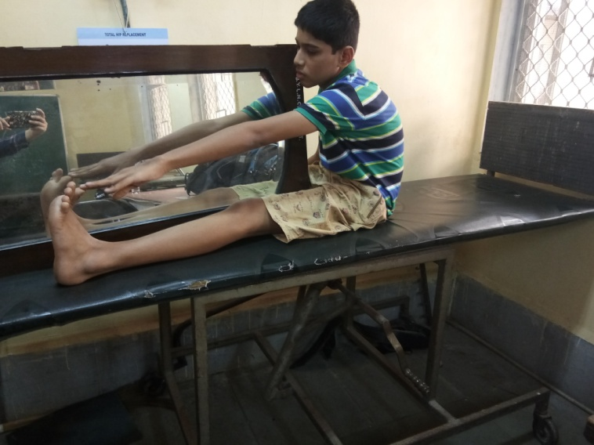
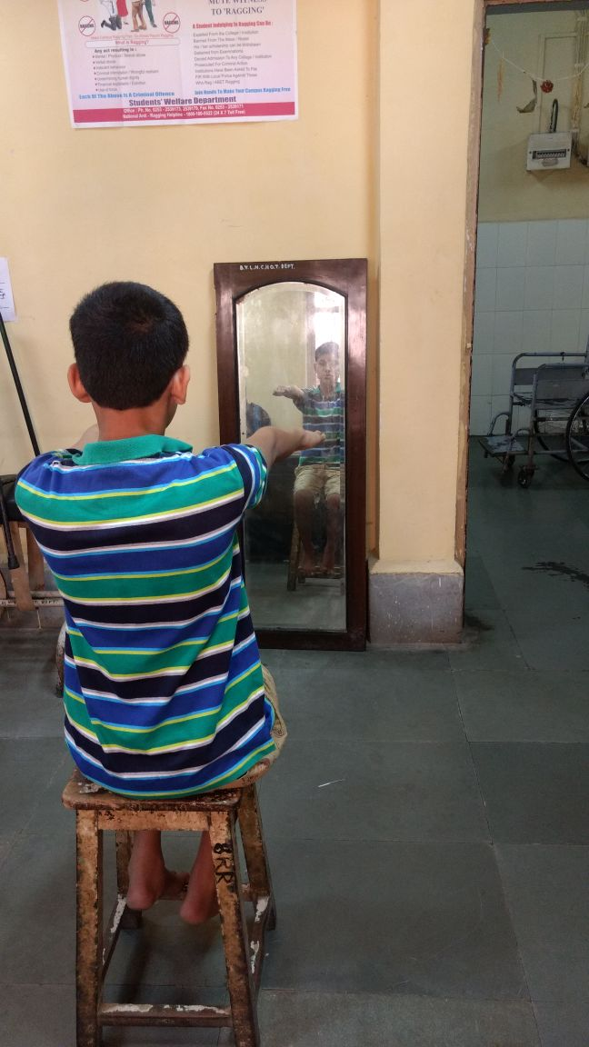

Observations-
It was observed that pain which was relieved was assessed on visual analogue scale and posture was improved on observation. Patient was able to transfer himself (get out of bed and sit on chair), toilet use (squat and get up), Bath, walking and stair case climbing and dress himself independently.
Results and Discussion-
Table 1:

Follow up days | 11/10/17 | 16/10/17 | 23/10/17 | 30/10/17 | 10/11/17 | 25/11/17
Pain on VAS Scale | 8 | 5 | 3 | 1 | 1 | 0
ROM | Lordosis  starts at 300 of hip flexion | Starts at  500 | Starts at  700 | Starts at  800 | Starts at  1000 | Starts at  1100

Fig. 1: X-axis shows duration of follow-up and Y-axis shows level of pain on VAS (Visual analogue scale).

Fig.2: Above diagram shows duration of follow up on X-axis and degree of lordosis on Y- axis.

Table 2:

 | Components | 11/10/17 | 25/11/17
1 | Bowel | 2 | 2
2 | Bladder | 2 | 2
3 | Grooming | 0 | 1
4 | Toilet use | 0 | 2
5 | Feeding | 2 | 2
6 | Transfer | 2 | 3
7 | Mobility | 0 | 3
8 | Dressing | 1 | 2
9 | Stairs | 0 | 2
10 | Bathing | 0 | 1
 | Total score | 9 | 20
ADL Evaluation : According to Modified Barthel ADL index
(Total possible scores in above table is 0-20, lower scores indicate increased disability.)
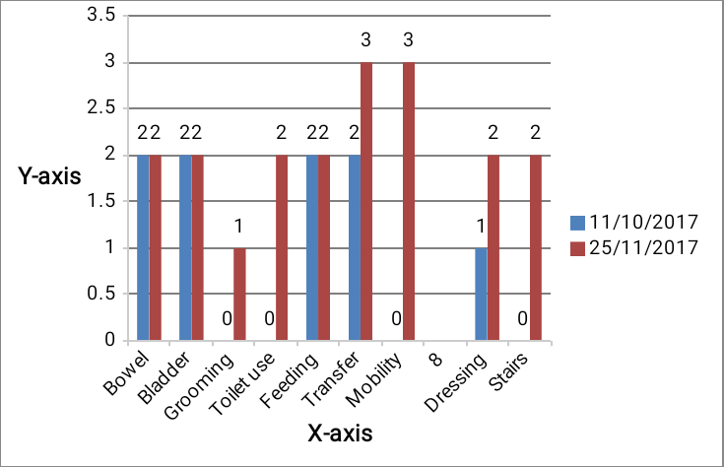

Fig.3: Above diagram shows ADL component on X-axis and scores of ADL scale on Y- axis.

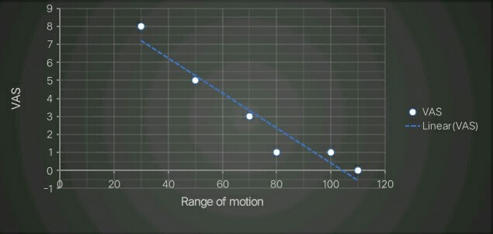

Fig 4: Above diagram shows Correlation between Range of motion on X-axis and VAS on Y-axis

Patient was treated with Mirror Therapy for pain management and postural correction. In fig. 1, Level of Pain was assessed on VAS scale which was 8 (severe pain) on 11/10/17 i.e. first day of assessment and was 0 (no pain) on 25/11/17 i.e. after treatment of around 6 weeks.
In fig.2, Earlier lordosis was starting at 300 of hip flexion and now after 6 weeks it is starting at 1100 which indicates tightness in right hip musculature is reduced.
Table 2 shows scores of ADL on Modified barthel index done on 11/10/17 and on 25/11/17.
In fig.3, patient is becoming independent as scores are improved from 9 to 20.
Table 3 and fig.4 shows high negative correlation between VAS and Range of motion which is found to be -0.96. This indicates as pain is decreased, range of motion is increased.
On observation, kyphosis was found to be improved.

Conclusions-
This study showed that patient with SI joint Koch’s had severe hip joint pain, postural abnormality i.e. lordosis and kyphosis and difficulty in performing ADL. Patient was treated with Mirror Therapy.
Significant improvement in level of pain, postural correction and ADL independence was observed. Hence Mirror therapy can be given as an adjunct to Occupational therapy in SI joint Koch’s rehabilitation in future.

Acknowledgement-
We are thankful to Dr. Ramesh Bharmal, Dean T.N.M. College and B.Y. L. Nair Ch. Hospital, Mumbai-08 for granting permission to conduct this study. We would like to express sincere gratitude to Dr. (Mrs.) Pratibha Vaidya, Associate Professor and In-charge, Dept. of Occupational Therapy for her kind support and timely guidance and also the patient and his family member for their kind support.

REFERENCES:
1)Tenglong Jiang, Jinming Zhao, Maolin He, Kun Wang, Mitra Fowdur, Yang Wu. Outcomes and Treatment of Lumbosacral Spinal Tuberculosis: A Retrospective study of 53 patients. PLOS ONE.
2)Prakash J. Sacroiliac tuberculosis- A neglected differential in refractory low back pain- our series of 35 patients. J Clin Orthop Trauma 2014 Sep; 5(3): 146-53
3)TK Shanmugasundaram. Bone and joint Tuberculosis. Indian Journal of Orthopeadics,2005;39:195-8.
4) J, Maheshwari. Essential Orthopedics, Tuberculosis of bones and joints. 4th edition. Page No. 176-177.
5)R.J.S Ramkalan & S.Govender. Spinal unit, King George V Hospital, University of kwa Zulu Natal, Durban, South Africa. Sacroiliac joint tuberculosis. Int.Orthop.2007 Feb.
6)Ashu Bhasin, MV Padma Shrivastava,et al. Neural interface of mirror therapy in chronic stroke patients : A functional magnetic resonance imaging study. Publication of neurological society of India .year 2012 volume 6.
7) Dunn EJ, Bryan DM, Nugent JT, Robinson RA, Pyogenic Infections of Sacroiliac joint Clin. Orthop. Jul-Aug (118): (1976) 113-7.
8) Gordan G, Kabins SA, pyogenic sacroilitis. Am J. med 69: (1980)50-56
9) Ohura T, et al. BMC Med Res. Methodology Validity and reliability of a performance evaluation tool based on the modified Barthel index for stroke patients. (2017)
10) www.physio-pedia.com

