Evaluation of Vranaropak property of Apamarg tail (anubhoot yoga) in Dagdhavrana: A case study.

AnkitaApte¹,Pushkar prabhu²
1. Assistant Professor, Dept. of Kayachikitsa, APM’s AyurvedMahavidyalaya, Sion, Mumbai, Maharashtra, India .
2. P. G. Scholar,Dept. of Rasashastra, APM’s AyurvedMahavidyalaya, Sion, Mumbai, Maharashtra, India

ABSTRACT
Purpose:
Dagdhavranas (Burn wounds) are very frequently and commonly seen in society, which are difficult to heal and leads to the intolerable painful condition to the subject. Such a burn conditions can be treat by topical applications in modern science, but none is perfect. So there is a need of an ayurvedic remedy for such dagdhavranas which will be cost effective too.
Method:
A 26 yrs young female presenting with history of burn injury with complaint of burning and burn marks in left foot since 15 days has presented here.
Results:
Positive results were seen in the patient.
Conclusion:
From the above case study we conclude that treating Dagdhavran with Apamarg tail for local application is a cost effective and successful remedy.
Key Words:
Dagdhavrana, Apamarg tail

Introduction:
Ayurveda is the oldest surviving science in the world. The word Ayurveda derived from its Sanskrit roots- Ayusha (Life) and Veda (Knowledge) and offering a rich and comprehensive outlook to a healthy life. This system of medicine dates back approximately 5000 years or more and is widely practiced today.
In this present era, due to industrialization, incidences of burn wound are increased. In day to day life, we used to come across various types of burns due to fire, moist heat, chemicals, electrical etc.
Acharya Sushrutahas explained about Agni Dagdhha Vrana, in Sutrasthan, chapter 12 Agnikarma vidhi adhyaya in detail. He has mentioned in detail about the prakara, lakshanas, and the management of Agni Dagdha Vrana. Similarly other Acharyas also mentioned Agni Dagdha in their respected samhitas. Agni Dagdha Vrana is caused by the application of heat which is explained in the context of cauterization under the heading "Itaratha Dagdha". Again this has been classified as that caused by dry heat (Ruksha Dagdha )and caused by fats and oils (Snigdha Dagdha ).Among these two varieties the Snigdha Dagdha is said to be more painful than Ruksha Dagdha. Because Sneha Dravya enters the minute channels along with heat and destroys the deeper tissues immediately.
According to modern medicine burn wound healing is a complex process in the biological objectives and mechanisms defined by the initial injury.Treatment prescribed in modern medicine has some limitations like it can’t prevent Escher, hypertrophic scar, post burn contracture which harms cosmetically.
So the ideal topical preparation for burns & any kind of wound should have several characteristics. It should be antiseptic & not interact with cellular wound substrate, keep the wound wet enough for cell movement but not macerate the skin around the wound, have an anesthetic effect, and be non- adhesive and easily removable from wound surface. So Apamarg tail was used as a local application. It helped to retained moisture which promoted faster wound healing as well as prevent Escher formation.
Aim:
To evaluate the Vranropak property of Apamarg tail in Dagdha Vrana.

Objectives:
- Literature study of Dagdha Vrana.
- Literature study of Apamarg.
- Literature study of Apamarg tail.

Materials and Methods:
Apamarg:
Ayurvedic Aspect: |  | Modern Aspect:
Name: | Apamarg | Latin Name: | Achyranthusaspera
Rasa: | Katu Tikta | Family: | Amaranthaceae
Virya: | Ushna | English Name: | Prickly chaff flower
Viapak: | Katu | Chemical Constituents: | Betaine, achyranthine,  hentriacontane, ecdysterone, achyranthessaponins
Guna: | Laghu, Ruksha, Tikshna | Chemical Constituents:
Doshaghnata: | Kafa vata shamak | Chemical Constituents:

Til Taila:
Ayurvedic Aspect: |  | Modern Aspect:
Name: | Til taila | Latin Name: | Oil of Sesamumindicum
Rasa: | Madhur Kashay | Family: | Pedaliaceae
Virya: | Ushna | English Name: | Sesame oil
Viapak: | Madhur
Guna: | Vyavayi , Sheet
Doshaghnata: | Vat kafa Shamak

Preparation of Apamarg Tail:
Ingredients:
- ApamargPanchangBharad: 1kg
- Water: 16 litres
- Apamarg patra Kalka: 250gm
- Til tail: 1 liter

Procedure for preparation of Apamarg Tail:
Prepared a kwath of 1kg of Apamarg panchang bharad using 16 liters of water and boiled it till become 4litres. Filtered the prepared kwath using cotton cloth.
Then added 1 liter of til tail to 4liters of prepared Apamarg kwath and added 250gms of apamarg patra kalka to it.
Boiled it and watched it for tail siddhi lakshnas.
Prepared Apamarg tail filtered using cotton cloth and packed in bottles.
Case Report:
Name: | ABC
Age: | 26 years
Sex: | Female
Weight: | 57 kg
History: | Had a history of burn with hot water 15days back
Complains: | Burning pain (on and off)
 | Burn marks
Size of Wound: | 7cm X 3cm
Colour of Wound: | Dark brown colour
Nature of wound: | Signs of burn, dry wound, no pustules noted, no deep tissue damage noted, no discharge seen.

Treatment plan:
Mode of Administration Time- | Thrice a day regular
Duration- | Up to epithelization
Diet- | High protein diet  speciallymentioned in  Shashti Upakrama as like  pulses, groundnut, cashew  Nut, almonds and palm dates.
Follow Up- | 0 day, 3rd day, 5th day, 10th day, 15th day, 30th day,

Results:
Positive results were noted during and after the treatment.
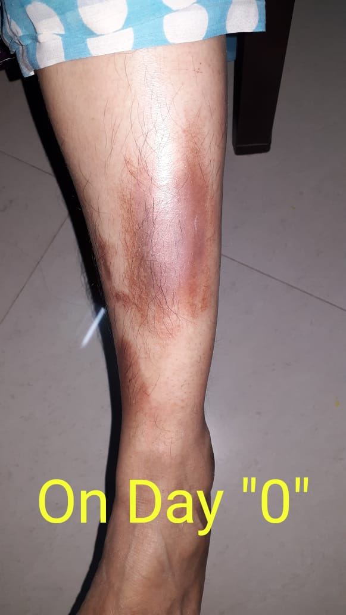 | 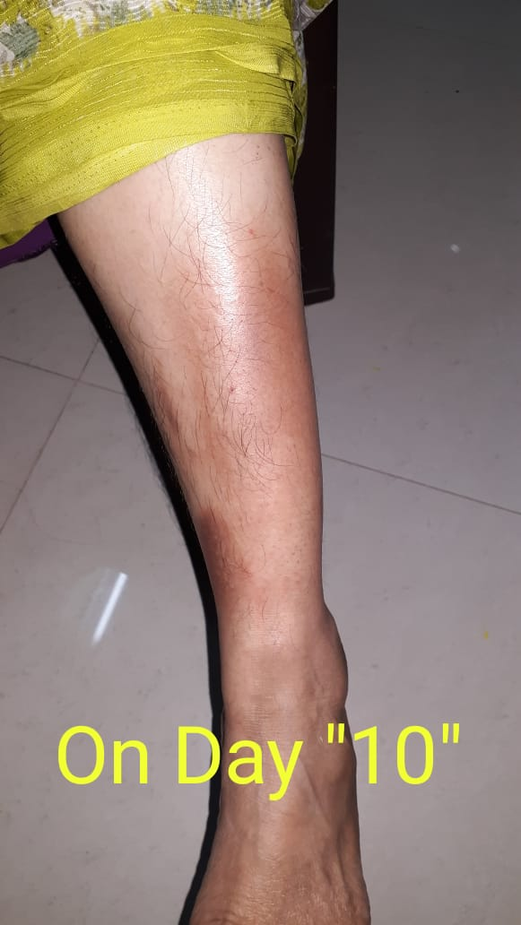
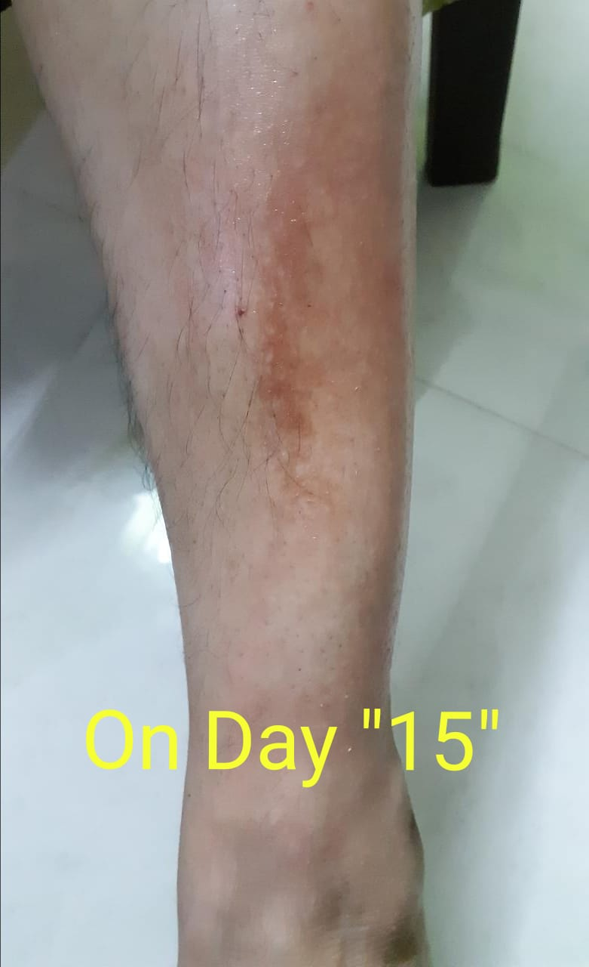 | 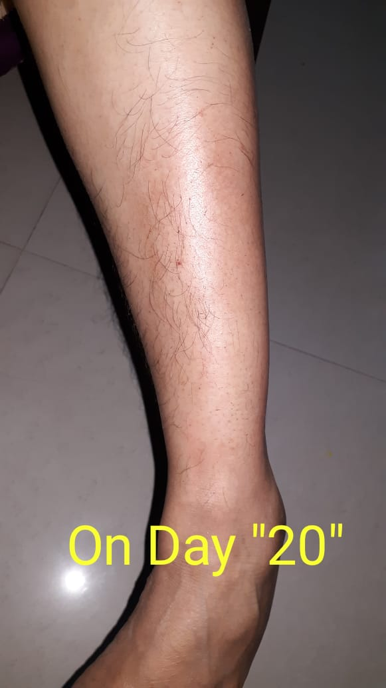
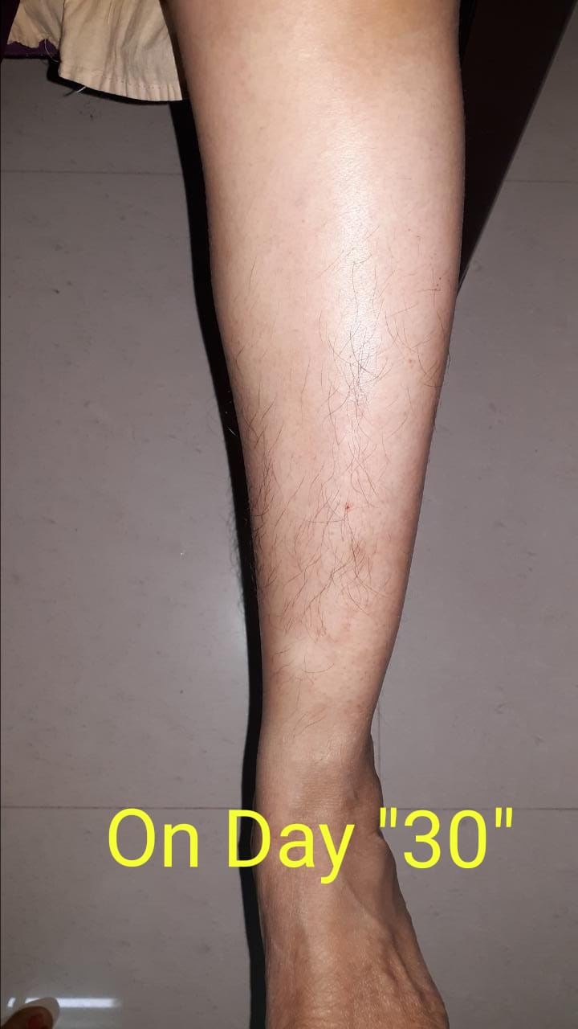

Observation:
 | Before Treatment | After Treatment
Size of Wound: | 7cm X 3cm | Nil
Colour of Wound: | Dark brown colour | Nil
Nature of wound: | Dry wound | Nil
Pain: | Burning Pain | No Pain
Onset of pain: | On and off | No Pain

Discussion:
Burn is a coagulation necrosis of tissue due to contact with fire, flame or contact with hot substances. It is commonest type of household injury and industrial injury as well.
Apamarg is explained as uttamraktapravahrodhak in sharangdharsamhita.
अपामार्गस्य संसिक्त पत्रोत्थेन रसेन तु |
सद्योव्रणेषु रक्तं तु प्रवृत्तं परितिष्ठति ||
शा.सं.

Further in Raj martandsamhita, Acharya have explained that apamargmool tail can be used to relieve shastraghaatjanitshool.
तिलतैलमपामार्गमूलेनाम्भोन्वितेन यत |
सिद्धं तत्स्वेदित: श्स्त्रघातो न कुरुते व्यथाम||
राज.मा.व्रणाधिकार १५/९

Aacharyasushrut had explained local application of oil in dagdhavrana. There are two types of Apamarg. Apamarg and RaktaApamarg.
In Raj nighantu acharya hse explained about Rakta Apamarg, that it is vranghna.
रक्तोऽपामार्गक: शीत: कटुक: कफवातनूत |
व्रण कंडू विषघ्नश्च संग्राहीवान्तिकृत पर:||
(रा.नि.शताह्वादि वर्ग ६३)
So upon studying properties of Apamarg we prepared Apamarg tail and given for local application.
Apamarg tail was prepared by tailpakavidhi according to standard operating procedure mentioned in sharangdharsamhita.
Pain:
Pain was reduced significantly.
Colour:
Colour was significantly improved i.e. no skin discolouration was noted after the tretment.
Healing:
Healing was significant.

Conclusion:
This study was found very useful in the management of burn wound by application of an ayurvedic preparation of Apamarg Tail.
Apamarg tail showed good pain relieving and healing property.
Present study proved Apamarg tail has effective healing property and with good cosmetic results.

References:
- Charak Samhita, Dr. RavidattaTripathi, ChaukhamabaPrakashan, Delhi, Edition 2011
- Chakradatta Samhita Dr. RavidattaShastriChaukhambaPrakashan , Edition 2012
- AshtangHridayam, Dr. BramhanandTripathi, ChaukhambaPrakashan, Delhi, Edition 2000
- Sharangdhar Samhita, Dr. BramhanandTripathi,ChaukhambaPrakashan, Varanasi, Edition 2007
- Sanskrut Hindi Shabdakosh, VamanShivaramApte, Ashok Prakashan, Delhi, Edition 2008
- AyurvediyaMahakosh, Vd. VenimadhavShastri Joshi, Vd. Narayan Hari Joshi, Maharashtra RajyaSahityaaaniSanskriti Mandal, Mumbai, Edition 1968.
- RajNighantu Dr. Satish Shakhyadhar, ChaukhambaPrakshan , Edition 2015
- Rajmartand ,Prof. Dr. Sidhinandan Mishra ,ChaukhambaPrakashan Edition 2011

