Role of Ayurveda in Dry Eczema
Krishna Kadam, Viraj Jadhav

- Asst. Professor, Department of Rog Nidan, Government Ayurved College, Nanded
- Associate Prof, Vikriti Vigyan, SAM Ayu. College, Bhopal

Email: drkvjadhav@gmail.com

INTRODUCTION:
In Ayurveda, various skin disorders are detailed under the heading Kushtha. It is one of the Mahagada defined by Ayurveda which not only affects the skin but also other dhatus for example Rakta, Mansa etc. Vicharchika is specially mentioned under the heading of Kshudra Kushtha (minor skin ailments). Even though, in terms of severity, incidence and prognosis it is not minor.Vicharchika, a type of Kshudra Kushtha (chronic skin disease) though involves only epidermis, its tendancy of recurrence continues to pose problems to the physician.Characteristics of Vicharchika as mentioned in the Brihat trayi are Atikandu, Shyavata, Pidika, Bahustrava or Rukshata and Raji. The consideration of characteristics of Vicharchika as Eczema may also reveal the same fact.
- Atikandu (excessive itching)- In eczema, itching varies from mild to severe paroxysm which even may interfere with work and sleep.
- Bahu strava (lasikadhya)- Eczema is characterized by superficial inflammatory oedema of epidermis associated with vesicle formation. In acute condition wet eczema is common
- Rukshata (dryness)- Chronic illness of Eczema also persists or it may be found in the same patients at different stages.
- Shyaava Pidika- In chronic cases of eczema, integument appears thickened and is hyperpigmented.
- Raji (Lichenification)- Due to scratching in chronic cases of eczema, the skin becomes thick, hyperpigmented with visible criss cross ridges known as lichenification.
Considering the fact that, the combination of external as well internal therapy will play its best role in cure of Eczema. With this view, for present research I have proposed to focus the upashayatmaka effect of Aragwadhadi Kashaya (kalpit compound) as internal medicine and Yashadamrut malahar as external application in patients of Vicharchika.
NEED OF STUDY:
- Incidence- Great prevalence of the disease i.e. 3% in Indian Population
- Burning problem- Severe itching disturbing routine and its nature susceptible to be chronic.
- Socio Psychological impacts- Affects psychological status and disturb the social life due to its appearance,
- WHO celebrates 29th October as World Psoriasis day
AIMS:
- To study Nidanpanchaka (aetiopathogenesis) of Vicharchika and its Upashaya according to Ayurveda.
- To study the Upashaytmaka effect of Aragwadhadi Kashaya and Yashadamrut malahara lepa on Vicharchika.
OBJECTIVES:
- To assess the efficacy of Aragwadhadi kashaya and Yashadamruta Malahara in the management of Vicharchika w.r.to Eczema.
- To draw a hypothesis regarding the mode of action of drugs used in the present research on the scientific basis.
MATERIALS AND METHODS:
- Conceptual Study
Disease Review: It comprises of
- Ayurvedic review
- Modern review
1) Ayurvedic review: In this, Vicharchika will be defined according to Ayurvedic literature
2) Modern review: In this, Eczema will be defined according to Modern literature
Following materials are used for this study.
- Selection of Patient- Minimum 60 patients having signs and symptoms of “Vicharchika” were randomly selected from OPD and IPD wings of Government Ayurved College, Nanded
- The patients will diagnosed on the basis of classical signs and symptoms of Vicharchika described in Ayurvedic classics like Kandu, Daha, Strava, Rukshata, Pidika, Vaivarnya, Raji and Vedna etc.
- Informed written consent was taken
- Type of study:-Clinical trial
- Study design:-Parallel group
- Patients selection:-Randomized
- Examination of Patient -Examination of Patient was done according to special case proforma which was included
- Etiological factors of Vicharchika with
- Dushti lakshan of Dosha,
- Dushya,
- Strotas etc.
- Resulting Pathogenesis or Samprapti after administration of hetu was studied in detailed.
INCLUSION CRITERIA-
1. Patients showing Pratyatma Lakshana of Vicharchika (eczema) described in classical Ayurvedic texts as well in modern medical literature.
2. Age group of 16 to 60 years of either sex
3. Chronicity of disease not more than 3 years.
EXCLUSION CRITERIA –
1. Patients suffering from disease like Anemia, Hemorrhagic disorders, Hemiplegia, Convulsion, Tuberculosis, Cancer; severe systemic diseases like Diabetes, Renal disease, H/O liver diseases etc.
2. Pregnancy, lactation
Registered 60 patients were divided in two groups as-
1. Group A: Control group
30 registered patients of Vicharchika were administered Tablet Defcort in the dose of 6 mg twice a day with a glass of water for 30 days.
2. Group B: Aragvadhadi Kashaya
30 registered patients of Vicharchika were administered with Aragvadhadi Kashaya (Kalpita compound) in the dose of 40ml twice a day for 30 days along with Yashadamruta Malahara lepa at night as external application on affected parts of body.
Tablet Defcort :
- Dose- 6 mg twice a day with a glass of water after food,
- Duration - at same time every day for 30 days.

Aragwadhadi Kashaya-
- Period: 4 weeks
- Dosage: 40 ml twice a day with parts of Ghrita
- Duration: Morning- 40ml and Evening- 40ml (daily)
- Bhaishajya Kal: Before meal
- Mode of Administration: Oral
Yashadamruta Malahara-
- Period: 4 weeks
- Dosage: Quantity sufficient as per affected area of body
- Period of application: In day time
- Mode of Administration: External application
LABORATORY INVESTIGATIONS -
- Routine investigations whereever needed
Actual Plan of Work-
- The patients were diagnosed on the basis of classical signs and symptoms of Vicharchika with the help of special standard case paper incorporating Nidanpanchaka
- More concentration was given on Evaluation of Hetus and resulting Samprapti or Nidanpanchaka.
- After diagnosis of the patients, study was intervened by Upashayatmaka therapy(exploration) in the form of Aragwadhadi kashaya and Yashadamruta Malahara
- Group A: Control Tab.Defcort 6mg twice a day
- Group B: Aragvadhadhi Kwatha: 40ml twice
- Patients were studied for 6 weeks with the follow up after every 1 week interval.
- The Upashayatmaka effect of Aragvadhadi kashaya and Yashadamruta Malahara was assessed in regards to the clinical signs and symptoms on the basis of grading and scoring systems and overall upashaya.
- Place of work: OPD and IPD Wings of Government Ayurved College, Nanded
- Formulation of drug : Was carried out in Rasashala, Government Ayurved College, Nanded
- Duration of work: Was completed in scheduled course of 4 week
Criteria of assessment:
- Criteria of assessment were kept on the basis of relief in the signs and symptoms of the disease Vicharchika.
  - For this, the cardinal signs and symptoms were given scores according to their severity, before and after treatment.
1. Kandu(Itching)
2. Daha (Burning sensation)
3. Vaivarnya (Discoloration)
4. Strava (discharge)
5. Raji (Lichenification, thickening and ridges on skin)
6. Rukshata (Dryness)
7. Pidika (Eruption)
8. Vedana (Pain)
Contents of Aragvadhadi Kashaya-(Kalpita compound)
S. N. | Contents | Botanical name | Part used | Quantity
1 | Aragwadha | Cassia fistula | Root | 1 Part
2 | Nimba | Azadiracta indica | Root | 1 Part
3 | Guduchi | Tinospora cordifolia | Kanda | 1 Part
4 | Khadir | Acacia catechu | Root | 1 Part
5 | Kutaja | Hollarhena antidysentrica | Root | 1 Part
6 | Atrushaka | Adhatoda vasica | Root | 1 Part
Contents of Yashadamruta Malahara-(Rasa tarangini)
S. N. | Contents | Botanical name | Quantity
1. | Siktha | Wax | 12 gm
2. | Tilataila | Sesamum indicum | q.s.
3. | Yashad | Zincum | 1 tula

Praman of lepa – ¼ angul ≈ 5mm
GRADING AND SCORING OF SIGNS AND SYMPTOMS –
Grading and Scoring -
For symptoms – subjective parameters were considered
For signs – appropriate clinical parameters were considered
Scoring –
Grade III +++ severe
Grade II ++ moderate
Grade I + mild
Grade 0 0 nil

- Kandu (itching) -
+++ - itching continuously and cannot concentrate on
routine work and in Night
++ - intermittent itching for more than 5 times per hour
+ - itching only once or twice a day
- - no itching

- Daha (burning sensation) -
+++ - continuously burning cannot concentrate on work and
even during sleep
++ - burning sensation but can concentrate on work
+ - burning only 1 or 2 times a day
- - no burning

- Vaivarnya (discolouration) -
+++ - easily looking discolouration
++ - mild discolouration only visible in light
+ - very mild discolouration only visible in light
- - no discolouration
- Srava (discharge) -
+++ - continuous discharge - patient requires dressing to
lesion to soak up the discharge and disturb his routine work
++ - need to put dressing but not disturbing
+ - need not to put dressing
- - scanty discharge need not to soak or dressing and dries
their own

- Raji -
+++ - multiple lines with discomfort
++ - lines without discomfort
+ - single line
- – absent

- Rookshata (dryness) -
+++ - with discomfort on skin
++ - without discomfort on skin
+ - negligible
- - absent
- Pidika (eruption) -
Number of Pitika per square cm on the effected skin will be measured.
- Ruja (pain) -
+++ - continuously paining or aching cannot concentrate on
work and even during sleep
++ - pain is there but can concentrate on work
+ - pain only 1 or 2 times a day
- - no pain
OVERALL EFECT OF THERAPY:
1. Cured:- 100% relief in the sign and symptoms with plain skin surface and significant changes in the color of the affected skin lesion towards normal was considered as cured.
2. Complete Remission: - more than 76 to 99% relief in the sign and symptoms was recorded as complete remission with marked improvement in the pigmentation and thickening of the skin.
3. Marked improvement: - 51-75% relief in sign and symptoms was considered as marked improve with in pigmentation and thickening of the skin.
4. Improvement:-patients showing improvement between 25-50% in sign and symptoms with slight improvement of pigmentation and thickening of the skin was taken as improvement.
5. No relief:-below 25% relief sign
OBSERVATIONS:
On the basis of results found during study upashayatmaka effect of Aragvadhadi kashaya and Yashadamruta Malahara was quoted as follows-
Observation | Result | Total % n=20
Age | 31-40yrs | 56
Sex | Female | 31
Religion | Hindu | 88
Habitat | Urban | 95
Socio-economic | Middle | 80
Education | Educated | 86
Marital status | Married | 76
Occupation | Housewife | 26
Diet | Mix | 86
Agni | Manda | 41
Prakruti | Vata-pitta | 40

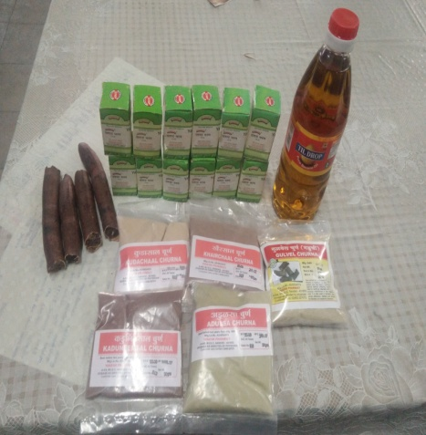
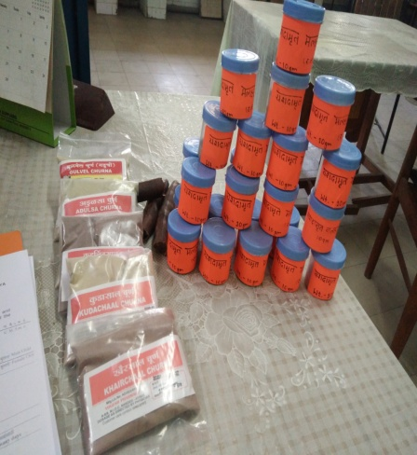
Formed Malahara
Contents of Yasahdamruta Malhara and Aragadhadi kashaya
RESULT
Symptoms | Group A % (n=10) | Group B % (n=10)
Kandu | 53 | 86
Ruja | 50 | 75
Vaivarnya | 50 | 77
Daha | 50 | 88
Strava | 20 | 83
Rukshata | 58 | 81
Raji | 77 | 80
Pidika | 0 | 0
Average | 53 | 81

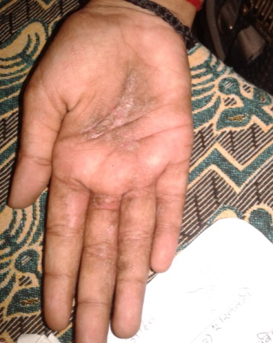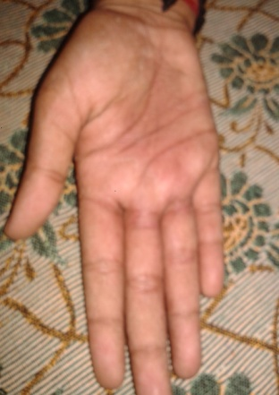
Before Treatment After Treatment
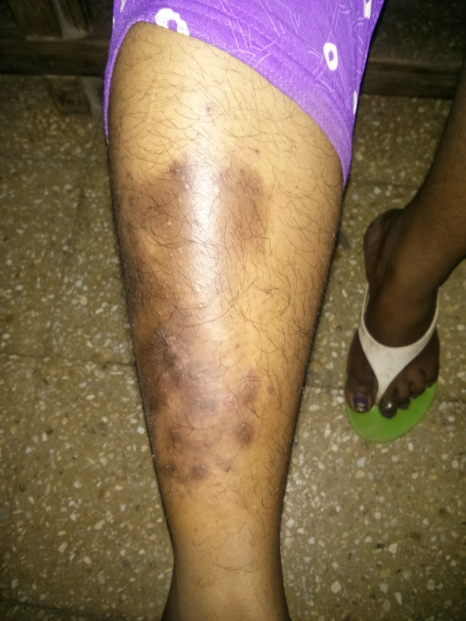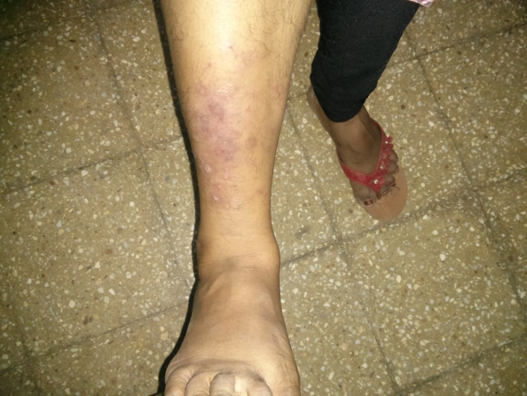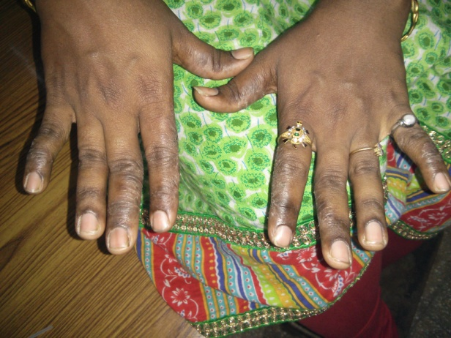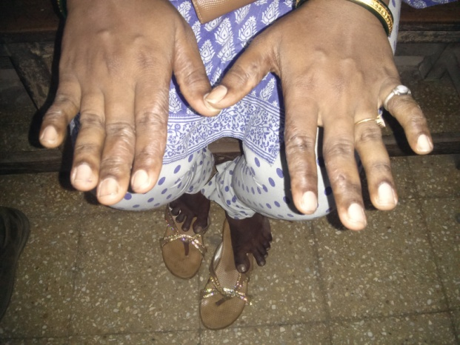
Before Treatment After Treatment
CONCLUSION:
- Combined effect of Aragwadhadi Kashaya with Yashadamruta malahara was found more effective in patients of Group B(81%) than that of Group A patients treated with Tab. Defcort (53%)
- Aragwadhadi Kashaya, a concentrated Decoction of herbal drugs showed mild laxative and detoxifier action.
- Yashadamruta malahara showed Shodhan property;reduction and thickness of skin by exfoliation andscrapping, ropan and rejuvenation
- More rate of recurrence observed with control group that of study group was nill, observed in follow up study
- Economical; Cost effective
- Yashadamruta Malahara provided better relief in thick dispigmented lesions of dry Eczema
- Drug used in present research, proved their best effect against Vicharchika, in their combination form.
REFERANCES:
- sa kNDU ipiDka Syaavaa bahUs~avaa ivacaica-ka È ca.ica.7À26
- rajyaao AitkNDU Ait$jaa sa $xaa Bavaint gaa~oYau ivacaica-kayaama\ È sau.ina.5À137
- ivaraoQaInyannapanaaina d`vaisnagQagau$iNa ca ÈBajataamaagataM Cid-M vaogaaMXcaanyaanp`itGnatama\ È
vyaayaamamaitsaMtapmaitBau@%vaaopsaoivanaama \ÈSaItaoYNala=Ganaaharana\ k`maM mau@%vaa inaYaoivaNaama\ …
vyavaayaM caaPyajaINao-|nnaoinad`aM ca BajataMidvaaÈivap`ana\gau$na\GaYa-yataM papM kma-M kuva-tama\ È ca.ica. 7
- i~kYa-M isa@qatOlantu pUvaao->ivaiQasaaiQatma\ È
taolakOkimatM dVat\ yaSadM vaihnajaairtma\ È
Klvao |itmasaRNao xaud`o mad-yoditya%nat: È
samaa#yaatao malahrao yaSadamaRtsaM&k: È r.t.19/146ú147
- matao malahrao|yaM tu ivaivaQava`NaraopNa: È
ivacaica-kahr: kamamaignadgQava`Naaph: È r.t.19/148
ACKNOWLEDGEMENT:
- I take this priviliage to express my gratitude to all those who directly indirectly inspired during course of research.
- Prepared trial product for present study is not a coomercial or Industry product.
- There are no any conflicts of interests.

