AYURVEDIC MANAGEMENT OF NON-HEALING
VARICOSE ULCER - A CASE STUDY
ABSTRACT:-
The varicose ulcer is the wound which occurs due to abnormal venous hypertension in the lower third of the leg ankle and dorsum of the foot. The pathogenesis starts with obesity and long standing due to dysfunction of venous valve causing venous hypertension around ankle lead to ulcer formation. If venous ulcer is not treated properly then it gets infected, leads to cellulitis and gangrene; so, may require amputation part of the limbs. The recurrence of venous ulcers is very common. The 70% of venous ulcer are healed within 12 weeks of period^{[1]}. There are so many conservative managements in allopathy like, compression stocking, foot elevation, antibiotic and dressing of the wound which when fails may require surgical treatment like skin grafting, sclerotherapy, laser ablation. But its very costly and not much significant. In Ayurveda this disease can be correlated with sirajanya vran, dushta vran. A 32 years male patient having complaints of Nonhealing varicose ulcer over medial malleolus of bilateral leg since 10 months. Treatment like abhyanga , raktamokshana and dressing by using panchavalkal ointment given to patient. Significant healing of wound is observed and the complaints were gradually subsides. The wound were completely healed within 35 days of treatment.

KEYWORDS:- Sirajanya dushta vran, jalaukavacharana , Varicose ulcer.

INTROUDUCTION: -
The varicose ulcers are the wound which occurs due to inappropriate function of venous valve. the damaged venous valve prevents backflow of the blood leading to stasis of blood vein causing significant reduction in arterial blood pressure such that blood is not pumped properly into that area ^{[2]}. Which ultimately damages capillaries of skin and sub cutaneous tissue resulting in capillary proliferation and inflammation causing ulcer formation^{[3]}. Venous ulcers may also occurs due to increase intravenous pressure and secondary to DVT, obesity, injury, chronic constipation, and long standing occupation etc. The varicose ulcers accounting 70 to 90 % are untreated or not treated properly, it can lead to cellulitis, gangrene which may require surgical intervention like amputation of the limb. The incidence rate of varicose ulcer in male is 0.76% and in female is 1.42%^{[4]}. In conservative treatment such as supportive care like wound dressing, compression stocking, physical exercise is used as a part from overall medications like Antibiotics , NSAIDS and surgical treatment .In Ayurveda varicose ulcer can be correlated with siragat dushta vrana (Non healing wound ) which is resulted from various etiology^{[5]}. The Ayurvedic treatment has potential and effectiveness in many chronic and challenging disorders. In Ayurveda there are too many easy procedure and formulation which corrected to many skin disorders and various types of ulcer. Here we have details of case of chronic venous leg ulcer which is well treated by ayurvedic formulations. Considerable healing of wound reduction of varicosity and Hyperpigmentation of leg occurs in 7 weeks of treatment. A 32 years old male patient complaining of wound over bilateral medial malleolus of lower legs with seropurulent discharge, difficulty in walking since 10 months. Patient was clinically diagnosed and selected for study. Weight-109 kg,
Prakruti -Kapha pradhan pittaanubandhi

HISTORY OF PRESENT ILLNESS :
The patient was asymptomatic before 10 months then he get started complaining of wound over bilateral lower legs gradually increasing in size ,seropurulent discharge, difficulty in walking with intense pain at wound and area near it. Patient had taken treatment from private hospital, but does not get relief and suggested for grafting and amputation with prosthetic leg. So for further management patient came to Government Ayurveda college and hospital, Osmanabad.
PAST HISTORY: No history of DM/HTN/KOCHS/BA or any other major illness.
SURGICAL HISTORY: No any major surgical history.
MEDICINAL AND ALLERGIC HISTORY:No any medicinal and drug allergic history.
FAMILY HISTORY:No any family history found.

INVESTIGATION :-
Hb - 16.3 gm%
BT – 1’.30’’/ min, CT-5’.00’’/min
BSL (Random) - 80 mg/dl
Urine routine - Nil
HBsAg and HIV – non-Reactive

GENERAL EXAMINATIONS:-
All vitals parameters were within normal limit, patient was haemodynamically stable.

LOCAL EXAMINATION :-
INSPECTION:-
- Site – Over bilateral medial malleolus.
- Size- Right leg (2 × 1 × 0.5cm)
    - Left leg (7 × 3.5 × 0.5cm)
- Shape - oval
- Smell – foul smell
- Discharge – Seropurulent
- Edges - Sloping
- Floor –unhealthy granulation with slough
- Hyperpigmentation – over bilateral lower legs
PALPATION:-
- Edge and margin- tenderness +++
- Base – Bone (tibia) with slough
- Local temperature – Raised
- Arterial pulsation-Dorsalis pedis and post tibial palpable.
- Lymph node – Not palpable
- DIAGNOSIS:- Non healing varicose ulcer.

CRITERIA FOR ASSESMENT: -

SIZE-
0. No discontinuity of skin /mucous membrane
1. ¼ of previous area of ulcer
2. _{½} of previous area of ulcer
3. > _{½} of previous area of ulcer

PAIN-
0. No pain
1. localized during movement but relieves on rest
2. localized pain even during rest
3. localized pain even during rest and also towards the others side
SMELL-
- No smell
- Bad smell
- Tolerable unpleasant smell
- Foul intolerable smell
EDGES-
- Adhere edge
- Smooth, even, regular edge
- Rough, oval edge
- Angry look
DISCHARGE-
- No discharge/ dry dressing
- Scanty discharge occasional/little wet dressing
- Often discharge need daily dressing
- Profuse continuous discharge need frequent dressing
FLOOR –
0. Smooth regular with granulation tissue /no need for dressing
1. Rough regular, mild discharge, less granulation tissue/need dressing
2. Unhealthy, less granulation tissue/needs daily dressing
3. Unhealthy, no granulation tissue, slough

PLAN OF TREATMENT:-
MATERIAL AND METHODS :-
- After proper assessment, wound washed with normal saline. Then 8 Leeches were applied all around lesion. When Leeches left the site by their own after sucking of blood for approximately 30 to 45 mins., wound cleaned and dressing done with guage piece by applying panchavalkala ointment.
- Daily dressing and weekly 2 settings of Leech therapy was done. Total duration of treatment was 35 days and during the treatment assessment was done on day -01, day-7, day -14, day-21, day-28, day-35.
- Internal Medications –
- kaishore guggul 500Mg BD
-Kanchanar guggul 500 mg 2BD
-Mahamajishthadi kwath 40 ml BD
-Guduchi swarasa 30 ml OD
-Shigrupatra swarasa 30 ml OD
-Tila tail for local application.
Oral medication given for 35 days with cleaning and dressing done daily for first 15 days then on alternate day upto 35 days.
OBSERVATION AND RESULTS:-
Sign and symptoms | Day 1 | Day 7 | Day 14 | Day 21 | Day 28 | Day 35
Size | 3 | 3 | 2 | 2 | 1 | 0
Pain | 3 | 3 | 2 | 1 | 0 | 0
Smell | 2 | 2 | 1 | 1 | 0 | 0
Edges | 3 | 2 | 2 | 1 | 1 | 0
Discharge | 2 | 2 | 1 | 1 | 0 | 0
Floor | 3 | 3 | 2 | 1 | 1 | 0

IMAGES:
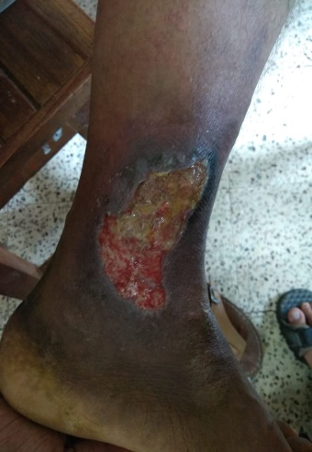
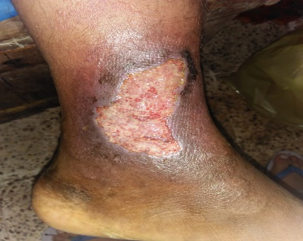
DAY 1 DAY 7

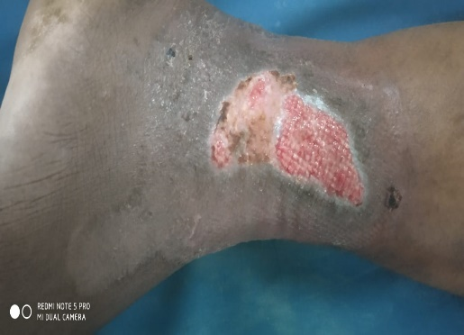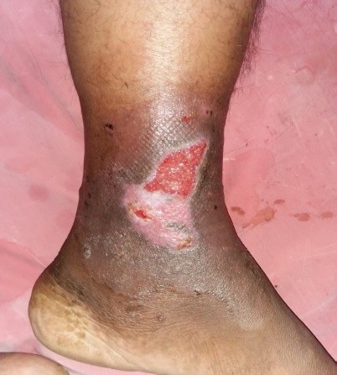
DAY 14 DAY 21
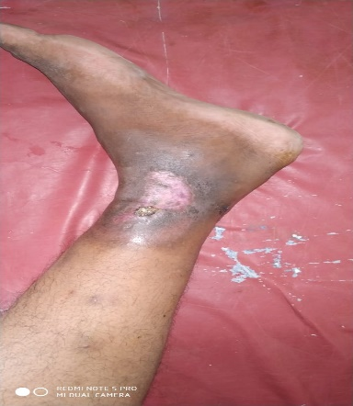
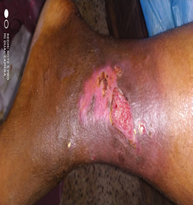
DAY 28 DAY 35

DISCUSSION:-
Varicose ulcer and its complication are common recurring problem. The primary goal is to reduce venous congestion and enhancing tissue perfusion and promotes tissue healing. Typically conservative management consist of elastic stocking, elevation of leg, at rest calf muscle exercise and majority of patient respond to it. However, some ulcer becomes more difficult to cure and do not respond to above treatment causing significant disability and need amputation of limb. According to Ayurveda leech application in venous ulcers gives better outcome^{[6].} Ayurvedic medicine shown its potentiality in many chronic and challenging disorders. There are many more formulation in Ayurveda to treat skin disorder^{[7]}. In this case vrana ropaka (wound healing), vrana shodhaka ( cleansing of wound), rakta shodhaka(blood purifier), shothahara ( anti inflammatory), drug strengthening the blood vessel and have rasayana (immunomodulation) properties were selected^{[8]}.
In varicose veins vitiated vyana vayu causes the vitiation of rasa and rakta dhatus and ultimately vitiates their updhatus like sira (vein) and kandara ( fibrous / collegen structure supports the veins architect such as its valve and walls ) to loose their elasticity and becomes tortuous.
Leeches (Hirudo medicinalis ) were used. Leeches remove blood from their host and release pain. And it pours the blood thinning substances into the blood through their saliva . Leeches of saliva contains various substances like anticoagulants , vasodilators, and Anaesthetic. All these contents work together to decrease the viscosity of blood, making its consistency thinner so as to promote better blood flow.
Kanchanar guggul prescribed in this case to reduce kapha dosha (kleda discharge ) and to reduce pain which is detoxifying in nature . It is also mentioned in Granthi, Arbuda ,Galaganda. Kaishore guggul is used to support healthy joints, muscles and connective tissue. It is pitta -hara (anti-inflammatory) and immunomodulatory in nature^{[9]}. Guduchi swarasa (tinospora cordifolia ) as per Ayurveda is shonitavibandha nashnini, which guna helps to removal of vitiation of blood .Shigrupatra swarasa (moringa olifera) is antioxidant, it protect our body from various infection and prevent our body from free radical. Mahamanjisthadi kwath supports the blood purification which contributes to healthy blood circulation and skin . Tila taila ( sesamum indicum ) is easily absorbed in skin. This is very effective and helps in improving blood circulation. Tila taila said to be the best for abhyanga.
CONCLUSION :-
Varicose ulcer is common cause of leg ulcer known for its recurrence. Ayurvedic management for varicose ulcer is beneficial and venous insufficiency can be prevented without any adverse effect. The leech therapy is adjuvant treatment of Ayurveda. This therapy proves to be cost effective, time saving, and acceptable treatment.

REFERENCES: -
1.S.Das A concise text book of surgery 10th Edition page No.270

2. http:// en Wikipedia org /wiki/ venous ulcer date 25/4/2013

3. Margolis DJ,Bilkar W,Santanna j, Baumgarten M. Venous leg ulcer: incidence and
prevalence in the elderly. J Am Acad Dermatol.2002 Mar;46(3) :381-386
4.Das S. Concise Textbook of surgergy,8th edition Kolkata : S Das publication;2014. p.286-269.

5.Williams NS, Bulstrode CJK O’Connell PR, editor.Bailey and love’s short practice of surgery,26th edition FL:CRC Press;2013.p.908-911.

6.Choudhary, Neelam .Ayurvedic Review o vranas and their Management According to acharyas.International journal of Research in Ayurveda and Pharmacy.2015;6:469-477
7.Bapat RD,Acharya BS, juvekar S,Dahanukar SA Leech therapy for complicated varicose veins. Indian J Med Res.1998 Jun;281-284.

8.Samarnayake GVP, pushpakumar AAJ,Waliwita WALC. Case study of Leech application in varicose ulcer.International Journal of Scientific and Technology Research 2016(5):260-262.

9.Anonymous.Ayurvedic Formularyof India , Part-1 frist edition new Delhi : Department of Indian Systems of Medicine and Homeopathy, Ministry of Health and Family Welfare, Govt of India ;2003
.
10.Lather A,Gupta V, BansalP,Sahu M,Sachdeva K , Ghaiye P. An Ayurvedic Polyherbal Formulation Kaishore Guggulu :A Review. International journal of Pharmaceutical and Biological Archives 2011; 2(1):497-503.

