A REVIEW ARTICLE: COMMON HERBS USED IN COSMETICS
Vd. Rajani D. Balwani¹, Vd. Isha P. Wasu², Dr. Vinod M. Choudhari³
1. Assistant Professor, Dept. of Rachana Sharir, Shri Ayurved Mahavidyalaya, Nagpur
2. M.D. Scholar, Dept. of Rachana Sharir, Shri Ayurved Mahavidyalaya, Nagpur
3. Professor & H. O. D, Dept. of Rachana Sharir, Shri Ayurved Mahavidyalaya, Nagpur
Corresponding Author- rajanibalwani87@gmail.com
Abstract-
Aim- To study about herbs used for cosmetic purpose Objective- 1.To study cosmetic properties of herbs 2.To enumerate general cosmetic uses of herbs Observation- Herbs play a significant role, especially in modern Times, when the damaging effects of food processing and over- medication have assumed alarming damages. This movement is based on the belief that the plants have a vast potential for their use as a curative medicine. The knowledge of Medicinal plants used by the people seems to be well known to its culture and tradition. In the present study we identified many plants used by the people to cure dermatological disorders and as cosmetics. Some of the plants were found to have dual effect, both as curative and cosmetic. Conclusion- Ayurveda offers vast amounts of information on principles of anti-aging activity, skin care and pigmenting herbs with natural ingredients for topical applications. In conclusion, healthy and glowing skin is difficult to achieve by using toxic commercial products. However, ancient Ayurvedic herbal medicine provides some science-backed, natural methods for healthy skin care.
Keywords- Cosmetics, Herbs, Skin care, Medicinal Plants, Ayurvedic Property

Introduction
Now a day’s people are getting more organic in approach for beauty. Ayurveda hold an upmost position in beautifying the skin in most natural way. As the haphazard use of steroids give the sudden results with lifetime of side effects peoples are getting aware regarding beautifying in organic way. Herbal Cosmetics, referred as Products, formulated, using various permissible cosmetic ingredients to form the base in which one or more herbal ingredients are used to provide defined cosmetic benefits only. It is well proved that chemical based cosmetics are harmful to the skin and an increased awareness among consumers for herbal products triggered the demand for natural products and natural extracts in cosmetics preparations. The increased demand for the natural product has created new avenues in cosmeceutical market. Allopathic system alone is proving insufficient so there is need to supplement it with herbal drugs.
Human skin, the external covering of the body, is the biggest organ in the body. It additionally constitutes the primary line of barrier. Skin contains numerous specific cells and structures. It is isolated into three primary layers viz epidermis, dermis and hypodermis. Every layer gives an unmistakable part in the general capacity of the skin. Epidermis, the external most layer of the skin, changes in thickness in various districts of the body. It is the most slender on the eyelids (0.05 mm) and the thickest on the palms and soles (1.5 mm). The dermis additionally fluctuates in thickness relying upon the area of the skin. It is 0.3 mm on the eyelid and 3.0 mm on the back of the body. The dermis is appended to a basic hypodermis or subcutaneous connective tissue. The subcutaneous tissue is a layer of fat and connective tissue that houses bigger veins and nerves. This layer is critical in the control of temperature of the skin itself and the body. The measure of this layer differs all through the body and from individual to-individual. Hair follicles, sweat organs and sebaceous organs are the primary skin members. Skin health is fundamental to total health. Plants have traditionally served as man’s most important weapon against pathogens.

Aim- To study about herbs used for cosmetic purpose
Objectives-
- To study cosmetic properties of herbs
- To enumerate general cosmetic uses of herbs
Cosmetic approach with Ayurveda
Anything which is sprinkled applied rubbed poured on skin to beautify it is cosmetics. The concept of beauty and cosmetics is as ancient as mankind and civilization. Women are obsessed with looking beautiful. So, they use various beauty products that have herbs to look charming and young. Indian herbs and its significance are popular worldwide. An herbal cosmetic have growing demand in the world market and is an invaluable gift of nature. Herbs have been used in maintaining and enhancing human beauty. Indian women have long used herbs such as Sandalwood and Turmeric for skin care, Henna to color the hair, palms and soles; and natural oils to perfume their bodies.
Indian Extracts for Herbal Cosmetics
Herbs play a significant role, especially in modern Times, when the damaging effects of food processing and over- medication have assumed alarming damages. This movement is based on the belief that the plants have a vast potential for their use as a curative medicine, some of most common herbs used are listed below
- Neem or Neemba¹: Neem is a well-known medicinal herb that is known for its anti-bacterial and anti-fungal properties. It is known to penetrate deep into the skin and remove dead skin cells. It also opens clogged pores helping stimulate natural oil production. It stimulate collagen production and improve elasticity. Its high Vitamin E content also helps prevent free radicals from harming skin.
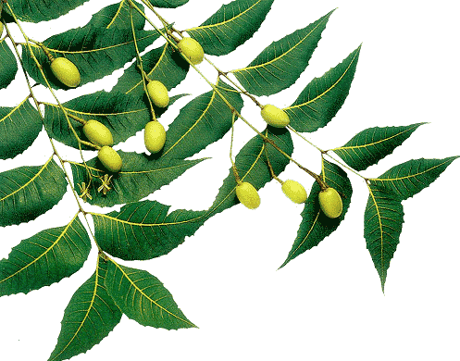
- Manjistha²: In ancient world, Manjistha is reputed as an efficient blood purifier, a Varnya herb and a Rasayan (rejuvenator) and hence it is extensively used in skin care from centuries. Studies have shown it can relieve the itching from eczema, psoriasis and dermatitis. Because of its lymph system, Manjistha is considered one of the best herb for healthy skin. It also help to lower melanin levels by inhibiting tyrosinase, the enzyme that controls the production on melanin.
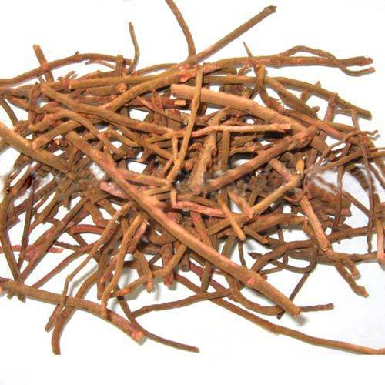
- Turmeric³: Turmeric is a powerful antioxidant that nourishes skin, fights ageing and breakouts, antibacterial action. Turmeric covers some of the major culprits of skin aging, from fighting inflammation to bacterial and fungal infections, making it one of the most effective herbs for treating skin conditions and improving skin health. A study in phytotherapy Research recommends further research on effects of turmeric in various skin disease internally as well as externally.
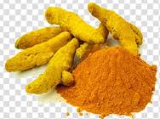
- Sandalwood⁴: The oil of sandalwood (Santalum album) has been traditionally used in India as a medicinal Ayurvedic herb for the treatment of inflammatory and eruptive skin diseases. It acts as best after sun lotion. It lightens blemishes, cleanses pores, heals dry and dull skin.
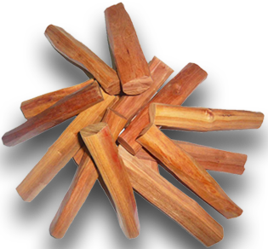
- Khus⁵: Vetiver also known as Usheer or Khus,is a well-known complexion enhancer. Khus oil is immensely nourishing and replenishes dry skin. Amongst most interesting benefits of this plant is its ability to reduce the appearance of blemishes, and pigmentation on the skin, helping to create a even skin tone.
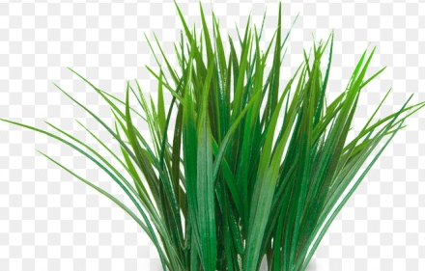
- Madhuyashthi⁶: It is also known as Madhuka or Licorice. Consistent use of Licorice helps to fade blemishes and dark spots. Integrating Licorice tea in the diet can protect the skin from the harmful UV rays. A Licorice root decoration can be used as a sunscreen lotion to protect the skin from sunburns and tan. You may apply a pack prepared by mixing the crushed cucumber, fresh turmeric in Licorice tea to treat the sun damage.
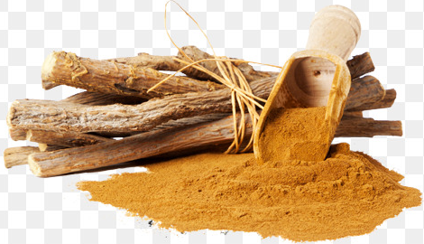
- Amla (Embilica officinalis): Due to high amount of antioxidants and Vitamin C present in its juice, it serves to great glowing skin. Daily intake of amla juice delays effect of premature aging such as fine lines, wrinkles and dark spots. When the skin loses collagen, its tissues lose their firmness and softness for which Vitamin C boosts the production of collagen and tightens the skin.
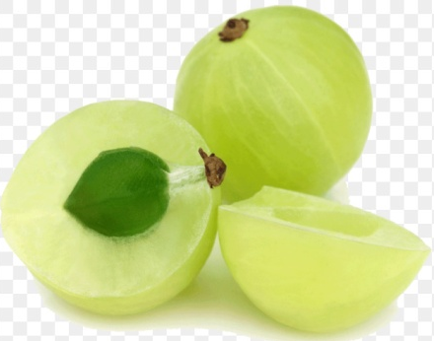
- Brahmi (Bacopa monnieri): Brahmi oil is great for treating a dry scalp and preventing hair fall. The antioxidant components not only help in rejuvenating your scalp but also promote regeneration of healthy hair. Brahmi is good for treating hair problems like dandruff, itchiness and formation of splitends. Prevents from alopecia by its rich bio- chemical compounds. Brahmi helps to dispel toxins from the body, especially from epithelium layer and improves skin complexion
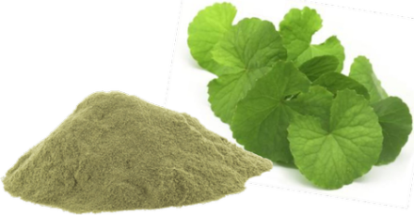
- Padmaka: Padmak helps to manage skin problems due to its pitta balancing property. It is also beneficial due to its kashaya and snigdha property which helps to maintain healthy and glowing skin. The powder of the plant Padmaka is applied as a paste to improve the complexion. Presence of six elements, including iron, zinc, and copper, in varying concentrations in the extract of Padmaka makes it a very effective herb for the skin. It retains moisture in the skin whilst helping to keep acne at bay.
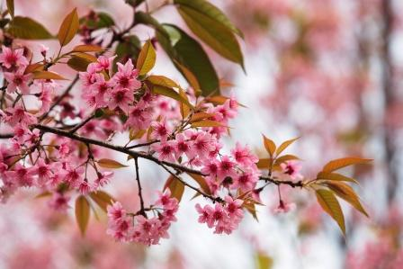
- Aloe Vera or Ghritkumari: Also known as ghritkumari, aloe vera is one of the most used herbs with numerous health benefits. It has anti-fungal, anti-bacterial, anti-inflammatory and cooling properties that can provide with a lot of relief from skin problems. The gel from this plant gives your skin a soothing effect leaving it rash and blemish free.
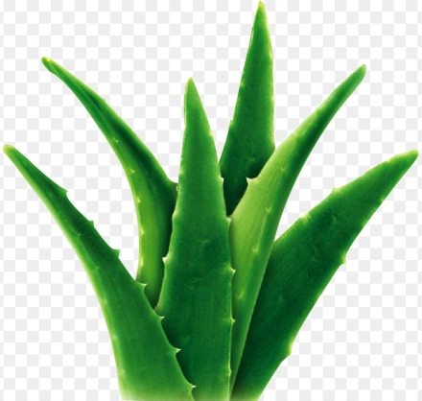

Skin Type and their Care⁷
Suitable Skin Care
Skin Type | Features | Herbal | Essential Oils
Normal | Even tone, soft, smooth texture, no visible pores or blemishes and no greasy patches or flaky areas | Pomegranate leaves juice, Herbal face pack, Gingli oil | Chamomile, Fennel, Geranium, Lavender, Lemon, Rose, Sandal Wood, Patchouli
Dry | Low level of sebum and prone to sensitivity. Has a parched look, feels tight. Chapping and cracking, dehydrated skin | Aloe vera, Olive oil, Calendula, Comfrey | Chamomile, Fennel, Geranium, Lavender, Lemon, Rose, Sandalwood, Patchouli, Almond, Avacado
Oily | Shiny, thick and dull coloured chronically oily skin has coarse pores and pimples and other embarrassing blemishes. Prone to black heads | Aloevera, Burdock root chamomile Horsetail, Oat Straw, Thyme, Lavender, Lemon Grass, Liquorice, Rosebuds, witch hazel | Bergamot, Cypress Frankincense Geranium juniper, Lavender, Lemon, sage evening primrose
Combination | Some part of our face are dry or flaky, while the center part of our face, nose, chin and forehead (called the T- zone) is oily | Witch Hazel, Menthol, Aloevera, turmeric, wheat germ, Sweetflag | Citrus Oils, Jasmine Oil, Sandalwood Oil

Special Skin problems and Herbal Remedies⁷
Skin Problem | Features | Remedies
Chapped Skin | Rough texture which sometimes causes the skin to crack | Application of oils of St. John Wort, Olive Oil or mashed Avacado after bathing or massaging with warm olive oil, mustard or coconut oil half an hour before bathing
Withered Skin | Very tough texture, full of wrinkles | Carrot juice along with a mixture of egg white and honey
Sallow Skin | No colour look, skin becomes lustureless and shows lack of vitality, react quickly to both heat and cold. Sunburns and wind burns occur easily | Inclusion of Vitamin B in diet
Sensitive Skin | Skin become dry delicate and prone to allergic reaction | Use of essential oil of chamomile, lavender Neroli, Rose and Sandalwood oil
Acne | Pockets of infection that manifest as red sore, boils and pimples | Usage of Red Sandalwood oil

List of plants with Cosmetic Application for Skin Care⁷
Scientific Name | Common Name | Part used | Uses
Acarus calamus | Sweet flag | Rhizome | Aromatic, Dusting Powders, Skin lotion
Alhagi camelorum | Jawasa | Leaves | Skin disorders
Allium sativum | Garlic | Bulb | Promotes skin healing, Antibacterial
Aloe vera | Aloe vera | Leaf | Moisturizer, Sunscreen, Emollient
Alpinia galangal | Galanga | Rhizome | Aromatic, dusting powder
Avena sativa | Oat | Fruit | Moisturizer, skin tonic
Azadiracta indica | Neem | Leaf | Antiseptic, reduce dark spots, antibacterial
Bauhinia racemosa | Kanchivala | Bark and leaves | Skin disorders
Calendula officinalis | Marigold | Flower | Skin care, Anti inflammatory, Antiseptic creams
Mesua ferrea | Cobras saffron | Flower | Astringent
Panax ginseng | Ginseng | Root | Stimulate blood flow to skin
Zizyphus jujube | Zizyphus | Fruit | Skin care
Zingiber zerumbet | Zamabad | Rhizomes | Skin care

Conclusion:
Ayurveda offers vast amounts of information on principles of anti-aging activity, skin care and pigmenting herbs with natural ingredients for topical applications. In conclusion, healthy and glowing skin is difficult to achieve by using toxic commercial products. However, ancient Ayurvedic herbal medicine provides some science-backed, natural methods for healthy skin care. The knowledge of Medicinal plants used by the people seems to be well known to its culture and tradition. In the present study we identified many plants used by the people to cure dermatological disorders and as cosmetics. Some of the plants were found to have dual effect, both as curative and cosmetic.
References-
- Ashtang Hrudaya uttarsthan 32/ 12, Adhyay 32, page no. 449, Ashtang Hruday, Dr. Bramhanand Tripathi, Chaukambha Sanskrit Pratishthan, Delhi, 2015
- Ashtang Hrudaya uttarsthan 32/ 17, Adhyay 32, page no. 449, Ashtang Hruday, Dr. Bramhanand Tripathi, Chaukambha Sanskrit Pratishthan, Delhi, 2015
- Ashtang Hrudaya uttarsthan 32/ 22, Adhyay 32, page no. 450, Ashtang Hruday, Dr. Bramhanand Tripathi, Chaukambha Sanskrit Pratishthan, Delhi, 2015
- Ashtang Hrudaya uttarsthan 32/ 25, Adhyay 32, page no. 450, Ashtang Hruday, Dr. Bramhanand Tripathi, Chaukambha Sanskrit Pratishthan, Delhi, 2015
- Ashtang Hrudaya uttarsthan 32/ 27- 30, Adhyay 32, page no. 450, Ashtang Hruday, Dr. Bramhanand Tripathi, Chaukambha Sanskrit Pratishthan, Delhi, 2015
- Ashtang Hrudaya uttarsthan 32/ 27- 30, Adhyay 32, page no. 450, Ashtang Hruday, Dr. Bramhanand Tripathi, Chaukambha Sanskrit Pratishthan, Delhi, 2015
- Herbal Cosmetics: Used for Skin and Hair, Kumar Sumit, Swarnakar Vivek, Inventi Rapid: Cosmeceuticals Vol. 2012, Issue 4, Inventi Journals Pvt. Ltd.

