Efficacy of myofascial release on plantar fasciitis.

Kothari Rabab ¹, Chandanshive Shashikant*².
- P. G. Scholar, M. O. Th.,
- Assistant Professor, shashikantc78@gmail.com, -+91 9820857059

Occupational Therapy School and Centre,
T.N.M. College and B. Y. L. Nair Ch. Hospital, Mumbai-08

*Corresponding author: Email: rababkothari@gmail.com; -+91 9769078752..

Abstract-
Plantar Fasciitis is the most common cause of the inferior heel pain which is bad with the first step taken on rising in the morning or after an extended refrain from weight bearing activity. Myofascial release and conventional occupational therapy are treatments given in the chronic conditions that causes tightness and pain in plantar fasciitis. The study was undertaken with the intention to find out the effectiveness of myofascial release on plantar fasciitis, in conjunction with conventional occupational therapy. Objectives of the study were to study the effectiveness of Myofascial release along with conventional Occupational Therapy in plantar fasciitis. In this prospective, randomized and comparative study 23 patients (Group A) received myofascial release and conventional occupational therapy whereas 24 patients (Group B) received conventional occupational therapy. Assessment done at baseline, at 2nd and 4th week for range of motion at ankle joint, VAS and foot function index.The results from repeated measures of ANNOVA test indicated statistically significant increase in range of motion at ankle joint within both the groups. Freidman ANNOVA test and Wilcoxon signed rank test indicated decrease in pain score and decrease in foot function index recorded within both the groups. The experimental group showed better improvement and is statistically significant at p<0.05. From the above discussion, patients from the group which received conventional occupational therapy exercises with myofascial release showed more reduction pain and foot function index as compared to group which received only conventional occupational therapy.
Key words-
Plantar fasciitis, myofascial release, conventional occupational therapy, Foot - function index, Visual analogue scale, Foot range of Motion
Introduction
Plantar Fasciitis is the most common cause of the inferior heel pain.. The classic presentation of plantar fascia is pain on the sole of the foot at the inferior region of the heel. Patient reports the pain to be particularly bad with the first step taken on rising in the morning or after an extended refrain from weight bearing activity. After few steps and through the course of the day, the heel pain diminishes, but returns if intense or prolonged weight bearing activity is undertaken. Initial reports of heel pain may diffuse or migratory, with time it usually focuses around the area of the medial calcaneal tuberosity. Generally, pain is most significant when weight bearing activities are involved.¹
Plantar fasciitis has been reported across a wide sample of the community. In the non-athletic population, it is most frequently seen in weight bearing occupations.40 65% of non-sports demographics are over-weight, with unilateral involvement most common in 70% of cases. Second major distribution of plantar fasciitis is in the athletic population. 10% of all running athletes, basket-ball, tennis, football, long distance runners and dancers have all noted high frequency of plantar fasciitis.²
Plantar fasciitis is more likely to happen due to:
Activity - Sports that place excessive stress on the heel bone and attached tissue, especially if you have tight calf muscles or a stiff ankle from a previous ankle sprain, which limits ankle movement e.g. running, ballet dancing and aerobics.
Overweight - Carrying around extra weight increases the strain and stress on the plantar fascia.
Pregnancy – The weight gain and swelling associated with pregnancy can cause ligaments to become more relaxed, which can lead to mechanical problems and inflammation.
On the feet – Having a job that requires a lot of walking or standing on hard surfaces i.e. factory workers, teachers and waitresses.
Flat Feet or High Foot Arches – Changes in the arch of your foot changes the shock absorption ability and can stretch and strain the plantar fascia, which then has to absorb the additional force.³
Middle-Aged or Older – With ageing the arch of your foot may begin to sag - putting extra stress on the plantar fascia.
Over pronation- excessive rolling of foot and ankle with each step.
Wearing old shoes: shoes lose their support and cushioning after 500 miles. (If shoes are one year old and one uses it regularly then the cushioning is over, so risk of injury is higher).
Weak Foot Arch Muscles - Muscle fatigue allows your plantar fascia to overstress and cause injury.
Over striding: taking too long of step in front of your body can also contribute to tight calves and plantar fasciitis.
Arthritis - Some types of arthritis can cause inflammation in the tendons in the bottom of your foot, which may lead to plantar fasciitis.
Diabetes - Although doctors don't know why, plantar fasciitis occurs more often in people with diabetes.³
Various therapy treatment protocols for plantar fasciitis have been advocated in the past such as rest, taping, orthosis- night splint, silicon heel cups, stretching and myofascial release. Electrotherapy modalities in the form of ultrasound, phonophoresis, laser, shortwave diathermy, iontophoresis, cryotherapy, contrast bath, paraffin wax bath have been given.⁴
Myofascial release has been one of the therapy treatments given in the chronic conditions that causes tightness and restriction in soft tissues (e.g.:- plantar fasciitis, fibromyalgia and post-polio syndrome), asymmetrical muscle weakness due to peripheral neuropathy and in inflexible rib cage due to chronic respiratory diseases
MYOFASCIAL RELEASE is a type of safe, low load stretch that releases tightness and the pain caused by these restrictions throughout the body so that the patient can move freely and the motion is restored.⁵.It is a soft tissue mobilization technique. If the condition is treated in the acute stage, then symptoms will be aggravated. If treated in the chronic stage, the symptoms will alleviate. Myofascial release techniques stem from the foundation that fascia, a connective tissue found throughout the body, reorganizes itself in response to physical stress and thickness along the lines of tension. By myofascial release there is a change in the viscosity of the ground substance to a more fluid state which eliminates the fascia’s excessive pressure on the pain sensitive structure and restores proper alignment. Hence this technique is proposed to act as a catalyst in the resolution of plantar fasciitis.
It stretches the elastic component, a shearing cross links that can develop at the nodal points of the fascia and change in the viscosity of the ground substance from more solid to a gel state. Thereby, increasing the production of the hyaluronic acid and increases the glide of the fascia tissue.⁶
Mechanism:Tractioning force to the fascia restriction elicit heat from a vasomotor response increases blood flow to affected areas which enhances lymphatic drainage of toxic metabolic wastes, realign fascial planes and reset the soft tissue proprioceptive sensory mechanism. Reprograms the CNS, enables patient to perform normal, functional ROM without pain.
There are different names for the technique that involve manual contact viz. Myofascial release, strain- counter strain, rolling, soft tissue mobilisation.
There are three methods of Myofascial Release:-
A. DIRECT METHOD:
The direct Myofascial release method claims to engage the Myofascial tissue “restrictive barrier” (tension). The tissue is loaded with a constant force until “release” occurs.
Practitioners use knuckles, elbows or other tools to slowly stretch the fascia
Direct Myofascial release is an attempt to bring about changes in the Myofascial structures by stretching or elongation of fascia or mobilizing adhesive tissues.
The practitioner moves slowly through the layers of the fascia until the deeper tissues are reached.
B. INDIRECT MYOFASCIAL RELEASE:
In this method, gentle traction applied to the restricted fascia will result in heat, increases blood flow in the area. The intension is to allow body’s inherent ability for self-correction returns, thus eliminating pain and restoring the optimum performance of the body.
C. SELF MYOFASCIAL RELEASE:
This is used when the individual uses a soft object to provide MYOFASCIAL RELEASE. Usually it is soft roll or a ball on which to rest one’s body weight, then by using gravity to induce pressure along the length of specific muscle or muscle groups, rolls their body on the object.
The technique used in the present study for plantar fasciitis was “J” stroke as it is common technique used on limited areas of tightness and on longitudinal scars. It is a multidirectional stretch; the hand draws short J’s along the restricted area.
Some of the patients also presented with forefoot pain resulted from increased weight bearing on foot so the “cross hand stretch” technique was used as it covers larger area, where hand moves longitudinally in opposite direction while stretching the tissue. In a variation, only one hand applies stretch and the other hand stabilizes the tissue. The stabilizing hand anchors the tissue so that pressures can be applied in the direction of restriction. The tissues slack is taken up and a steady pressure into the restriction is continued until the area releases.
Conventional occupational therapy:
The exercises include strengthening of the intrinsic muscles of the foot and improvement of range of motion of ankle and toes. The exercises are towel curl ups, active ankle exercises
and TA stretching. Patients are advised to use soft heel wear and not to stand for long period of time.⁷
The present study was undertaken with the intention to find out the effectiveness of myofascial on plantar fasciitis, in conjunction with conventional treatment and to compare the effectiveness of myofascial release over conventional occupational therapy.

Aims and objectives
Aim:
To study the effectiveness of Myofascial release as an adjunct to conventional occupational therapy on Plantar Fasciitis.
Objectives:
1. To study the effectiveness of Myofascial release along with conventional Occupational Therapy in plantar fasciitis.
2. To study the effectiveness of conventional Occupational Therapy in plantar fasciitis.

Materials and methodology
It was a prospective, comparative, randomized control study for a period of 18 months. Study population that was included in the study was according to simple random sampling. Patients diagnosed as plantar fasciitis coming to orthopaedic OPD, T.N.M. College and B.Y.L.Nair Ch. Hospital, Mumbai, Maharashtra, India during the study duration were included in the study. Two equal groups were made by the method of randomization used in this protocol was simple random sampling using the computerized generated table
Group A, experimental had 23 patients who were given Myofascial release and conventional Occupational therapy
Group B, control had 24 patients were given only conventional Occupational therapy.
All the patients were randomly divided into two groups.

INCLUSION CRITERIA:
- 1. Clinically diagnosed cases of plantar fasciitis not less than 4 weeks and no exacerbation of pain.
- Age group 20-60 yrs.
- Both genders.
- Pain in heel on the first step in the morning.
EXCLUSION CRITERIA:
- Corticosteroids injection in heel preceding 3 months.
- Surgical Intervention done for fracture ankle and foot joints.
- Patients with clinical disorder such as dermatitis. Malignancy, Hyper mobile / lax joints, recent fracture, hemorrhage, osteoporosis, acute inflammation, local infection, arthritis.
- Patients with impaired circulation to lower extremities.
- Patients with referred pain due to sciatica and other neurological disorders.
- Diabetes mellitus.
- Sensory loss.
- Cognitive deficits.
OUTCOME MEASURES: Foot - function index⁸, Visual analogue scale⁹, Foot range of Motion.
INTERVENTION:
Subjects were explained the purpose and nature of the study. A consent letter was taken from the subject and the relatives in the language best understood by them. Any queries regarding the study were explained to the subject. Subjects were assigned to any one of the two groups and then they were subjected to an initial baseline evaluation. Protocol was for 4 weeks. A clinical evaluation was performed Pre-therapy on day 1 and later at intervals of 2nd week and 4th week. They were called for Occupational therapy treatment 8 hours post pain killer dosage.
Group A:
  - Patients received Myofascial release to plantar fascia and gastrocnemius muscle using all three techniques for 15mins.
  - Conventional treatment in form of exercises for intrinsic muscles strengthening.^{7,10,11,12}
- Towel curl up: For towel curl ups patients sat with foot flat on the end of towel placed on an even surface small weight was kept at the other end of towel. Keeping the heel on the floor, the towel was pulled towards the body by curling the towel with the toes, for 10 times.
- Active ankle exercises: For active ankle exercises – dorsiflexion, plantar flexion, inversion and eversion in sitting with ankle foot exerciser for 10 times.
- TA stretching: Active tendon Achilles stretching in standing by leaning against the wall, holding each stretch for 1 minute and repeating 5 times each session. In long sitting, with towel under the foot. Have the patient pull on the forefoot to cause ddorsiflexion at the ankle.
- Plantar fascia stretching with tennis ball. Subject sitting on the chair rolling foot on the ball for 5 minutes.
- Sewing machine pedaling for 20 repetitions.
- Ankle toe movements with activities that included paper crumbling and picking small pegs from the floor.
The total therapy was for 30 mins. If pain got aggravated, rest was advised.
Group B:
Conventional Occupational Therapy exercises, as given in Group A, was given for 15 mins.
If pain got aggravated, rest was advised.
The patients were called in the Occupational Therapy Department, thrice a week for 1 month. Each session was of 30 mins. Patients progressed with the exercises as per their tolerance in
terms of intensity and number of repetitions. The patients were asked to do similar exercises twice a day at home.
All the patients were advised to use soft heel foot wear, not to stand for long time and not to walk bare foot. Patients were instructed not to do any self- stretching exercises at home.
Outcomes were assessed, at the end of 4th week of intervention, based on Foot Function Index, pain on Visual Analogue Scale and ankle range of motion using long handle goniometer.
Results and Discussion
In the present study, age group participated was between 20 years to 60years. Total of 50 patients were included in the study.

Table 1: Gender distribution in two groups
 |  |  | GROUP
 |  |  | Group A |  | Group B | Total
Gender | Male | Count | 10 |  | 9 | 19
 |  | % within | 52.6% |  | 47.4% | 100.0%
 |  | Gender | 52.6% |  | 47.4% | 100.0%
 |  | % within | 43.5% |  | 37.5% | 40.4%
 |  | Group | 43.5% |  | 37.5% | 40.4%
 |  | Residual | .7 |  | -.7
 | Female | Count | 13 |  | 15 | 28
 |  | % within | 46.4% |  | 53.6% | 100.0%
 |  | Gender | 46.4% |  | 53.6% | 100.0%
 |  | % within | 56.5% |  | 62.5% | 59.6%
 |  | Group | 56.5% |  | 62.5% | 59.6%
 |  | Residual | -.7 |  | .7
Total |  | Count | 23 |  | 24 | 47
 |  | % within | 48.9% |  | 51.1% | 100.0%
 |  | Gender | 48.9% |  | 51.1% | 100.0%
 |  | % within | 100.0% |  | 100.0% | 100.0%
 |  | Group | 100.0% |  | 100.0% | 100.0%

Table 1 shows gender distribution in the study. The total percentage of males participated in the study is 40.4% and that of the females is 59.6%.
Group A had 43.5% (n=10) of males and 56.5% (n=13) of females. In group B, 37.5% (n=9) were males and 62.5% (n=15) were females.

Table 2: Age distribution
 |  |  |  |  | Std. | Std. Error
 | GROUP | N | N | Mean | Deviation | Mean
Age | Group A |  | 23 | 39.65 | 8.451 | 1.762
 | Group B |  | 24 | 40.75 | 6.110 | 1.247

Table 2 shows the age distribution in population.In group A and group B. The mean age in group A was 39.65 and the mean age in group B was 40.75.

Table 3: Intra group values of group A and Group B for VAS.

The table 3 shows the intra group comparison of VAS. The table shows significant improvement in pain scores according to VAS in both groups A and B from baseline to Week 2, baseline week 4, week 4 to week 2 respectively since p<0.05 (.000).
Table 3: Median score of visual analogue scale and its value of ‘p’ for Baseline, week 2 and week 4.
Measure | Factor | Group | N | Mean | Median | Mann- | Z value | Significa
 |  |  |  | Rank |  | Whitney |  | nce level
 |  |  |  |  |  | U score |  | (P value)
VAS | Baseline | Group | 23 | 24.50 | 9.00 | 264.500 | -.256 | .798
VAS | Baseline | A
 |  | Group | 24 | 23.52 | 8.50
 |  | B | 24 | 23.52 | 8.50
 | Week 2 | Group | 23 | 16.30 | 5.00 | 99.000 | -3.886 | .000
 | Week 2 | A
 |  | Group | 24 | 31.38 | 6.00
 |  | B | 24 | 31.38 | 6.00
 | Week 4 | Group | 23 | 12.09 | 1.00 | 2.000 | -5.945 | .000
 | Week 4 | A
 |  | Group | 24 | 35.42 | 4.00
 |  | B | 24 | 35.42 | 4.00
Table 3 shows the median score of visual analogue scale and its value of ‘p’ for Baseline, week 2 and week 4. At baseline, the value of p>0.05 (.798) which is insignificant, it shows that at baseline, all the Pain scores on VAS is equal for both the groups. At week 2 and week 4, the value of p<0.05 (.000), which is statistically significant.
Graph 1: The graph shows the median values of Group A and Group B for VAS.

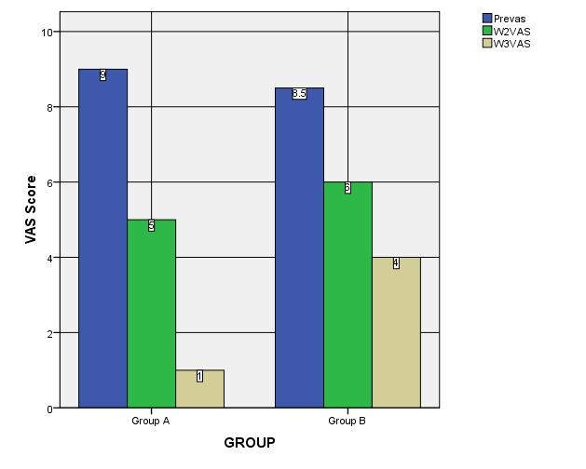

On the basis of the results and graphical representation, the findings emphasizes that there is improvement in level of pain on VAS in both the groups, but the experimental group showed better improvement and is statistically significant at p<0.05.

Table 4: Intra group values of group A and Group B for VAS.

The table 4 shows the intra group comparison of VAS. The table shows significant improvement in pain scores according to VAS in both groups A and B from baseline to Week 2, baseline week 4, week 4 to week 2 respectively since p<0.05 (.000).
Table 4: Median score of visual analogue scale and its value of ‘p’ for Baseline, week 2 and week 4.
Measure | Factor | Group | N | Mean | Median | Mann- | Z value | Significa
 |  |  |  | Rank |  | Whitney |  | nce level
 |  |  |  |  |  | U score |  | (P value)
VAS | Baseline | Group | 23 | 24.50 | 9.00 | 264.500 | -.256 | .798
VAS | Baseline | A
 |  | Group | 24 | 23.52 | 8.50
 |  | B | 24 | 23.52 | 8.50
 | Week 2 | Group | 23 | 16.30 | 5.00 | 99.000 | -3.886 | .000
 | Week 2 | A
 |  | Group | 24 | 31.38 | 6.00
 |  | B | 24 | 31.38 | 6.00
 | Week 4 | Group | 23 | 12.09 | 1.00 | 2.000 | -5.945 | .000
 | Week 4 | A
 |  | Group | 24 | 35.42 | 4.00
 |  | B | 24 | 35.42 | 4.00

Functional assessment was done by using foot function index. Foot function index was designed to measure the impact of foot pathology on functions in terms of pain, disability and activity restriction.
Table 5: Intra group values of group A and Group B for Foot function index

Table shows significant improvement in foot function index in both groups A and B from baseline to week 2, baseline to week 4, week 4 to week 2 respectively since p value is less than 0.05 p< 0.05.
Table 5: Median score of foot function index and its value of ‘p’ for Baseline, week 2 and 4

Measure | Factor | Group | N | Mean | Median | Mann- | Z value | Significa
 |  |  |  | Rank |  | Whitney |  | nce level
 |  |  |  |  |  | U score |  | (P value)
Foot | Baseline | Group | 23 | 23.61 | 65.00 | 267.000 | -.194 | .846
Foot | Baseline | A
Function |  | Group | 24 | 24.38 | 68.00
Function |  | B | 24 | 24.38 | 68.00
Index | Week 2 | Group | 23 | 14.78 | 22.00 | 64.000 | -4.518 | .000
 | Week 2 | A
 |  | Group | 24 | 32.83 | 42.00
 |  | B | 24 | 32.83 | 42.00
 | Week 4 | Group | 23 | 12.00 | 3.00 | .000 | -5.929 | .000
 | Week 4 | A
 |  | Group | 24 | 35.50 | 29.00
 |  | B | 24 | 35.50 | 29.00

Table 5 shows the median score of Foot function index and its value of ‘p’ for Baseline, week 2 and week 4. At baseline, the value of p>0.05 (.846) which is insignificant, it shows that at baseline, all the scores on Foot function index is equal for both the groups. At week 2 and week 4, the value of p<0.05 (.000), which is statistically significant.

Graph 2: The graph shows the median values of Group A and Group B for Foot function index.
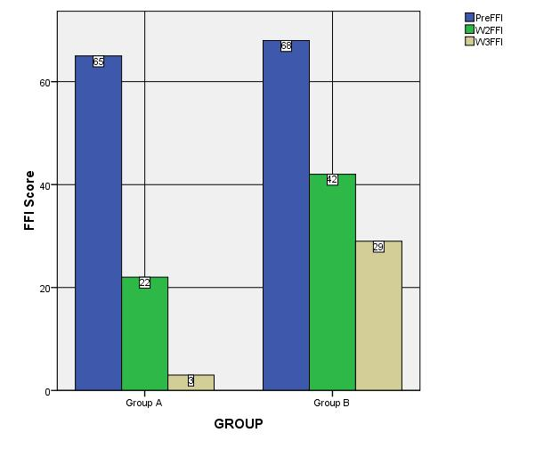

On the basis of the results and graphical representation, the findings emphasizes that there is improvement in level of foot function index in both the groups, but the experimental group showed better improvement and is statistically significant at p<0.05.

The foot function is divided in to three components:
- Pain
- Disability
- Activity restriction

Graph 3: The graph shows the median values of pain component of foot function index of Group A and Group B
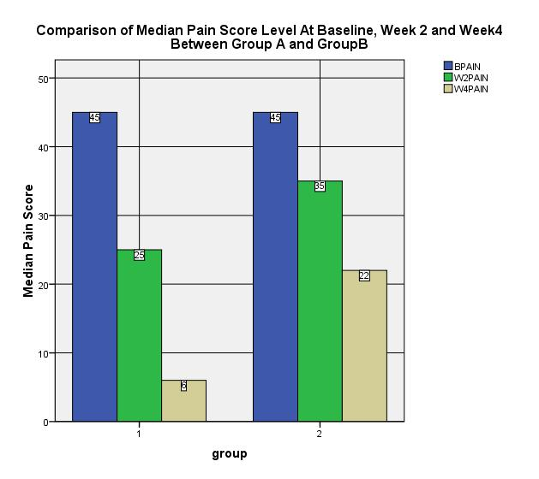

Graph 4: The graph shows the median values of disability component of foot function index of Group A and Group B.

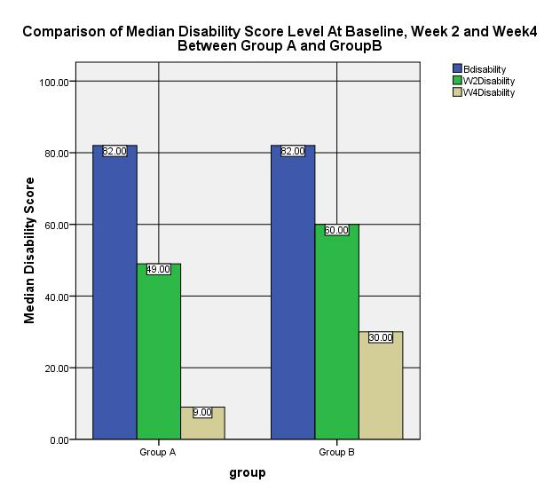

Graph 5: The graph shows the median values of activity restriction component of foot function index of Group A and Group B.
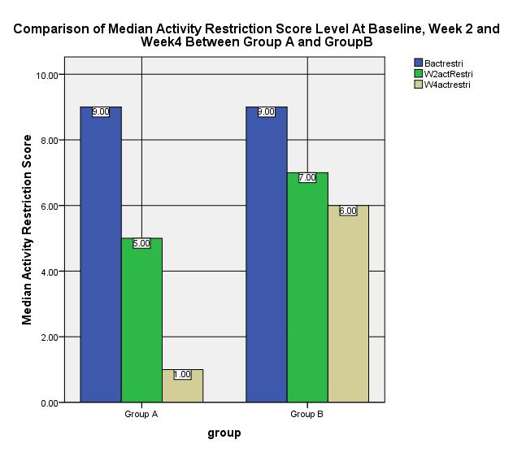

Above graphical representation shows improvement in both the groups from baseline to weeks 2 and 4 but experimental group B shows better improvement than group A.

Graph 6: The graph shows the mean values of plantar flexion between Group A and Group B.
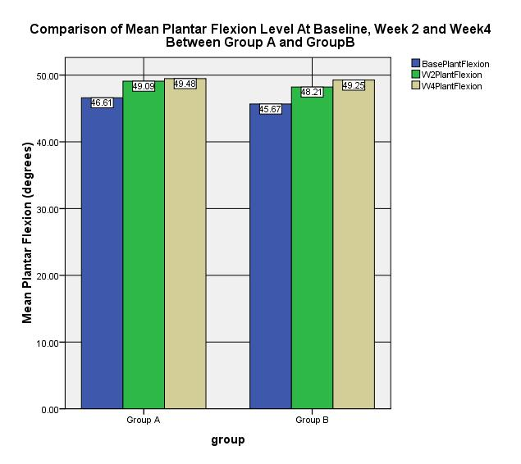

Graph 7: The graph shows the mean values of dorsal flexion between Group A and Group B
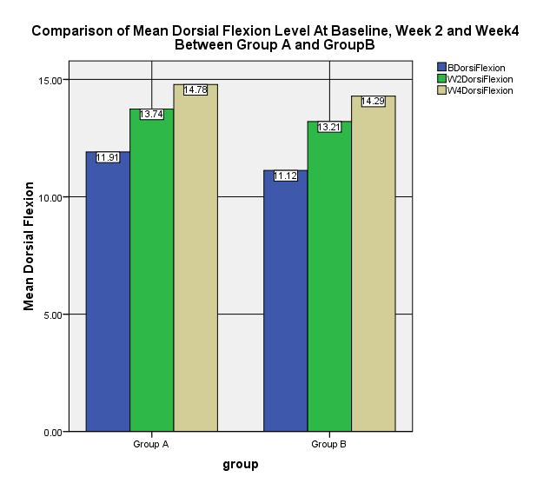

Graph 8: The graph shows the mean values of eversion between Group A and Group B.

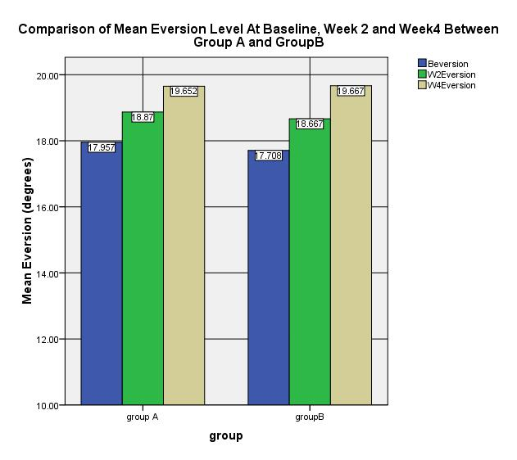

Graph 9: The graph shows the mean values of inversion between Group A and Group B.

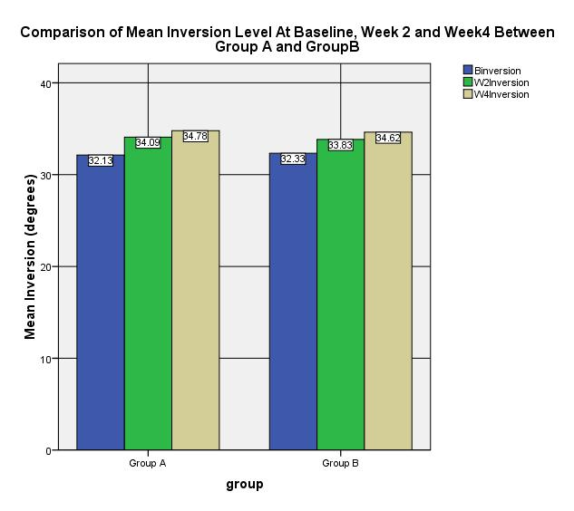

Above graphical representation shows improvement in both the groups from baseline to weeks 2 and 4.There is significant improvement is seen in range of motions in both the groups.

This differences can be attributed to the myofascial release technique used for the experimental group patients. Myofascial release refers to soft tissue manipulation techniques. Myofascial release therapy has hands on manipulation of the whole body to promote and relieving pain. Injuries, stress, trauma and poor postures can cause restriction to fascia. The goal of myofascial release therapy is to release fascia restriction and restore its tissue.

Myofascial release is also said to enhance the body’s innate restorative powers by improving circulation and nervous system transmission.

Burke- Doe A. in a chapter on pain management elaborates that myofascial release therapy as used to release the built in imbalances and restrictions within the fascia and to reintegrate the fascial mechanism. Myofascial release is useful in treating musculoskeletal injuries, headaches, adhesions and scars.

Greenman PE in a chapter on principles of MFR and integrated neuro-musculoskeletal techniques in the 3rd edition of “Principles of manual medicine” wrote, myofascial release techniques use direct and indirect actions with activating forces that are extrinsic and intrinsic. They influence biomechanics of the musculoskeletal system and the reflexes that direct, integrate and modify movement. The goal is restoring functional balance. The techniques are useful in acute, sub-acute and chronic condition with simple and complex problems. This can be used in multiple patient positions. It applies the principles of biomechanical loading of soft tissues and neural reflex modifications by stimulation of mechano- receptors in the fascia.

Study done by Shirat Ling, Do, 1999, concluded that direct myofascial release is a highly effective technique for plantar fasciitis who need to recover quickly. Direct myofascial release method works directly on the restricted fascia.

All patients who had come for the study had ambulatory jobs like nurses, tailors, shopkeepers, salesman and housekeepers. It concluded that the same amount of improvement was seen.

From the above discussion, patients from the experimental group which received conventional occupational therapy exercises along with myofascial release showed more improvement in levels of pain and foot function index as compared to control group which received only conventional occupational therapy. This difference can be attributed to myofascial release therapy with conventional therapy.

Conclusion
Plantar fasciitis is a condition characterised by painful, stiff plantar fascia that may persist for a long period. In the study, patients presented were with pain in foot on the first step in the morning and with foot function difficulty.
Based on the results obtained after 4 weeks of rehabilitation, it can be concluded that the program of occupational therapy along with myofascial release is beneficial in alleviation of symptoms and associated disability in plantar fasciitis. However the subjects treated with myofascial release showed an additional benefit in terms of reduction of pain on Visual analogue score and functional ability in terms of Foot function index.
It generates a clinical evidence for the effectiveness of Myofascial release techniques in plantar fasciitis.
Hence it can be concluded that myofascial release is an effective therapeutic option in the treatment of plantar fasciitis along with conventional occupational therapy.

Limitations

- The sample size for the study was limited to 25 patients in each group. The study can be conducted on a larger population using the same protocol.

- Unavailability of sufficient clinical studies on myofascial release used in plantar fasciitis.

- We cannot deny to a patient if they were taking therapy at some centre as well.

- Limited time period.

References
- 1.Diagnosis and treatment of plantar fasciitis. Goff JD1, Crawford R.Am Fam Physicain.2011 Sep 15:84(6):676-682
- 2.Dr.Douglas Richie, DPM for Podiatry Management Magazine. August 2002.
- Pathomechanics of plantar fasciitis, journal of sports medicine (Auckland).
- Roberts, VJ and Baker, KG. A review of therapeutic ultrasound: Effectiveness studies,Physical therapy,(87) 2001.
- 5.Hanten WP, Chandler SD. Effects of Myofascial release leg pull and sagittal plane isometric contract release techniques on passive straight leg raise angle, Journal of Orthopaedic & Sports Physical Therapy,Vol.20:,Issue.3,:Pages.138-144
- Barnes J F and Smith G, The body is a self-correcting mechanism. Therapeutic Insight, Physical Therapy Forum,July8, 1987.
- Therapeutic Exercise: Moving towards function; 3rd editionCarrie M. Hall and Lori Thein Brody, publisher-Lippincott Williams & Wilkins, a Wolters Kluwer business,chapter 21 the ankle and foot, Jill Mcvey, Carrie M. Hall et.al 555-556
- The Foot Function Index: a measure of foot pain and disability. Budiman-Mak E1, Conrad KJ, Roach KE. Journal of Clinical Epidemiology, August 27,1991
- Wewers M.E and Lowe NK, A critical review of visual analogue scales in the measurement of clinical phenomena, Research in nursing and health.13(4),227-236,1990
- Therapeutic Exercise: foundations and techniques; Carolyn Kisner and Lynn Colby.6th edition, F.A.Davis company, Chapter 22,The Ankle and Foot,Page 885-889
- 11. Clinical orthopaedic rehabilitation: Foot and ankle rehabilitation; Brent Brotzman.,Mosby, publisher- Anne.S.Patterson, 1996, pg. 314
- Young CC, Rutherford DS, Niedfeldt MW. Treatment of plantar fasciitis. Am Fam Physician 2001.Aug 15;64(4):570

Acknowledgement
We are thankful to Dr. Ramesh Bharmal, Dean T.N.M. College and B.Y. L. Nair Ch. Hospital, Mumbai-08 for granting permission to conduct this study. We would like to express sincere gratitude to Dr.Odette Gomes Ex Head of Dept, Dept. of Occupational Therapy, Dr. (Mrs.) Pratibha Vaidya, Associate Professor and In-charge, Dept. of Occupational Therapy for her kind support and timely guidance and also the patient and his family member for their kind support.

