Analgesic, anti-inflammatory and blood thinning effect of Leech Therapy In patients of Rheumatoid Arthritis -- An exemplary pilot Study
*Dr Sheetal G Asutkar, Professor, Dept. of Shalyatantra, Shri Ayurveda College, Nagpur(M.S)
**Dr Subhash Chandra Varshney, Professor Emeritus, MGACH&RC, Salod, Wardha (M.S)
Corresponding Author- Dr Sheetal Asutkar
Email id- sheetalasutkar16@gmail.com
Mo no- 9766811974
Abstract:
Joint pain is the worst of sufferings of humans and man's efforts to conquer the pain are older than his efforts to prevent death. In Ayurveda, joint diseases are discussed categorically as Vatavyadhi(disease originating from vitiation of vata), amadoshajanya (diseases due to indigested food juice), dushitaraktajanya (diseases due to impurities in blood) and asthisandhigata(diseases due to bone and joint deformities) roga and have a common characteristic of joint pain among them. From various studies it is found that, Rheumatoid Arthritis(RA) is the most common form of joint illnesses and is a major cause of pain and disability in the young and elderly population. Leech therapy has been successfully practiced by ayurveda practitioners in the management of musculoskeletal diseases since long. In the present scenario, considering the analgesic, anesthetic and multiple anti-inflammatory properties of leech salivary gland secretions(SGS) and its applicability in inflammatory conditions of skin and joints, and the experimental and investigational status of leech therapy (jaloukavacharan) in RA, a clinical research is presented comprising of 44 patients of Rheumatoid Arthritis (Aamvata). In this study, leeches (jalouka) were applied on alternate days for 10 sittings on preferably knee joints and ankle joints and patients were subjected to certain assessment criteria like pain, redness, tenderness, rise in local temperature, restricted movements, walking effect and pathological parameters. Leeches were applied following the standard operating procedures (SOP’S).The clinical data on various aspects of joint pain, signs of joint inflammation and pathological parameters was statistically analysed, significant results were found which are elaborated under relevant sections of this article. Follow ups taken and observations noted suggest that mean % relief in pain was found to be 69.66%, Swelling - 55%, Redness – 61.66%, Tenderness – 63.66%, Rise in local temperature - 36.33, Restricted movements – 61.33%, Walking effect – 52.64% after treatment leech therapy. There was statistically insignificant rise in tlc, and lymphocytes. Similarly,statistically insignificant decrease in other parameters like hemoglobin and polymorphs was found. Bleeding time was found to increase by 10-15 sec and Clotting time was found to increase by 12-16 sec. CRP was found to reduce by 10 mg/dl and ESR was found to reduce by 10-15 mm as average in 44 patients after raktamokshana by leech for 20 days..
Keywords- Leech therapy, pain, CRP, ESR, anti-inflammatory, anesthetic, salivary gland secretions
Introduction
“Sense of pleasure we may well spare out of life perhaps & not repine, But pain is perfect misery, the worst of evils and excessive, overturns All patience. "(JOHN MILTON: Paradise Lost)
Joint pain is the worst of sufferings of humans and Man's efforts to conquer the pain are older than his efforts to prevent death.¹ In Ayurveda, joint diseases are discussed under certain Vatavyadhi(disease originating from vitiation of vata), amadoshajanya(diseases due to indigested food juice), dushitaraktajanya (diseases due to impurities in blood) and asthisandhigata(diseases due to bone and joint deformities) roga and have a common characteristic of pain among them.² Of these Aamvata is a disease characterized by swollen painful joints affecting younger population, presenting with inflammatory type of arthritis which can be correlated to rheumatoid arthritis(RA) a long-lasting autoimmune disorder. Most commonly, the wrist and hands are involved, Large Joints are also involved. There is characteristic crippling nature of the diseasse.³ Leech Therapy can be defined as the use of leeches in medical treatment. This therapy helps in letting out impure or deoxygenated blood from given area with the help of leech bite. The Leech sucks blood from the site as well as transmits some enzymes in its saliva having anesthetic, anti-inflammatory, anticoagulant, vasodilatation effect etc. thereby giving prolonged oozing effect from the site of bite. Leech therapy has been suggested and successfully practiced by ayurveda physicians in the management of musculoskeletal diseases since antiquity.⁴ The American College of Rheumatology (ACR) and the European League against Rheumatism (EULAR) in 2012 jointly established a point value scale between 0 and 10 to diagnose RA based on the levels of Inflammatory markers i e, ESR and CRP.In these, 1 point is attributed to elevated ESR (erythrocyte sedimentation rate)and or elevated CRP value (C-reactive protein).Another 1 point is attributed to the involvement of 2-10 large joints.⁵In the present scenario, considering the analgesic, anesthetic and multiple anti-inflammatory properties of leech salivary gland secretions (SGS)⁶ and its applicability in inflammatory conditions of skin and joints, and considering the painful and inflammatory condition of joints in Rheumatoid Arthritis and the experimental and investigational status of leech therapy (jaloukavacharan) in RA ⁷, a clinical research is presented comprising of 44 patients of Rheumatoid Arthritis (Aamvata). In this study, leeches (jalouka) were applied on alternate days for 10 sittings on preferably knee joints and ankle joints and patients were subjected to certain assessment criteria like pain, redness, tenderness, rise in local temperature, restricted movements, walking effect and pathological parameters leeches were applied following the standard operating procedures(SOP’S).A thorough study was done on various aspects of joint pain, signs of joint inflammation and pathological parameters, significant results were found which are elaborated under relevant sections of this article. Follow ups were taken and observations noted and statistical findings were noted which conclude that overall Effect of leech therapy was found significant on all subjective parameters and objective parameters.
AIM and OBJECTIVES
Aim- To assess the efficacy of Leech Therapy on knee joint Pain
Objectives-
- To assess the anti-inflammatory effect of Leech Therapy in patients of Aamvata (Rheumatoid arthritis-RA) wsr inflammatory markers
- To assess efficacy of Leech Therapy on blood thinning parameters(BT,CT) in the patients of RA
Protocol--This is an observational type of experimental study in which convenience sampling method is applied
Methodology
Materials-- Leeches and Leech Lab and other procurements as per the requirements and tablets of Paracetamol
Methods-The patients suffering from Aamvata (RA) in whom knee and ankle joints were involved (minimum 2 joints as per ACR/EULAR CRITERIA 2012). Each patient was subjected to Leech Therapy on alternate day for 10 sittings. On every instance, 1 to 3 leeches of small to moderate size, were applied, which were found to suck 5 to 15 ml of blood as average.
a) Purva karma- Jalouka of moderate size was first prepared for Raktamokshana by keeping it in Haridra Jala. Joint site cleaned by tap water and then by dry gauze.
b) Pradhana karma- After wearing the latex gloves prepared active leeches were kept over the joint and., then wet cotton pad were placed over it. When leech started to suck blood by itself ,it was continuously observed till the completion of procedure.
C) Paschatkarma- Detached leech was collected.Haridra Churna was sprinkled over the leech’s anterior sucker (mouth) for inducing vomiting. After expelling all the blood from its gut, the leech became active again and was stored in fresh water container. Haridra Churna was applied over the bite lesions and pressure dressing done.⁸
Inclusion criterion
- Patients in the age group 20 to 60 yrs.
- Swollen joints preferably knee joints, and ankle joints
- Patient with painful knee joints and ankle joints
- Symptoms lasting six weeks or longer
¬ Patients who gave written consent of study
¬ Patients of uncomplicated RA were included in the study
Evaluation Measures: Subjective parameters like measurement of pain, swelling, tenderness, redness, walking effect and rise in local temperature were assessed prior to and after leech therapy. Objective parameters ie, markers of inflammation like bleeding time, clotting time. CRP and ESR were specifically measured prior to and after leech therapy. Statistical tests like mean % relief in symptoms and laboratory parameters were calculated in the given sample
Exclusion Criterion
- Anemic patient in which Hb is below 9 gms
- Pregnant ladies, Lactating Mothers, Children
- Patient below 20 yrs. and above 60 yrs. of age
- Patient who is HIV and Hbsag positive
- Patient having IHD and on treatment
- Patient having bleeding disorders such as hemophilia and Arterial Insufficiency
- Allergy to leeches ⁹
End Points-The observations and results obtained from the clinical study were analyzed statistically to evaluate the clinical significance of the curative properties of Leech Therapy
Images depicting Leech Therapy
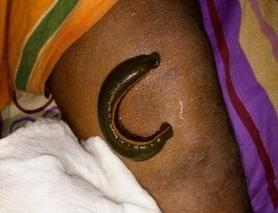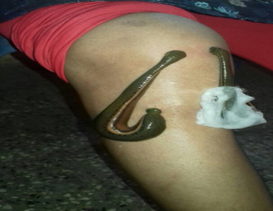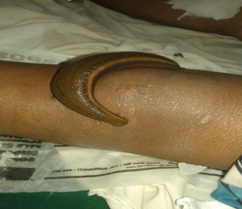
Application of leeches in RA patients with knee joint involvement
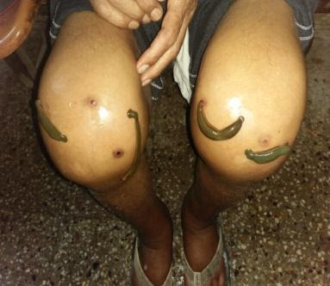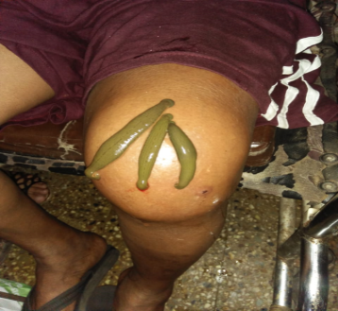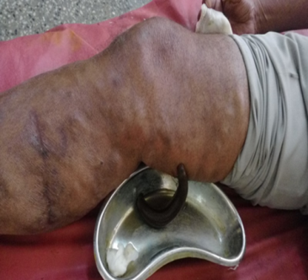
Application of leeches in RA patients with knee joint involvement
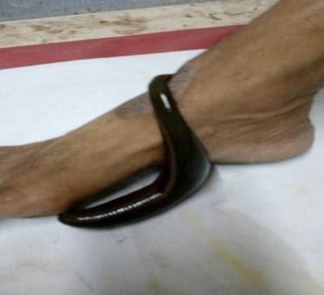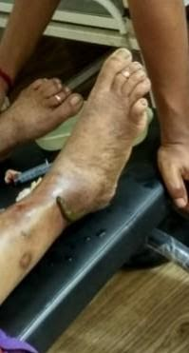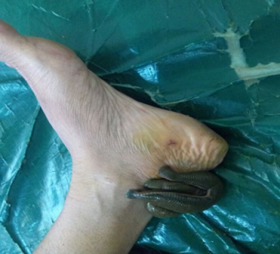
Application of leeches in RA patients with ankle joint involvement
Observations and Results
From total 44 patients of RA,Female (56%) > male (44%),Married patients (86.67%) > unmarried patients (13.33%). ,distribution of patients according to joint involvement, Knee joint pain- 68 , Ankle joints.= 34 , Wrist joints - 22 , Elbow joints – 20, Shoulder joints - 12 .Knee joint (50) patients are in the highest position to get involved probably being the weight bearing joints. Acute pain – 20 patients (38.67%), Chronic pain – 47 patients(61.33%). It was noted that 7 patients required to take tablet of paracetamol for pain relief during treatment due to less pain tolerance.44 patients of Rheumatoid Arthritis were subjected to leech therapy on alternate day for 10 sittings,(of them 4 were dropouts) and observations were noted .Observations from right knee joints were compared prior to and after leech Therapy..
The tables and graphs of the observations are as follows:
Subjective Parameter | Mean % relief  after treatment
Pain | 69.66
Swelling | 55
Redness | 61.66
Tenderness | 63.66
Local temperature | 36.33
Restricted movement | 61.33
Walking effect | 52.64
Table no 1
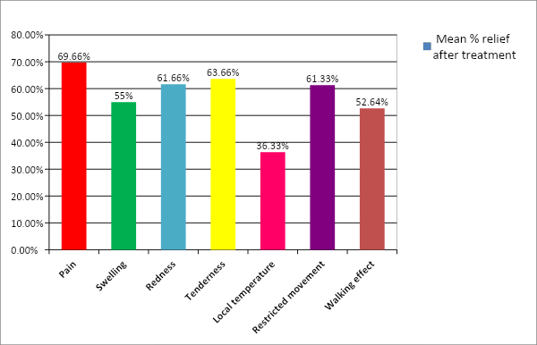
Graph no 1
Table no 1 and graph no 1 reveals that Mean % relief in Pain was found to be 69.66%, Swelling - 55%, Redness – 61.66%, Tenderness – 63.66%, Rise in local temperature - 36.33, Restricted movements – 61.33%, Walking effect – 52.64% after 10 sittings(20 days) of leech therapy
Levels | Initial | Final
Pain | 79.5 | 46.5
Swelling | 31.28 | 29.07
Redness | 100 | 61.66
Tenderness | 100 | 41.66
Rise in local temperature | 91.66 | 33.33
Resticted movement | 69 | 45
Walking effect | 28.99 | 59.44
Table no 2

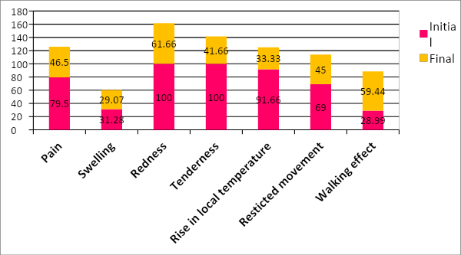
Graph no 2
Table no 2 and graph no 2 reveal that there is statistically significant decrease in the initial and final levels of all assessment parameters like pain, swelling, redness, tenderness, rise in local temperature, restricted movements and walking effect
Sr. No. | Joint Pain related Complaints | Total Recovery of complaints
Sr. No. | Joint Pain related Complaints | After 1st wk. | After 2nd wk | After 3rd wk
1 | Pain Relief | 16.68% | 29.29% | 40.99%
2 | Increase in pain with movements | 57.64% | 70.58% | 17.27%
3 | Stiffness | 34.60% | 49.74% | 72.97%
4 | Heaviness | 35.7% | 50.00% | 69.04%
5 | Radiation of pain | 68.88% | 71.11% | 69.11%
6 | Range of motion | 63.15% | 70.27% | 71.33%
7 | Acute Pain |  |  | 65.33%
8 | Chronic Pain |  |  | 72.91%

Table no 3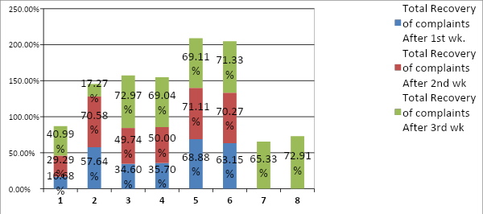

Graph no 3
Table no 3 and graph no 3 reveal the % weekly recovery of joint pain characters like stiffness, heaviness, radiation of pain, range of motion(degree of joint flexion).and it is radiation of pain which got hihest relief among pain characters.Among chronicity of pain,it were both acute and chronic pain which were clinically and statistically significantly relieved,more relief found in chronic pain patients in RA after treatment by leech therapy.
Sr. No. | Signs and Symotoms | % weekly Recovery
Sr. No. | Signs and Symotoms | After 1st wk. | After 2nd wk | After 3rd wk
1 | Joint Pain (VAS) | 36.48% | 48.64% | 67.56%
2 | Swelling in cemeteries | 38.28% | 58.48% | 71.18%
3 | Redness | 6.66% | 31.16% | 61.16%
4 | Tenderness | 32.35% | 47.05% | 64.70%
5 | Rise in local temperature | 27% | 45% | 65%
6 | Restricted movements  (Degree of flexion} | 62% | 69.81% | 71%
7 | Walking effect  (Range of motion in mtrs) | 17.69% | 34.65% | 50.65%
Table no 4
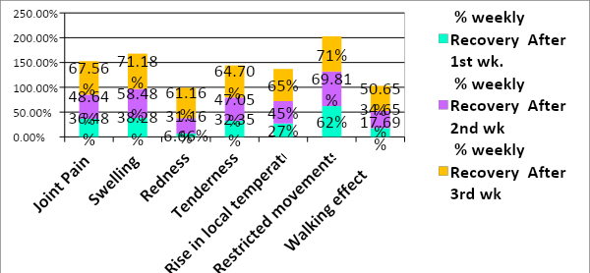

Graph no 4
Table no 4 and graph no 4 explains % weekly recovery of all symptoms of joint inflammation till 3 consecutive weeks which is found as remarkable and statistically significant in all characters but highest in restricted movement of joint followed bynswelling and pain,and other characters respectively.
Sr. No. | Recurrence noted | No of Patients reported  After 1 month | No. of patients reported After  2 months
1 | No recurrence | 7 | 5
2 | 15-25 % recurrence | 9 | 11
3 | 25-40 % recurrence | 5 | 6
4 | 50-60 % recurrence | 2 | 0
5 | Complete recurrence | 0 | 0

Table no 5
Graph no 5
Table no 5 and graph no 5 reveals relapse of symptoms on first follow up which shows maximum of 15-25% of recurrence in 9 patients after 1 month. It again shows similar relapse of symptoms in 11 patients on second follow up after second month. There is no patient with complete relapse of symptoms till 2 months of follow up.
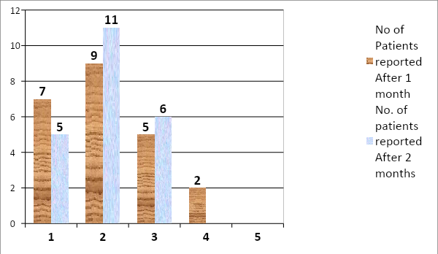
Levels of pathological inv. | Average Increase after Treatment | Average Decrease after treatment
CRP |  | 14.33
ESR |  | 11.65
Hb% |  | 1.33
TLC | 333.33
DLC -Polymorphs |  | 4.33
Lymphocytes | 6.33
Bleeding Time | 14.33
Clotting Time | 15.73

Eable no 6
Results in Pathological Investigations-
Table no 6 reveals difference in pathological investigations before and after leech therapy in RA patients. Hemoglobin was found to reduce by approximately 0.5 to 1.5 gm after treatment. TLC was found to increase by almost 200 to 500/cu.mm.In the DLC, polymorphs were reduced by 5 and lymphocytes were increased by 6 approximately. Sometimes eosinophils were also found to increase. Bleeding time was found to increase by 10-16 sec and Clotting time was found to increase by 12-17 sec. CRP was found to reduce by 15 mg as average in 44 patients after raktamokshana by leech 20 days. ESR was found to reduce by 12 mm at the end of 1 hr.
Discussion-
As RA is a disease characterized by inflammatory arthritis and joints which are swollen and warm and painful is a typical finding with other peculiar characters. Leech saliva has many properties like anti-inflammatory, analgesic, anesthetic, decongestant action, anti-ischemic properties and anti-coagulant action which allow the blood to flow freely even after the leech is removed. The bdellins, eglins, hirustasin, hyaluronidase render analgesic and anti-inflammatory activity associated with the blockage of amidolytic and kininogenase activities of plasma kallikrein, resulting in prevention of pain or pain relief during leech sessions .This allows the local toxins to flow freely, releases the local stagnant pool of inflammatory secretions. It eliminates microcirculation disorders, restores damaged vascular permeability of tissues and organs, eliminates hypoxia, reduces blood pressure, increases immune system activity, detoxifies the tissue, releases it from the threatening complications, thereby reducing rubor, calor, dolor, tumor and local warmth in the tissue.¹⁰The combined effect of the multiple bioactive salivary secretions with other actions like, anesthetic properties, thrombolytic effect, tissue rejuvenation effect, anti-ischemic effect, renders the improvement in the pain, swelling, tenderness of joint relieving stiffness and improvement in the restricted movement of joint. Leech therapy is effective in reducing the CRP in patients of Aamvata to a level which is statistically significant in a population of RA patients with sample of n= 44. Agapn,it can be concluded that Leech Therapy is an effective treatment in reducing ESR in patients of Aamvata in both genders significantly irrespective of any gender specific finding. This finding goes hand in hand with the fact that there are certain enzymes in leech saliva like that contain acetylcholine, histamine like vasodilators that prolongs the bleeding time and clotting time as an outcome of anticoagulant complex isolated from lyophilized medicinal leech saliva which exerted pronounced antithrombotic, thrombolytic, and hypotensive effects. It contains decorsin which is a potent inhibitor of platelet aggregation in combination with PAFA(platelet aggregation factor activation) enzyme, and more importantly hirudin and hirustasin which is responsible for the enhanced clotting time.^{11 This} The increased bleeding and clotting time of patients suggest the blood thinning actionof leech saliva. Together the anti-inflammatory and anticoagulant effect of leech salivary gland secretions result in the prolonged oozing from the leech bites thereby aiding the reduction in inflammation. In this way it is found that there is significant reductionin the patient’s pathophysiological status of inflammation of joints and marked improvement in the diseased status of joints in RA.
Conclusion-
From the study presented and data produced, following conclusions can be drawn-
Joint pain relief action: Leech Therapy gives statistically significant Joint pain relief in patients of RA (After a 3 week treatment and monthly follow up twice),
Type of Pain –Leech Therapy is a good treatment for long standing chronic pain as compared to acute pain.
Parameters- Leech therapy rsigns of inflammation enders undeniable anti-inflammatory action on joints (Subjective) and inexplicable action on Inflammatory markers (Objective).
Side effects if any- Not reported (Oozing occurred from bite site for 36 to 48 hours in 6 patients).No need of any other analgesic during treatment with leech therapy
Hypersensitivity – not reported (2 patients had itching at bite site and 3 patients had burning sensation for 48 hours)
Recurrence- 15 to 25% of recurrence of symptoms noted after 2 months of follow up in 11 patients
Inferences-
Thus the fact which can be concluded as a whole from this study is that Leech therapy (Jalloukavacharan) proves to provide statistically significant Pain relief and equally convincing anti-inflammatory effect in joints with special reference to inflammatory markers giving significant blood thinning effect in patients of RA and paves its way towards establishing itself as a novel bio-therapy in Rheumatoid Arthritis, thus covering two points in ACR/EULAR criteria 2012,by reducing CRP and ESR after a 10 sittings and 20 days treatment. Hence, there is requirement of many randomized controlled trials to be taken for study to establish the results on larger population and many new arenas to be opened for research scholars.
.
Conflict of Interest –nil Source of support –nil
References
1.Follow up of the first series of pain exposure physical therapy(PEPT)treated CRPS-1,patients show further improvementJan willem EK 2 etal,acta rheumatologicaVol 7,no 1,,2020
2.A concept of research on change in inflammatory markers in patients of Aamvata (wsr Arheumatoid arthritis)treated with leech therapy,sheetal Autkar,IJRIM,jan-Mar 2017,vol 1,issue 1,pg 1-13
3.Rheumatoid arthritis:early diagnosis and treatment outcomes,Behzad Heidan,MD,caspian Journal of Internal Medicine,2011,winter2(1),161-170
4.Effect of Leech Therapy (Hirudo Medicinalis) in painful osteosrthritis of the knee: a pilot study,A,Michaelson,U.DeuseAnnals of rheumatic diseases,vol 60,issue 10
5.ACR/EULAR 2010 rheumatoid arthritis classification criteria,Jonathan Kay,Katherine S,Rheumatology Vol5,issue 1,dec 2012,pg 5-9
6. Leech Therapy: Coherent Review of history, functional components in Saliva and therapeutic applications in surgical diseases; Sheetal Asutkar, Amit Paliwal, IJAR; April 2019; volume 9; issue 4.
7. Aetna-Clinical surgery bulletins-Number: 0556 , Bio-Surgery: Medicinal Leech Therapy and Medical Maggots, 2015
8.The cumulative anti inflammatory effect of bloodletting by leech in patients of arthritis(Aamvata) wsr linflammatory markers –A research realm,IJRIM,vol 2,issue 5, aug-2018
9.Interdicipilinary critical review of leech therapy:evolution,indications,salivary gland secretions, and mode of action-The scientific way,sheetal Asutkar,IOSR-PHR,Journal of pharmactvol issue 9,mar apr 2019
10. A Systematic Overview of the Medicinal Importance of Sanguivorous Leeches: Alternative Medicine Review Volume 16, Number 1; pg no 59-65 ; - S.M. Abbas Zaidi, MD; S.S. Jameel, MD; F. Zaman, MD; Shazia Jilani, MD; A. Sultana, MD; Shariq A. Khan, MD
11. Proteins and Peptides of the Salivary Gland Secretion of Medicinal Leeches Hirudo verbana, H. medicinalis, and H. orientalis; BIOCHEMISTRY Journal (Moscow)/Official English Translation of Biokhimiya; ISSN: 0006-2979 (Print);ISSN: 1608-3040 (Online);CODEN: BIORAK;I.P. Baskova1*, E. S. Kostrjukova2, M. A. Vlasova3, O. V. Kharitonova1, S. A. Levitskiy2, L. L. Zavalova4, S. A. Moshkovskii3, and V. N. Lazarev2

