An effect of Ayurvedic formulations orally and Karanj Tailam topically in the management of Vicharchika WSR to Eczema- A case study.

Dr. Subhash B Jamdhade¹ Dr. Kalyani P. Nalkande²
Associate professor P.G. Scholar P. G. Dept. Of Kaychikitsa P.G. Dept.Of Kayachikitsa
D. M. M.Ayurved college, Yavatmal D. M. M .Ayurved college,Yavatmal

3) Dr. S. K. Jaiswal³
HOD/ Professor
P.G. Dept. of kaychikitsa
D.M.M. Ayurved college, Yavatmal
Abstract:-
Skin diseases commonly known as Dermatitis, are occurs all over the world at significant levels. The skin is most important part of the body which protects the body from various external factors.
In the ayurvedic literature all skin diseases were included under the “Kushtharog” which is classified in two divisions i.e. Mahakushtha and kshudrakushtha.
In ayurveda vicharchika is described under kshudrakushtha. All the clinical features of vicharchika are similar to eczema in modern dermatology.
Eczema which is also known as Atopic dermatitis , is refers to a group of inflammatory conditions, it affects the outer layer of the skin the epidermis.characterized by dry itchy skin, which is classified in two phase i.e. acute phase and chronic phase. Dermatitis results from a variety of different causes and has various patterns.
In ayurveda there are many formulations for internal and topical application mentioned by the different Acharays in samhitas, which can shows significant effect on vicharchika.
Methodology:- In this case Arogyavardhini vati and Gandhak rasayan administer orally and Karanj tailam topically given to the patient.
Result:- There is significant effect on clinical signs and symptoms of patient and size of affected area.
Conclusion:- In this case study combine use of Arogyavardhini vati and gandhak rasayan orally and Karanj tailam topically was very effective in reducing signs, symptoms, and size of affected area of vicharchika. .
Keywords:- Vicharchika, Kushtha, Arogyavardhini vati, Eczema, Karanj tailam.

INTRODUCTION:-
Skin is the outermost covering of the body, accounting for 16-20% it’s weight, skin forms protective barrier between the body and external environment .but sometimes skin shows response to external stimuli and longstanding irritable condition is formed known as Eczema.
In Ayurveda, all skin disorders describes under the heading of ‘kushtha‘.
“kushnatee iti kushtham”
The disease which destroy the affected part of the skin called kushtha. (cha.chi7\3)
Which have been classified mainly into two groups-
Viz.
Mahakushtha
Kshudrakushtha
च.नि.५/४
Vicharchika being one among kshudrakushtha, is also a rasa, rakta and mansa dhatu pradoshaj vikara. vicharchika is described in many of ayurved text.
विचर्चिका-
१)"सकण्डु पिडका श्यावा बहुस्त्रावा विचर्चिका……….|| “च.चि.७/२६,भा.प्र.५४/२७,यो.र
२)"राज्यो अतिकण्ड्वर्तिरुज: सरुक्षा भवन्ति गात्रेषु विचर्चिकायाम् ॥"..........सु.नि.५/१३
३)"सकण्डुपिटीका श्यावा लसीकाढ्या विचर्चिका ॥"..........अ.ह्र्.१४/१८
४)"श्यामलोहित व्रण वेदना स्त्राव पाक वती विचर्चिका ॥..........का.सं Pg.No.116
५)"कण्डुविचर्चीभुवने प्रतीता श्वेतानि सुक्ष्माणि च पाटलानी ॥..........हा.सं.३रे स्थान ३६/१२
६)"पित्तेनोदुम्बरं प्रोक्तं कफान्मण्डलचर्चिके ॥"..........शा.सं७/८७
"कफप्राया विचर्चिका ॥".............च.चि.७/३०
According to charak samhita ,vicharchika is kaphapradhan vyadhi , symptoms of vicharchika are kandu(Itching), shyava varna(blackish discolouration) ,pidika(carbuncles) ,bahu strava(discharge), ruja (pain), rajyo (marked lining due to thickness of lesion ), rukshata(dryness) ,lohit varna(redness of lesion) .
All the clinical features of vicharchika can be very well correlate to clinical features of Eczema, which is distinctive pattern of inflammatory response of the skin, i.e dermatitis according to modern science.
Eczema is broad term used for many types of skin inflammations, usually first symptom of eczema is intense itching, the rash appears later ,and is red in nature has a carbuncles of different sizes ,for this reason ,Eczema is also called as “itch that rashes.”
In some of the people there may be different types of skin inflammations occurred such as chapping (roughness), flaking rupturing of skin and bleeding too.
Even the intensity of eczema differs from one person to another,so the present study research is to treat vicharchika with the oral administration of Arogyavardhini vati and Gandhak rasayan and topical application of karanj tailam .
According to the journal of allergy and clinical immunology , prevalence of current eczema ranged 0.9%in INDIA .
A CASE REPORT:-
A 20 years female patient came to OPD of kayachikitsa department of L.K.Ayurvedic hospital, Yavatmal with chief complaints of-
1)Kandu( Itching)
2)Shyava varna(Blackish discolouration)
3)Pidika
4)Bahu strava
5)Ruja (pain)
6)Rajyo(marked lining due to thickness of lesion)
7)Rukshata(dryness)
8)Lohit varna (redness of lesion ) on Right thumb and right elbow joint.
Patient having above complaints since 10 years
N/H/O- HTN & DM
No any H/O major illness.

HISTORY OF PERSONAL ILLNESS:-
The patient was normal before 10 years ago
Since then patient has been suffering from kandu, shyav varna, pidika, bahu strava, ruja, rajyo, rukshata and lohit varna on right thumb symptoms get aggravated from 5-6 months.
For Ayurvedic treatment patient came to our hospital L.K. Ayurvedic hospital yavatmal in OPD of kaychikitsa department.

Rugna parikshan:-
Nadi(pulse) - 72/min
Mala( stool) - Prakrit
Mutra(urine) -Prakrit
Jivha(tounge) - Alpa sam
Netra(eyes) - shwetabh
Shabd(speech)-Spashta (normal)
Sparsh(skin) - samshitoshna
Akriti - Madhyam
Bala - Madhyam
Raktachaap(B.P) - 120/70 mm of Hg

MATERIAL AND METHODS:-
METHOD:-
- A case study.
- Centre of study:- Postgraduate Department of kaychikitsa, L.K Ayurvedic hospital , Yavatmal affiliated to D.M.M. Ayurved college Yavatmal.

MATERIAL:-
Table 1 - showing material of case study.
Sr.No | Dravya | Dose | Matra | Anupana
1  2 | Arogyavardhini Vati  Gandhak Rasayan | 250mg each | Twice a day | Warm water
3 | Karanj tailam | - | Twice a day | -

DISCUSSION:-
Hetu :-
1)Aahar – Virodhi Annapana,
- Snigdha / Guru Ahar,
- Kshara-amla-lavana-ushna aahar
- Mounsa Sevan (Machali)
- Dudha - Duda - Tila - Udida–Mula etc.

2)Vihar - Diwaswap
- Ativishranti
- Chinta virhita

3)Manas - Kama, chinta, Bhay, Krodh, Shok etc.
hetu

SAMPRAPTI GHATAK:-

- Dosha – kapha
- Dushya – Rasa ,Rakta, mansa
- Strotas - Rasavaha strotas
Raktavaha strotas
Mansvaha strotas

4)Udbhavsthan – Twaka
5) Adhishthan - Rasa, Rakta, Mansa,
6) Vyaktisthan- Twaka
TABLE 2-MODE OF ACTION OF FORMULATIONS USED IN CHIKITSA:-
Sr.No | Drug | Mode of Action
1 | Arogyavardhini vati | Regulation of pitta secretion, Agnideepana, Grahani dosha nashak
2 | Gandhak Rasayan | Balances Tridosha, vanhikara, Kandughna
3 | Karanj tail | Vata-kaphahara, Shothahara, Bhedana etc.

The patient had started improving during treatment and the symptoms decreased gradually .
TABLE 3- SHOWING CHANGES IN AFFECTED AREA DURING CHIKTSA:-
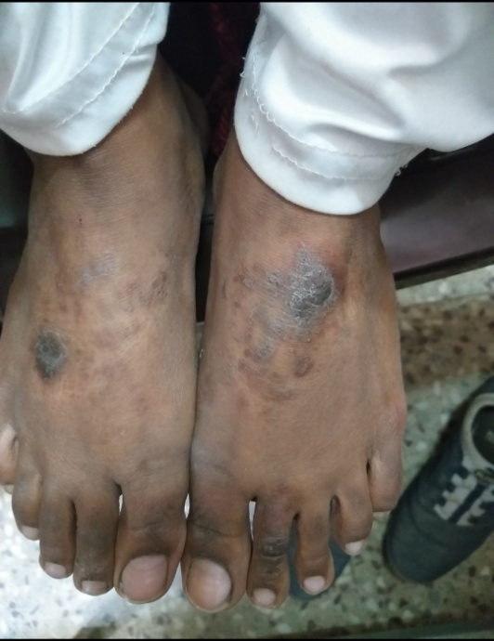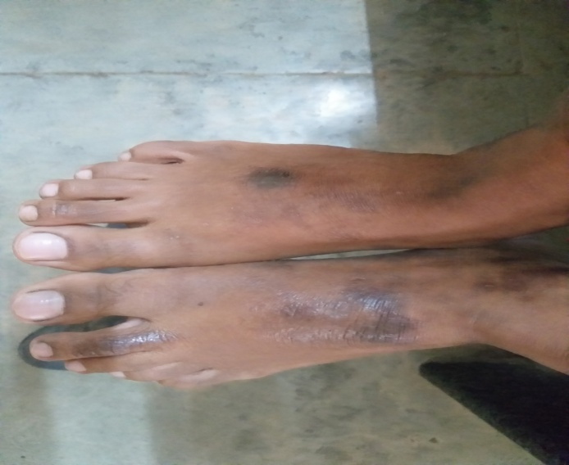
BEFORE TREATMENT AFTER TREATMENT

Discussion :-
In this case study the drug used Arogyavardhini vati and Gandhak Rasayana contains dravya which mostly acts as kaphagna and vatashamak which reduced the symptoms like kandu, rukshata, shyavata, rajyo, ruja ,lohit varna etc. And the Karanj tailam which also contain kaphavatshamak dravya decreases the kandu( Itching) and shyavata ( blackish discolouration) significantly .
The symptomatology of vicharchika is similar with eczema .Eczema can be defined as a disease in a form of dermatitis or inflammation of the epidermis. The term eczema is broadly applied to a range of persistent skin conditions. There is no sure cure for eczema in modern medical science. The treatment of eczema was discussed here in detail, but they have many side – effects e.g topical corticosteroids have side effects.
So, now the duty of ayurveda is to provide a safe and effective medicine to the world so, present case study is a humble effort to give a medicine from classical ayurvedic preparation .
Conclusion and result:-
From above discussion it is concluded that a classical ayurvedic preparation can also be shows significant effect in the skin diseases. Arogyavardhini vati and Gandhak Rasayan orally twice a day and Karanj tailam topically twice a day decreased symptoms of vicharchika with some pathyapathya ( i.e avoid fish intake) without any side effects.

References:-
1)Charkacharya:- charak samhita edited by Ravidatta tripathi, chaukhamba prakashan Sanskrit pratishthan Delhi ,2007 edition, chikitsa sthan chapter no7. Shloka no.27 and 30.

2)Sushrut:- sushrut samhita ,edited by Ambikadatta shastri, chaukhamba prakashan Varanasi, Nidan sthan chapter no .5 shloka no 13

3)Madhav nidan edited by Ayurvedacharya shri. yadunandnopadhyay, chaukhamba prakashan part 2 ,reprint 2009

4)Vagbhatt:- Ashtanghridayam with viawananoranjini hindi commentary and notes by pandit kashinath shastri edited by indradev tripathi and shrikant tripathi published by chaukhamba prakashan Varanasi first edition 1994,nidan sthan chapter no.14 , Chikitsa sthan chapter no.19

5)Sharangdhar samhita edited by bramhanand tripathi,chaukhamba prakashan Varanasi 2015,pratham khanda,(Rogaganana)chapter no7.shloka no.87

6)yogratnakar edited by vaidyaraj, datto ballal borkar published by shri.gajanan book depo, pune, part 2 kushthnidan 30 shloka no.23

7)Rasratna samuchhay edited by sanghguptasunu shri. vagbhatacharya virchit,published by shivaji vidyalaya, Kolhapur 1972,uttarardha adhyay.20

8)Harita samhita:-edited by acharya ramvalamba shastri, prachya prakashan 1st edition 1985,3rd sthan chapter no.36 shlok no.12

10)Kashyapa samhita ,Nepal rajgurana p.hemraj Sharma ,chaukhamba prakashan ,Varanasi 1988 4th edition ,page no.116

11) Bhaishajya Ratnavali- by prof. sidhinandan mishra, chaukhamba surbharti prakashan, Varanasi, page no.871, page no.919
12) Bhaishajya Ratnavali- by prof. sidhinandan mishra, chaukhamba surbharti prakashan, Varanasi, page no.919
13) yogratnakar edited by vaidyaraj, datto ballal borkar published by shri.gajanan book depo, pune, part 2 ,Rasayanadhikar

