“RANDOMIZED OPEN CONTROLLED CLINICAL STUDY OF THERAPEUTIC EFFECT OF SNUHYADYA TAIL EXTERNALLY AS SHIROABHYANGA WITH COMPARISON TO BHRUNGARAJ TAIL EXTERNALLY AS SHIROABHYANGA IN KHALITYA PATIENTS HAVING AN AGE GROUP 15-60 YEARS WITH SPECIAL REFERENCE TO ALOPECIA.”
Patil Dakshata Santan¹, Jaiswal Suryaprakash K.², Jamdhade Subhash B.³
P.G. Scholar¹, P.G. Guide², Associate Professor and HOD³
Kayachikitsa Department, D.M.M. Ayurved College, Yavatmal, Maharashtra, India
Corresponding author: patildakshata179@gmail.com

ABSTRACT
Introduction - Healthy, beautiful, long and attractive hairs add charm of personality. According to Acharya charak, Ashtanga Hridayakar, Sharangdhar khalitya is under shirorogas. As per Acharya Sushruta, Ashtang Sangraha, Yoga Ratnakara and Madhavnidana Khalitya is under heading of kshudraroga. According to Acharya Sushruta Khalitya occurs when vata dosha get vitiated along with pitta dosha it enters the romkupam or hair follicle and which result in hair fall. Snuhydya tail is taken from Bhaishyajya ratnavali kshudrarogadhikar.
Aim and objective- To study the therapeutic effect of external use of snuhyadya tail as shiroabhyanga with compare to external application of bhrungaraj tail as shiroabhyanga in the management of khalitya having an age group 15-60 years.
Material and method –
Method- 60 clinically dignosed patient of khalitya selected from opd / ipd unit of pg department of kayachikitsa, L.K. Ayurvedic hospital, yavatmal
Material – shnuhyadya taila and bhrungaraj taila
Result and conclusion- Snuhyadya taila and bhrungraja tail both are effective in the management of khalitya to reduce the sign, symptoms i.e. khalitya. On the basis of overall percent relief, snuhyadya tail external application as shiroabhyanga has found more effective than that of bhrungraja tail external application as shiroabhyanga in the management of khalitya.
Keywords- khalitya, alopecia, snuhyadya taila, kshudraroga, keshchyutti, bhrungraj tail, shirorogas.

INTRODUCTION
Healthy, beautiful, long and attractive hairs add charm of personality. It offers a lot of aesthetic value and is a person’s crowning glory. According to Acharya charak, Ashtanga Hridayakar, Sharangdhar khalitya is under Shirorogas. As per Acharya Sushrut, Ashtang Sangraha, Yoga Ratnakara and Madhavnidana Khalitya is under heading of kshudraroga.
तेजोऽनिलाद्यैः सह केशभूमिं दग्ध्वाऽऽशु कुर्यात् खलति नरस्य । किंचित्तु दग्ध्वा पलितानि कुर्याद्धरिप्रभत्वं च शिरोरुहाणाम् (च.चि. 26/132)
Tejas, when combined with aniladi doshas, reaches the shira-kapala and causes hair fall through the dahana of roma koopa, according to Acharya Charaka. This is referred to as khalitya. Chakrapani while commenting on this status the word Tejas here denotes deha ushma as well as pitta dosha.

रोमकूपानुगं पित्तं वातेन सहमूर्च्छितं ॥ प्रच्यावयति रोमाणि ततः श्लेष्मा सशोणितः ।
रुणध्दि रोम कूपांस्तु ततोऽन्येषामसंभवः ॥ तर्दिद्रलुप्तं खालित्यं रुज्येति च विभाव्यते ।। (सु.नि.13/32-33).
According to Acharya Sushruta vrudda pitta in combine with vata, reaches Romakoopa and causes hair fall whereas kapha combine with rakta dosha causes avarodha to the Romakoopa which prevent hair regeneration and this disease is known as Indralupta, Khalitya, or Ruhya. Acharya Vagbhat says khalitya and indralupta are same but in khalitya the process of hair fall is slower when hair loss in patches it called as indralupta.
According to modern medicine khalitya is known as alopecia which refer to partial or complete loss of hair especially from the scalp. Khalitya is remarkable problem in the society in modern era, so it has a high cosmetic importance, which is affecting approximately 60.3% of the population. Hair fall is more in male than females. According to survey up to 40% of men and 25% of women in India are victims of hair fall. It is progressive disorder, people who lead sedentary lifestyles experience stress, which causes hectic schedule, this combined with indiscriminate dietary habits causes many disturbances and inefficiencies in the body which are reflected in the hairs.
In Ayurveda also Aharaj, Viharaj, Manas hetu play important role in samprapti of khalitya and also not following dinacharya, ritucharya may collectively increases pitta, vata which lead to hairfall. In ayurveda various bahya and abhyantar chikitsa is described for khalitya such as lepa, nasya, abhyanga, shirodhara, shiropichu, parishek etc. among these abhyanga is best for khalitya, so in this study snuhyadya taila (group A -30 patient) and bhrungaraj taila (group B-30 patient) for khalitya was given for shiroabhyanga up to 30 days and after that 30days follow up taken.

Aims and Objectives-
1.Primary objectives-
To study the therapeutic effect of external use of snuhyadya tail as shiroabhyanga with compare to external application of bhrungaraj tail as shiroabhyanga in the management of khalitya having an age group 15-60 years.
2.Secondary objectives-
1.To study details about snuhyadya taila and classical view of khalitya.
2.To evaluate the efficacy of bhrungaraj taila as shiroabhyanga in the management of khalitya.
3.To compare the effects of shiroabhyanga with snuhyadya taila and bhrungaraj taila in the management of khalitya.
MATERIAL AND METHODS- STUDY DESIGN: Prospective, randomized, controlled, open labelled clinical study.
Place – PG Department of kayachiktsa Laxmanrao Kalaspurakar Ayurved College Yavatmal, affiliated with D.M.M, Ayurved, College, Yavatmal
Duration –One month drug intervention and after that one month follow up.
SELECTION OF PATIENT –
INCLUSIVE CRITERIA
*Patients of both sexes with an age group between 15 to 60yrs.
*Cases with classical sign &symptoms of khalitya were considerd
*Hair fall (keshchyuti)
*Hair pull test
*Patients willing for clinical trial.
*Patients belonging to any socio-economic class irrespective of cast, religion, occupation.
*Patient who will fulfill criteria and take regular medicines with Regular follow up.
B- EXCLUSIVE CRITERIA
*Patients not willing for clinical trial.
*patient whole age is less than 15 & above 60 yrs.
*Allergic disorders (Tenea capitalis), scalp psoriasis
*Patient is known case of any autoimmune disorder like thyroid & rheumatoid disease.
C- WITHDROWAL FROM THE STUDY
*Patients not following regular follow up.
*Allergic to trial medicine.
*Progressive worsening of disease & development of complication during trial.
*Non-co-operative behavior of the patients.

TREATMENT DETAIL
Group | Group A | Group B
No. of Patients | 30 | 30
Treatment | Snuhyadya taila | Bhrungaraj taila
Dose | 5 ml | 5 ml
Kalpna | Tail (oil) | Tail (oil)
Duration | 30 days therapy and post therapy 30 days follow up | 30 days therapy and post therapy 30 days follow up
Time of Administration | Once in night (before one hour of bed time) | Once in night (before one hour of bed time)
Route | Local (shiroabhyanga) | Local (shiroabhyanga)

SNUHYADYA TAILA CONTENT-
snhuhipaya, arkapay, bhrungraj, langali, vatsnabh, ajamutra, gomutra, gunja, indravaruni, sarshap, jyotishmati and sarshap taila.
BHRUNGRAJ TAILA CONTENT-
Brungraj, Lohkitta, (triphala) Haritaki, Bibhitaki, Amalaki, Sariva, Til taila.

ASSESSMENT CRITERIA-

1)Keshochyutti (Hair Fall)

 | GRADATION | SEVERITY | NO. OF HAIR FALL PER DAY
Grade | 0 | NORMAL | 0-30
Grade | 1 | MILD | 30-60
Grade | 2 | MODERATE | 60-100
Grade | 3 | SEVERE | 100-160
Grade | 4 | MORE SEVERE | >160

2)Hair pull test(objective)

 | GRADATION | SEVERITY | NO. OF HAIR PULL AT TIME
Grade | 0 | Normal | 0-1
Grade | 1 | Mild | 2-3
Grade | 2 | Moderate | 3-6
Grade | 3 | Severe | MORE THAN 6

OBSERVATION AND RESULT

1.Keshchyuti: -

Group | Mean score |  |  | Median diff. | IQR of diff.  Q₃ – Q₁ | Sample size | Wilcoxon signed rank test (T+) | P Value
Group | B.T | A.T | Diff
Group A | 1.13 | 0.2 | 0.93 | 1.00 | 0.0  (1.0 –1.0) | 30 | 378.00 | < 0.05
Group B | 1.26 | 0.4 | 0.86 | 1.00 | 0.0  (1.0 –1.0) | 30 | 300.00 | <0.05

For group A and group B, the median reduction in Keshchyuti score after treatment is significant (P-value < 0.05) at 5% level of significance. i.e. it can be said that there is significant reduction in Keshchyuti for group A and group B.

Comparative Analysis of Groups:
Using Mann-Whitney U test, to test the hypothesis –
Group | Median difference (bef–aft) | Mean of difference (bef-aft) | S.D. of difference (bef-aft) | Mann-Whitney U statistic | P- Value
Group A | 1.00 | 0.9333 | 0.3651 | 480.00 | 0.531
Group B | 1.00 | 0.8666 | 0.5074 | 480.00 | 0.531

Reductions in Keshchyuti score group A and group B were not significantly Different (p –value=0.531) at 5% level of significance.
Thus, treatment A and treatment B can be considered as equal efficacious in reducing Keshchyuti.

Keshchyuti |  | Grade 0 |  | Grade 1 |  | Grade 2 |  | Grade 3
 |  | No. | % | No. | % | No | % | No | %
Group A | BT | 0 | 0% | 27 | 90% | 2 | 7% | 1 | 3%
Group A | AT | 24 | 80% | 6 | 20% | 0 | 0% | 0 | 0%
Group B | BT | 0 | 0% | 23 | 77% | 6 | 20% | 1 | 3%
Group B | AT | 18 | 60% | 12 | 40% | 0 | 0% | 0 | 0%
2.Hair Pull Test:-(Objective parameter)

Group | Mean score |  |  | Median diff. | IQR of diff.  Q₃ – Q₁ | Sample size | Wilcoxon signed rank test (T+) | P Value
Group | B.T | A.T | Diff
Group A | 2.00 | 0.333 | 1.667 | 2.0 | 1.0  (2.0 –1.0) | 30 | 465.00 | < 0.05
Group B | 2.33 | 0.3 | 2.03 | 2.0 | 0.0  (2.0 –2.0) | 30 | 465.00 | < 0.05

For group A and group B, the median reduction in Hair Pull Test after treatment is significant (P-value < 0.05) at 5% level of significance. i.e. it can be said that there is significant reduction in Hair Pull Test for group A and group B.

Comparative Analysis of Groups:
Using Mann-Whitney U test, to test the hypothesis –

Group | Median difference (bef–aft) | Mean of difference (bef-aft) | S.D. of difference (bef-aft) | Mann-Whitney U statistic | P- Value
Group A | 2.00 | 1.6667 | 0.5466 | 315.50 | 0.9896
Group B | 2.00 | 2.0333 | 0.6149 | 315.50 | 0.9896

Reductions in Hair Pull Test score for group A and group B were not significantly Different (p –value = 0.9896) at 5% level of significance.
Thus, treatment A and treatment B can be considered as equal efficacious in reducing Hair Pull Test.

Hair Pull Test |  | Grade 0 |  | Grade 1 |  | Grade 2 |  | Grade 3
 |  | No. | % | No. | % | No | % | No | %
Group A | BT | 0 | 0% | 7 | 23% | 16 | 53% | 7 | 23%
Group A | AT | 20 | 67% | 10 | 33% | 0 | 0% | 0 | 0%
Group B | BT | 0 | 0% | 3 | 10% | 14 | 47% | 13 | 43%
Group B | AT | 21 | 70% | 9 | 30% | 0 | 0% | 0 | 0%

Parameter | Group A | Group B | Comparative efficacy
Keshchyuti | Significant | Significant | Equally Effective
Hair Pull Test | Significant | Significant | Equally Effective

According to % Relief In Symptoms
Sr. No. | Parameter | Group A |  | Group B
Sr. No. | Parameter | day 30 | day 60 | day 30 | day 60
1 | Keshchyutii | 90.55% | 85.55% | 78.88% | 70.56%
2 | Hair Pull Test | 89.44% | 86.66% | 90.55% | 88.88%
% Improvement |  | 90.00% | 86.11% | 84.72% | 79.72%
Associated Variable
1 | Darunak | 78.94% | 78.94% | 86.20% | 72.41%
2 | Kandu | 85.71% | 71.42% | 50% | 45.33%
3 | Keshrukshtwa | 90% | 82.75% | 93.10% | 72.41%
4 | Kesh Bhumi Daha | 100% | 100% | 100% | 100%
5 | Kesh Bhumi Dourgndhya | 100% | 100% | 100% | 100%
 | % Improvement | 90.86% | 86.62% | 85.86% | 78.03%
% Improvement |  | 90.61% | 86.47% | 85.53% | 78.51%

% Improvement According to Patients: -

PATIENTS | Group A |  | Group B
 | Day 30 | Day 60 | Day 30 | Day 60
Complete Improvement | 21 | 16 | 19 | 15
Marked Improvement | 5 | 10 | 3 | 6
Moderate Improvement | 4 | 3 | 8 | 6
Mild Improvement | 0 | 1 | 0 | 3
Unchanged | 0 | 0 | 0 | 0
 | 30 | 30 | 30 | 30

DISCUSSION-

In Trial Group and In Control Group (By Wilcoxon Signed Ranks Test)-
Wilcoxon Signed Ranks test was applied to both groups separately to observe whether the difference between Before and after treatment significant or not. From tables we can observe that P-Values for Group A and Group B are less than 0.05 in both groups. The test has shown significant difference between D-0 and D-60 symptom scores. It is hence concluded that snuhyadya taila externally as shiroabhyanga (Trial Group) and bhrungraja taila externally as shiroabhyanga (Control Group) has significantly reduced keshchyuti (hair fall), hair pull test (objective).
Statistical Analysis:- Comparison Group A and Group B (By Mann Whitney’s U Test)-
Both groups were compared and analyzed statistically by Mann-Whitney’s U test.-
In the case of symptoms keshchyutti (hair fall), hair pull test (objective). Reductions in Keshchyuti score group A and group B were not significantly Different (p –value=0.531) at 5% level of significance. Mean diff. of group A is 0.933 and group B is 0.866 and it is neatly equal, thus P value is greater than 0.05 hence H₀ is reject and H₂ is accepted. Thus, treatment A and treatment B can be considered as equal efficacious in reducing Keshchyuti.
Reductions in Hair Pull Test score for group A and group B were not significantly Different (p –value = 0.9896) at 5% level of significance.
Mean diff. of group A is 1.666 and group B is 2.033 and it is nearly equal, thus P value is greater than 0.05 hence H₀ is reject and H₂ is accepted.
Thus, treatment A and treatment B can be considered as equal efficacious in reducing Hair Pull Test.
So, the snuhyadi taila external application as shiroabyanga and bhrungaraj taila external application as shiroabhyang is equal effective in the management of khalitya.

BEFORE TREATMENT
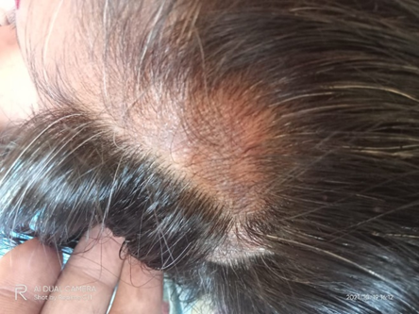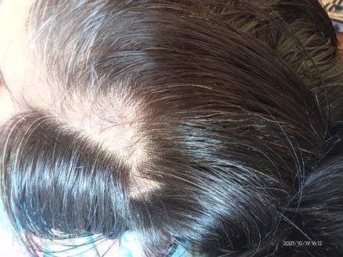

AFTER TREATMENT
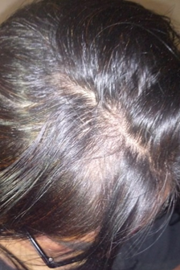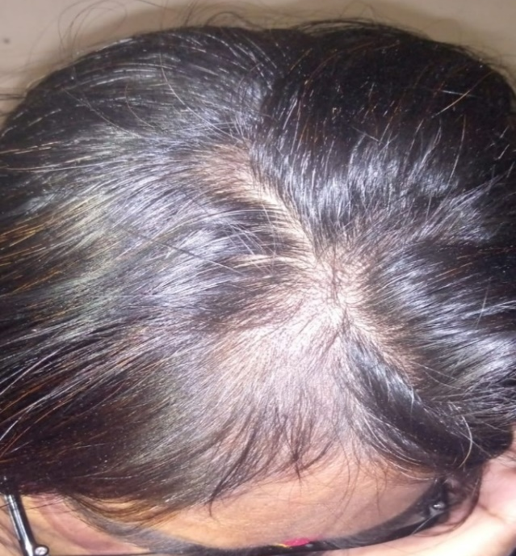

CONCLUSION-
In group A 90% at day 30 and 86.11% at day 60.
In Group B 84.72% at day 30 and 79.72% at day 60.
Thus according to mean percent relieve it can conclude that the group A i.e. snuhyadya taila is more effective than group B i.e. bhrungaraja taila to reduce the sign and symptoms of khalitya. Finally we concluded,
Snuhyadya taila and bhrungraja taila both are effective in the management of khalitya.
On the basis of overall percent relief, snuhyadya taila external application as shiroabhyanga has found more effective than that of bhrungraja taila external application as shiroabhyanga in the management of khalitya.
Both Snuhyadya taila and bhrungaraja taila reduced the associated symptoms like darunaka, kandu, keshrukshtwa, keshbhumi daha, keshbhumi dourgandhya.

REFERENCES-
- Charak Samhita with Vaidya Manorama commentary; hindi author acharya vidyadhar Shukla and prof. ravidatta Tripathi published by chaukjhamba Sanskrit pratishtan, dilli. Trancelated by marathi bhashantarkar Vaidya vijay shankar kale. Part 2, chikitsasthan 26th chapter, shlok no.132, Pg no. 634
- Drushtarth sushrut chintan with acharya dalhan’s nibandh sangaraha commentary, with gayadas’s nyayachandrika commentary and also with athawalekrut pandmini commentary by author Vaidya p. g. Athawale; published by godavary publishers and book promotors 148, shastri nagar, Nagpur. First edition; khand first.; kshudraroga nidan A- 13/33-34, Pg no. 515; B-13/3, Pg no. 510.
- Drushtarth sushrut chintan with acharya dalhan’s nibandh sangaraha commentary, with gayadas’s nyayachandrika commentary and also with athawalekrut pandmini commentary by author Vaidya p. g. Athawale; published by godavary publishers and book promotors 148, shastri nagar, Nagpur. First edition; kshudra roga chikitsa 20/24-26 pg no. 145.
- Vriddha Vagbhata. Astanga Samgraha with Hindi commentary by Kaviraj Atrideva Gupta.Varanasi:Krishnas Das Academy;2002.
- Sarth vaghbhatt (Asthang sangrah)Marathi transalation Dr.Ganesh krushna garde,Choukhamba surbharati prakashan varanasi shiroroga vidnyaniya 23 chapter ,shlok no.24-25-26., page no424.
- Sarth vaghbhatt (Asthang sangrah) Marathi transalation Dr.Ganesh krushna garde,Choukhamba surbharati prakashan varanasi shiroroga pratishedh 24 chapter,page no426,shlok no28-34.
- Harita Samhita–Hindi translation by Vaidya Ravidatta Shastri.;Mumbai: Sri Lakshmi venkateshwara publishers. (Tri.stha.pg.428-430)
- Sharangadhar Samhita – sharangdharacharya vicharit sharngadharsamhita with dipika hindi vyakhya; author dr bramhanand Tripathi; published by chaukhambha surabharati prakashan, Varanasi ;2015; purva khanda 7th chapter ; shlok no. 151-152; page no. 77
- Sarth vaghbhatt(Asthang sangrah)Marathi transalation Dr.Ganesh krushna garde,Choukhamba surbharati prakashan varanasi shiroroga pratishedh 23chapter, shlok no. 20, page no424
- MADHAVANIDĀNAM OF SRI MADHAVAKARA With The Madhukosa Sanskrit Commentary By Srivijayaraksita and Srikanthadatta With The 'Vidyotini' Hindi commentary and Notes By SRI SUDARSANA SASTRI, Revised & Edited by YADUNANDANA UPADHYAYAS ;Part II ;CHAUKHAMBHA SANSKRIT SANSTHAN Publishers and Distributors of Oriental Cultural Literature; kshudraroga nidanam 55th chapter; shlok no. 28-29; page no. 203-204,.
- Govindadasvicharit Bhaishajya Ratnavali, with vidyotini hindi vyakhya by kaviraj shri ambikadatta shastri edited by rajeshwardatta shastri published by choukhambha Sanskrit Sansthan; 1991 –Chapter 60

