Manuscript type :- Case Report

Title: Anatomical Variation of Flexor Hallucis Longus Tendinous Slips to Second and Third Toes: A Cadaveric Insight

Running Title- An Anatomical variation of Flexor Hallucis Longus with two extra slips

Corresponding Author-Dr Nidafazli Khan
M.D Scholar
Department Of Rachana Shareer
National Institute of Ayurveda, Jaipur
Orchid id-0009-0006-9329-2795
1342, Krishna Kunj, Darjiyo ki galli, Chokdi Gangapol, Amer Road, Jaipur -302002
Email Id- nidafazli.96@gmail.com

Co-Author- Dr. Rohini Hivarale
M.D Scholar
Department Of Rachana Shareer
National Institute of Ayurveda, Jaipur
Email Id – hivaralerohini010@gmail.com

Co-Author- Dr. Aakanksha Soni
M.D Scholar
Department Of Rachana Shareer
National Institute of Ayurveda, Jaipur
Email Id - suchitasoni05@gmail.com

Co-Author- Dr. Lakshita Sharma
M.D Scholar
Department Of Rachana Shareer
National Institute of Ayurveda, Jaipur
Email Id -lakshitashrm@gmail.com

Co-Author- Dr. Sandeep M. Lahange
Professor
Department Of Rachana Shareera
National Institute of Ayurveda, Jaipur
Email Id - sandiplahange@gmail.com

Co-Author- Dr. Vikash Bhatnagar
Professor
Department Of Rachana Shareer
National Institute of Ayurveda
Email Id-shailjavakas@gmail.com

TITLE: Anatomical Variation of Flexor Hallucis Longus Tendinous Slips to Second and Third Toes: A Cadaveric Insight

Abstract:

Introduction: Flexor hallucis longus (FHL) is a powerful muscle located on the posterior aspect of the fibula below the deep fascia of the calf. It originates from lower two-thirds of posterior fibula and inserts at the Plantar surface at the base of the first distal phalanx.

Background: Anatomical variations in the plantar musculotendinous architecture, particularly at the Chiasma Plantare (Master Knot of Henry), can influence foot biomechanics and have surgical significance.
Main Clinical Findings: During routine cadaveric dissection, a rare unilateral variant was identified in which two tendinous slips originated from the flexor hallucis longus (FHL) tendon and merged with the flexor digitorum longus (FDL) tendons insert at distal phalanx of second and third toes. The slips arose deep to the quadratus plantae at the classical FHL–FDL crossover.
Discussion: This configuration corresponds to Type I-b of Plaass et al.’s classification and may contribute to enhanced toe flexion strength, improved force distribution, and functional redundancy. Such variations have surgical relevance during tendon grafting, Achilles tendon reconstruction, and in managing tibialis posterior dysfunction.
Conclusion: Documenting such rare patterns enriches anatomical databases, aids preoperative planning, and deepens our understanding of plantar biomechanics.

Keywords: Master Knot of Henry, Plaass classification, Chiasma Plantare, Second layer of sole, extra slip of FHL

Abbreviations: Flexor Hallucis Longus (FHL), Flexor Digitorum Longus (FDL), Master Knot of Hennery (MKH)

Introduction:
The human foot integrates structural complexity with functional adaptability. Among its key elements are the long flexor tendons: the flexor hallucis longus (FHL), originating from the posterior fibula, and the flexor digitorum longus (FDL), originating from the posterior tibia. At the second layer of the sole, these tendons intersect at the Chiasma Plantare, also called the Master Knot of Henry (MKH), where intertendinous communications are common but highly variable. ^{1,2}
The FHL primarily flexes the great toe and assists in plantar flexion, while the FDL flexes the lateral four toes. Variations in their tendinous connections may affect biomechanics, proprioception, and clinical outcomes in foot surgery .^{3,4,5} Though slips from FHL to FDL are often observed, the precise pattern, number, and insertion vary greatly. Reports from Indian cadaveric studies are limited.
Here, we present a unique dual-slip variant from FHL to the second and third toes, discuss its biomechanical and surgical implications, and correlate it with prior morphometric studies.

Materials and Methods:
- The dissection was conducted in the Acharya Sushruta Dissection Hall, Department of Rachana Sharira, National Institute of Ayurveda, Jaipur. The dissection procedure adhered to the systematic guidelines outlined in Cunningham's practical manual for the dissection of the sole of the foot. During the dissection of the plantar region of a lower limb, after removal of the skin, superficial fascia, and plantar aponeurosis, the superficial muscle layer comprising the flexor digitorum brevis and abductor hallucis was carefully reflected. On exposing the second muscular layer of the sole, a noteworthy anatomical configuration was identified.

- The tendon of the FHL was seen coursing beneath the FDL tendon and quadratus plantae. At this point of crossing, two well-defined tendinous slips branched off from the FHL. These slips coursed obliquely and united with the tendons of FDL that were directed toward the second and third toes. The arrangement was found unilaterally and was located distinctly deep to the quadratus plantae muscle. No further extensions toward the fourth or fifth toes were identified. The rest of the plantar musculature and tendinous structures appeared normal.
- Based on existing classification systems, this variant corresponds to a Type I connection (from FHL to FDL), subtype b—where slips extend to the second and third digits.

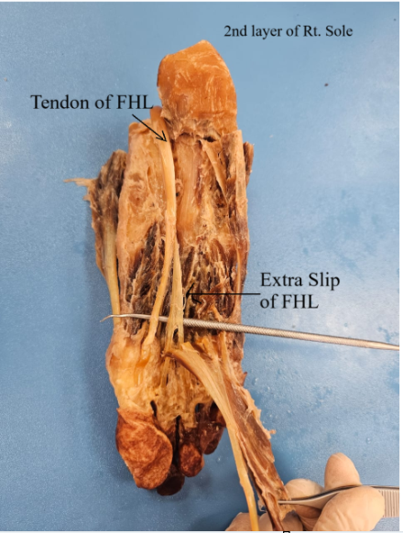
Figure 1: - Showing extra slip of FHL in the second layer of right sole (In-situ).

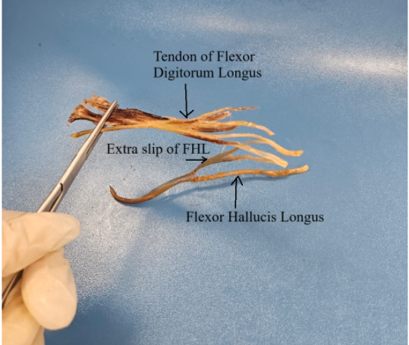
Figure 2: - Showing extra slip of FHL merging with the tendon of FDL, inserting at the distal phalanx of 2nd and 3rd toe in the second layer of right sole (Ex-situ).

Developmental Significance:

These slips are developmentally conserved remnants of a primitive common flexor system. Their Functional relevance persists in modern gait—these are not vestigial but integrated in locomotor biomechanics.

Results:
On exposing the second layer of the sole: The extra slip of FHL tendon coursed beneath the FDL tendon at and quadratus plantae. Two distinct tendinous slips branched from FHL at the MKH level:
Slip 1: to the FDL tendon for the second toe.
Slip 2: to the FDL tendon for the third toe.
These unilateral slips lay deep to quadratus plantae and joined FDL tendons obliquely. No extensions to fourth or fifth toes were found. This pattern matched Type I-b connection per Plaass et al.

Discussion:

Incidence and Classification:
- Plaass et al. (2013): Proximal–distal slips from FHL to FDL in ~95% of feet, with subtype I-b representing slips to second and third toes (branching ~5.3 cm distal to medial malleolus) (7).
- Pretterklieber (2017): FHL to second toe in ~97%, to third toe in ~53%; bidirectional FHL–FDL connections in ~39% (8).
- Beger et al. (2018): MKH ~4.2 cm distal to medial malleolus, a critical landmark for surgery (2).
Slips may assist coordinated toe flexion, particularly during push-off in gait, sprinting, or tiptoe stance. They enhance force sharing and redundancy—preserving function after partial tendon injury. Support proprioception and stability during stance (9).

In Achilles tendon reconstruction, posterior tibial tendon dysfunction, or peroneal tendon tears, unrecognized slips can hinder tendon mobilization (10,11). Amlang et al. (2012) recommend direct plantar approach to MKH to visualize and release such slips (12).Variations may complicate tendon gliding in tenosynovitis or entrapment syndromes.

Conclusion:
The rare finding of dual tendinous slips from FHL to second and third toes highlights the variability of the Chiasma Plantare. Such configurations have functional, evolutionary, and surgical importance. Awareness of these variants can aid surgeons in avoiding inadvertent injury, improving tendon harvest outcomes, and understanding preserved toe function after reconstructive procedures. They enhance the efficiency and stability of the flexor system during activities like standing on tiptoes, jumping, or sprinting by load sharing and force distribution. They contribute to functional reserve, especially in complex foot movements in dancers and athletes.

References
- Plaass C, Abuharbid G, Waizy H, Ochs M, Stukenborg-Colsman C, Schmiedl A. Anatomical variations of the flexor hallucis longus and flexor digitorum longus in the chiasma plantare. Foot Ankle Int. 2013;34(11):1580-7. doi:10.1177/1071100713494780.
- Beger O, Coşkun N, Kara M, Yıldız S, Özkan M. Anatomy of Master Knot of Henry: a morphometric study on cadavers. Acta Orthop Traumatol Turc. 2018;52(2):139-45. doi:10.1016/j.aott.2018.01.003.
- Pretterklieber B. The high variability of the chiasma plantare and the long flexor tendons: anatomical aspects of tendon transfer in foot surgery. Ann Anat. 2017;211:21-32. doi:10.1016/j.aanat.2017.01.011.
- Mao H, Shi Z, Wapner KL, Dong W, Yin W, Xu D. Anatomical study for flexor hallucis longus tendon transfer in treatment of Achilles tendinopathy. Surg Radiol Anat. 2015;37(6):639-47. doi:10.1007/s00276-014-1399-y.
- Amlang M, Rosenow MC, Friedrich A, Zwipp H, Rammelt S. Direct plantar approach to Henry's knot for flexor hallucis longus transfer. Foot Ankle Int. 2012;33(1):7-13. doi:10.3113/FAI.2012.0007.
- Romanes GJ, ed. Cunningham’s Manual of Practical Anatomy. Vol 1. 15th ed. Oxford: Oxford University Press; 2017.
- Henry AK. Extensile Exposure. 2nd ed. Edinburgh: Churchill Livingstone; 1973.
- Standring S, ed. Gray’s Anatomy: The Anatomical Basis of Clinical Practice. 42nd ed. London: Elsevier; 2020.
- Perry J, Burnfield JM. Gait Analysis: Normal and Pathological Function. 2nd ed. Thorofare, NJ: SLACK Incorporated; 2010.
- Singh D, Angel J, Trevino S. Flexor hallucis longus tendon transfer for chronic Achilles tendonosis. Foot Ankle Clin. 2006;11(2):439-47. doi:10.1016/j.fcl.2006.02.005.
- Wapner KL, Hecht PJ, Mills RH. Reconstruction of neglected Achilles tendon injury. Orthop Clin North Am. 1995;26(2):249-63.
- Kitaoka HB, Luo ZP, An KN. Analysis of function of the toes in walking. Foot Ankle Int. 1996;17(9):513-7. doi:10.1177/107110079601700901.

